**The world-renowned Professor Rashid Sumaila of UBC is One of UP’s highly cited researchers by Clarivate**

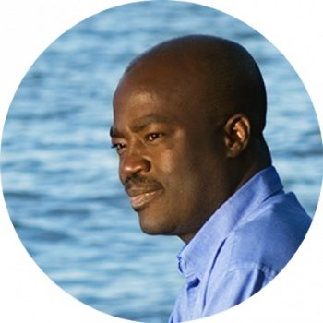

Professor Rashid Sumaila is a Professor and Canada Research Chair (Tier 1) in Interdisciplinary Ocean and Fisheries Economics at the Institute for the Oceans and Fisheries, and the School of Public Policy and Global Affairs, University of British Columbia (<https://oceans.ubc.ca/2023/05/19/rashid-sumaila-frsc/>). He is also an Extraordinary Professor at the University of Pretoria, Department of Agricultural Economics, Extension and Rural Development (AEERD). Prof. Sumaila has been recognized as a Highly Cited Researcher in the Cross-Field category by Clarivate (<https://clarivate.com/highly-cited-researchers/?action=clv_hcr_members_filter&clv-paged=1&clv-category=&clv-institution=University%20of%20Pretoria&clv-region=&clv-name=>) for four successive years (2021–2024). UP and the department (AAERD) are celebrating this exceptional achievement, which promotes UP’s profile through collaboration. This prestigious accolade, granted to individuals among the world's best 1% of scholars, underscores his seminal work on fisheries economics, environmental sustainability, and global ocean conservation. From his cross-disciplinary research synthesizing environmental science, fisheries, international relations, and marine biology. Professor Sumaila has not only advanced scholarly writing, but also developed capacity and shaped policymaking towards securing the world's oceans. His affiliation with the University of Pretoria, and other great institutions, also bears witness to the department's growing reputation as a center for cutting-edge research, inspiring staff and students in equal measure by his enthusiasm for sustainability and generating workable solutions to global environmental problems.