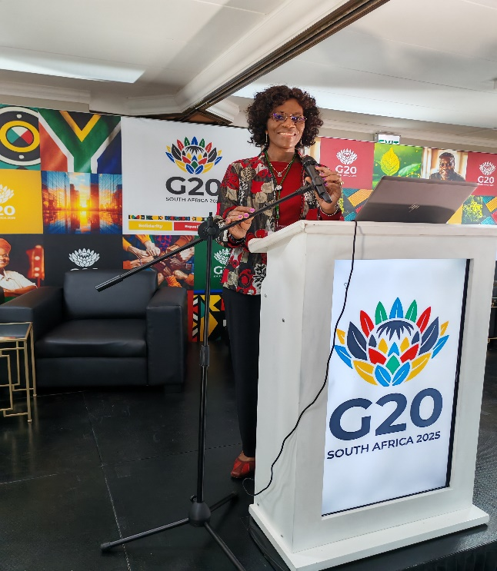 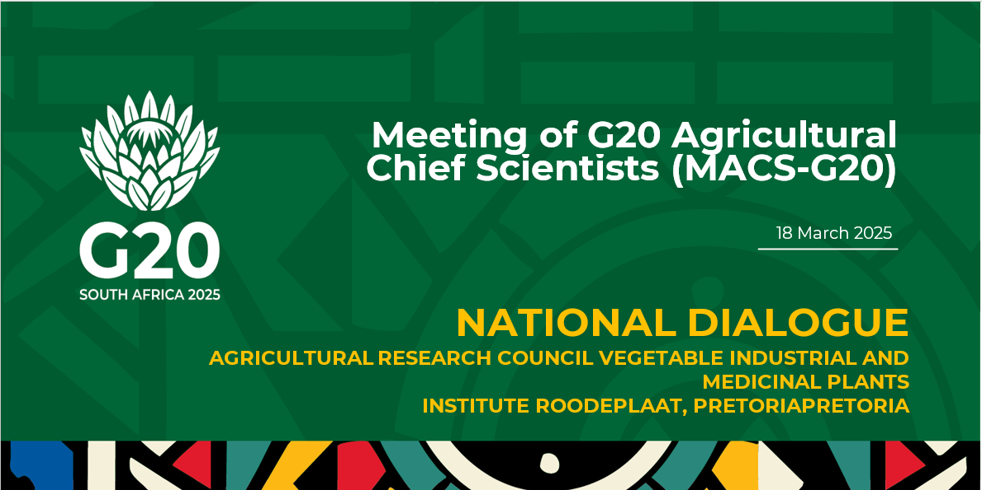

The Agricultural Research Council (ARC), in partnership with the Department of Agriculture, and the Food, Agriculture and Natural Resources Policy Analysis Network (FANRPAN), held the G20 National Dialogue towards the Agricultural Working Group engagement and the G20’s Meeting of Agricultural Chief Scientists (MACS-G20) on 18 March 2025. This event was held at the Agricultural Research Council Vegetable Industrial and Medicinal Plants Institute (ARC-VIMP) facility in Roodeplaat, Pretoria.

Dr. Selma Karuaihe from the University of Pretoria, Department of Agricultural Economics, Extension and Rural Development was invited to moderate over two themes that focused on: (i) Reinforcing Climate Smart Agriculture for resilience, mitigation, and early warning systems; and (ii) Building resilient Agricultural Bio economies in Africa. The dialogue unpacked key questions that have been identified as crucial to assist South Africa – holding the current Presidency of the G20, in its preparation towards hosting the G20 meetings later this year.

The primary objectives of the National Dialogue were to:

* Discuss the priorities identified in the issue note for South Africa’s G20 Agriculture Working Group (AGW).
* Strengthen South Africa's policy and research position within international agricultural science fora.
* Contribute towards prioritisation of key thematic areas for discussion in the MACS-G20 and elaboration of key issues under each theme.
* Enhance collaboration between researchers, policymakers, and industry stakeholders to align national research priorities with global trends.

Dr. Karuaihe's presence at the event shows the university and the department's commitment and role in guiding national and global policy debates, using its capacity on diverse skills to offer high level expertise on topical issues. Follow at: <https://x.com/DrSelmaK/status/1903117206763810915>