University of Pretoria relaunches its Curriculum Transformation Drive: ‘Curriculum Transformation is not a future event, but a present activity’ on 13 May 2021

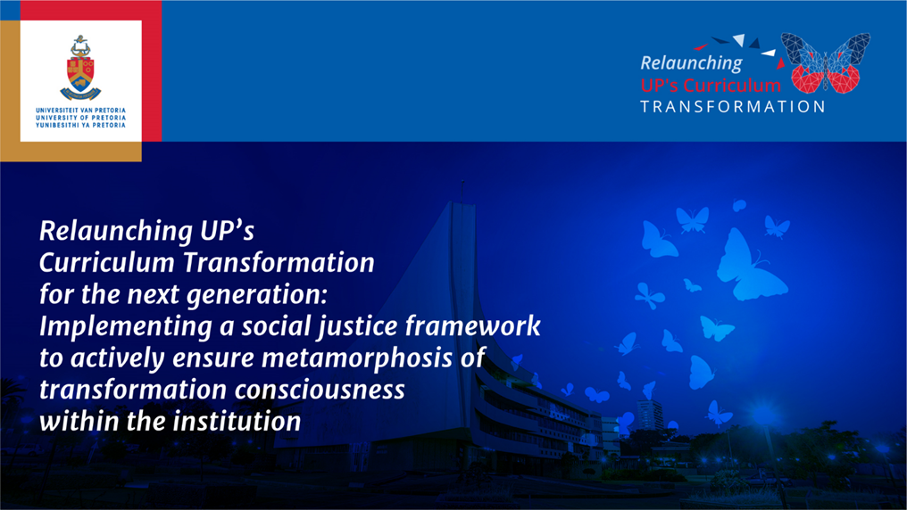

On Thursday, 13 May 2021, the University of Pretoria (UP) relaunched their Curriculum Transformation Drive (CTD) themed ‘Curriculum transformation is not a future event, but present activity’. The relaunch was conducted via a live-stream event for UP students and staff from UP’s Future Africa Research Institute and Pan-African platform that enable fundamentally new approaches to research and innovation which span disciplinary fields and geo-political boundaries.

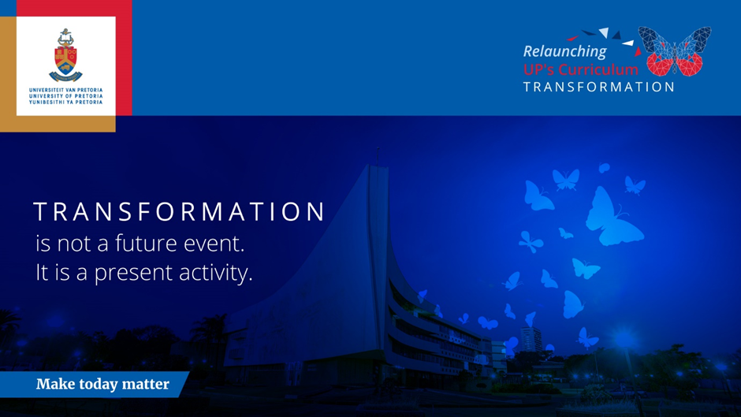

The four-member panel presenting the relaunch consisted of the Vice-Chancellor and Principal Professor Tawana Kupe, Vice-Principal and Deputy Vice-Chancellor Academic Professor Norman Duncan, Deputy Dean of the Faculty of Law Professor Charles Maimela and acting head of the Department of Jurisprudence in the Faculty of Law Professor Joel Modiri. A live-audience, consisting of members of UP staff and students, joined the virtual launch, and had the opportunity to engage and pose questions at conclusion of the four official presentations.
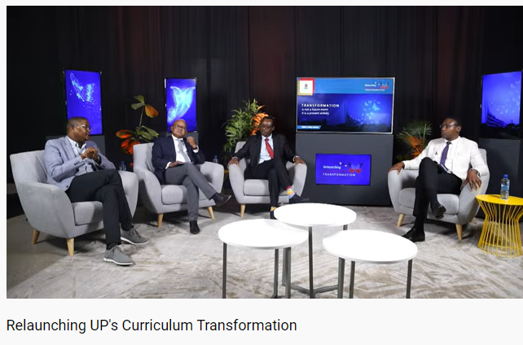

‘From cocoon forth a butterfly
As UP from its door
Emerged — a summer afternoon —
Repairing everywhere, …’
- With apologies and acknowledgement to Emily Dickinson

Introduction and background by Prof Charles Maimela
Maimela welcomed the panellists and online attendees, and said that the broadcast from Future Africa, UP’s Future Africa research institute and pan-African platform that enables possible fundamentally new approaches to research and innovation that span disciplinary fields and geo-political boundaries, was an apt relaunch platform for UP’s Curriculum Transformation Drive (CTD).
In 2016, a UP work stream crafted a policy document on Curriculum Transformation (CT) after extensive consultation and engagements with the UP community, which policy was accepted consequently by the UP Senate. The aim of this policy document is to serve as a guideline, platform and driving force for faculties to work towards decolonisation and transformation of the UP Curriculum. ‘And that the aim of the relaunch is to set the tone of the planned activities for the 2021 academic year.’
Next Maimela introduced the Vice-Chancellor and Principal of UP, Prof Tawana Kupe, to the audience.

Introduction and the objectives of the CTD relaunch by Professor Tawana Kupe
Setting the pace and the objectives of CT, Kupe said that ‘it is the process of re-thinking, re-imagining, recreating and creating new courses and curricula in all disciplines at UP, based on the critical examination of current knowledge on among others:
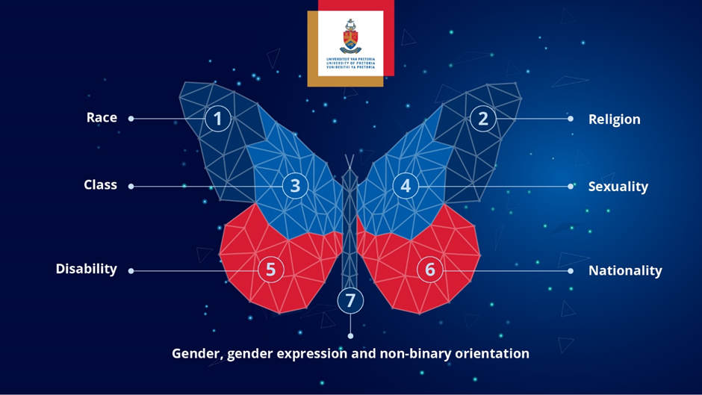

Kupe, quoting Professor John Mendy at the University of Lincoln, and Dr Maria Madiope from the University of the Free State, said that ‘CT in the higher education sector has been gaining traction globally and in South Africa, particularly from students, government and other stakeholders. Nearly all 24 higher education institutions in the country have been tasked with the implementation of CT as a response to the global and local pressures faced to create a new identity befitting the emerging South African educational discourse and practice.’
He also highlighted that their study further summarises the seven areas of CT in South Africa as follows:
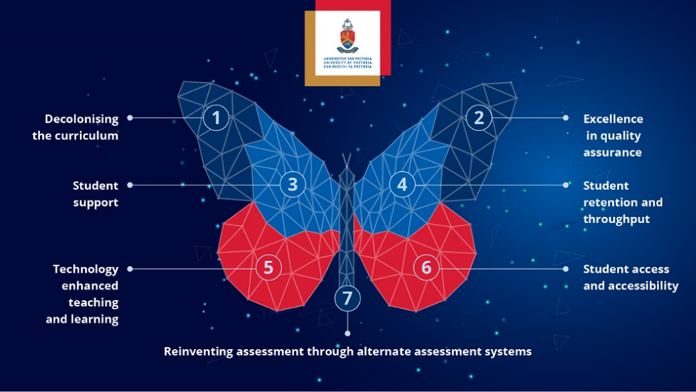

Kupe continued by saying that ‘Their analyses also reflect how the implementation should be guided by a new Socio-Democratisation Framework.’ He further referred to author Tshepo Masipa’s 2018 article on ‘South Africa's transition to democracy and democratic consolidation: A reflection on socio‐economic challenges’. Herein Masipa states that ‘although the 1994 democratic project has made considerable strides to enhance the well‐being of society, socio‐economic challenges of unemployment, poverty and inequalities still persist in contemporary South Africa — hence South Africa's governing party mantra of radical socio‐economic transformation’.
Further, inter alia briefly referring to bleak recent statistics in Sub-Saharan Africa re unrest, unemployment and the Gini coefficient, Kupe stated that ‘these statistics require of UP to use knowledge and education to make a decisive difference, and not operate as a disengaged institution indifferent to society’s challenges.’
Kupe further emphasised that ‘Transformation requires us to appreciate that diversity, equity and inclusion are key elements of progress. Our approaches, attitudes, pre-set ideas and stances need a rebirth, spreading our wings, to bring forth the democratic beauty and freedom of our University, our country and our continent, and our commitment to the achievement of the United Nation’s 17 Sustainable Development Goals in the best interest of UP, South Africa, and Africa.
The critical appreciation of multiculturalism is a prerequisite for an enabling, nurturing and inclusive institutional culture for our lecturers, staff and students in context of diversity.’
Instructing all UP parties to actively and immediately pursue and implement UP’s CT policy, Kupe further stated that ‘it demands a mutual and cooperative approach, attitudes and process, a specific objective and attainment deadline, with the objective to attain synergy, creating and producing impact that is far greater than the sum of the individual elements on UP’s campuses. It further expects all UP members to take a critical stance on power and differences in the classroom and other institutional contexts, interweave multiple perspectives and integrate student voices and knowledge in the teaching and learning process – to the benefit and transformation of all in the institution and our country.
For the sake of growth and development, it is essential for UP to actively and without further delay discard archaic, outdated practices, processes and beliefs that hinder transformation at all institutional levels. He further informed the audience that for this purpose, UP’s management has tasked Professor Charles Maimela, Deputy Dean of the Faculty of Law, to drive this purposeful process to fruition within a given timeframe. He called on the ‘cooperation of every student and staff member to enable UP to successfully and actively relaunch its CTD, resulting in significant metamorphoses - to change the appearance and character of UP – a UP improved for the greater good of all – now and in the future…’
Kupe concluded his presentation in the words of Andy Grove:

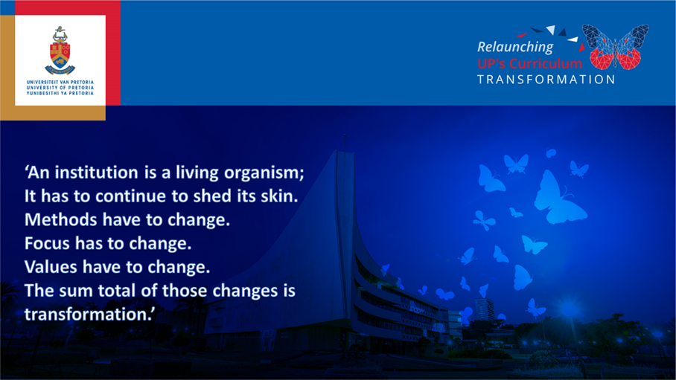

A brief overview of Curriculum Transformation Drivers by Professor Norman Duncan
After thanking Professor Kupe for his inspiring introduction, Professor Duncan briefly revisited the four adopted drivers of the 2016 policy. In his view, the relaunch was taking place at an apposite time, for two reasons: ‘Firstly, it is five years since the Curriculum Transformation Framework (CTF) was first adopted by the UP Senate to serve as the vehicle for the ongoing processes that are required by universities to constantly transform and update or renew their curricula. Secondly, 2021 is the year in which UP in all earnest started the process of reimagining itself.’
He elucidated the context in which the CTF, ‘Reimagining Curricula for a Just University in a Vibrant Democracy’, was developed. ‘On 5 March 2016, within the context of heightened student activism on a range of issues, an important lekgotla was held between our student societies and the UP Executive, during which it was decided, amongst other matters, to establish a work stream on CT. The work stream’s mandate was to undertake a process of critical reflection and debate on issues pertinent to curriculum transformation at the University of Pretoria.
It is pellucid that, although important CT endeavours and steps taken in South Africa just prior to and with the advent of democracy in the 1990s, there is much more required.
Duncan explained that ‘A group of approximately 20 academics and students constituted the work stream and ultimately developed a CTF titled ‘Reimagining Curricula for a Just University in a Vibrant Democracy.
Drafted in 2016, the CTF intentionally did not provide a narrow definition of transformation of curriculum. Instead, flowing from discussions in the work stream, the four identified drivers were to guide an inclusive process of engagement on what CT should entail in the UP context. The approach adopted was cognisant of the differences in disciplines across UP’s nine faculties and business school, including the requirements of professional bodies.’
Duncan proceeded by mentioning the four drivers of CT:
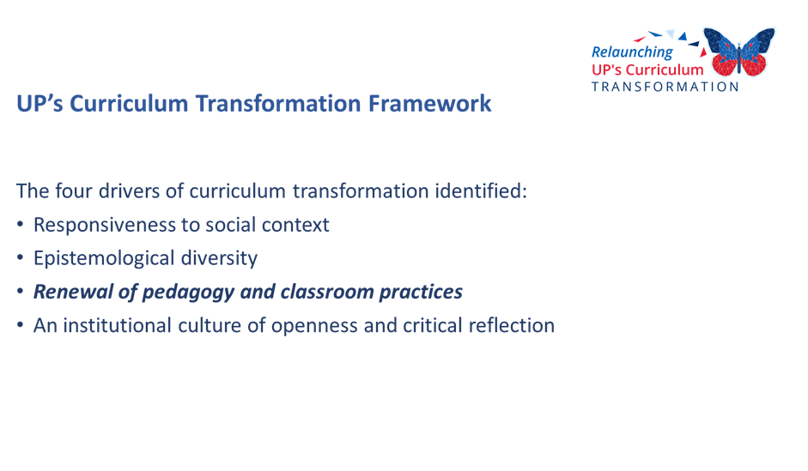
He highlighted the third pillar of the framework, namely Renewal of pedagogy and classroom practices.
He continued by saying that ‘At the end of last year, all our Deputy Deans: Teaching and Learning undertook to assume institution-wide leadership for the following initiatives aimed to enhance student success at UP.

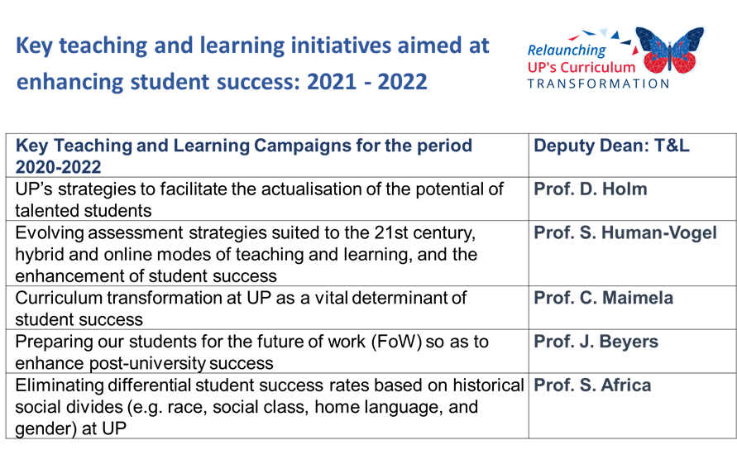
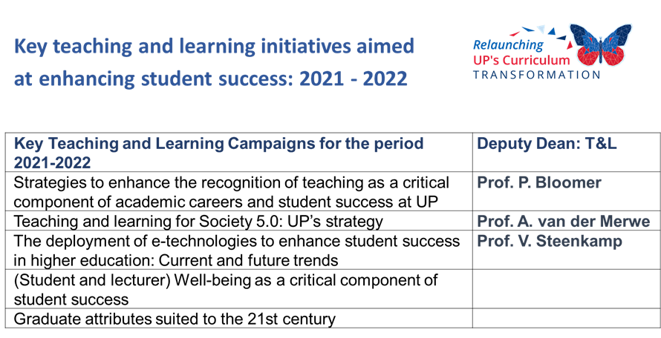
Duncan affirmed the following key duties of UP’s staff and students:
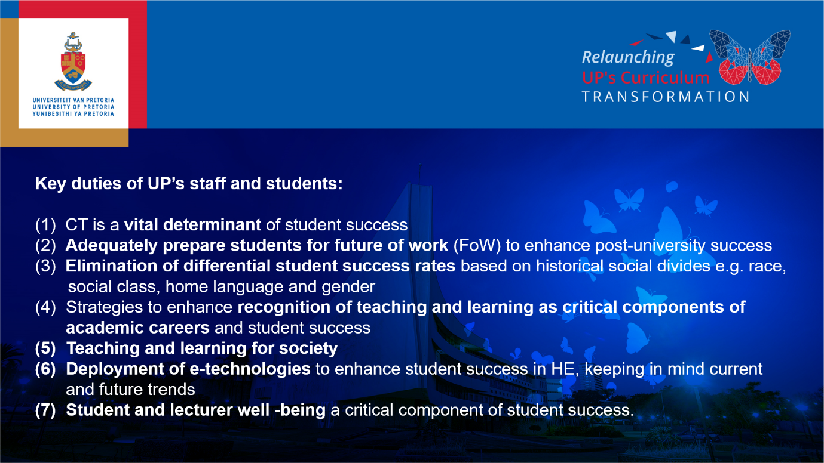

Expressing his appreciation, Duncan further informed the audience that ‘Professor Charles Maimela undertook to provide scholarly and practical leadership to the University community in the area of CT and that this event is first in a series of CT activities that Professor Maimela has planned for the coming year’.
Renewal of pedagogy and classroom practices
Duncan emphasised that the Covid-19 pandemic has illustrated the vital importance of the continuous renewal and transformation of our teaching practices. He stated ‘that if it had not been for the foresight of the UP leadership in the 1990s to start introducing the use of e-technologies in our teaching, we would have come a cropper quite serious in the 2020 academic year. With that lesson learnt we should constantly strive to see how best to innovate to ensure inclusive student success. This is in fact a challenge to all faculties: How can we innovate in the field of teaching and learning, to ensure greater levels of success for our students while they are at the UP and after they had left UP?’
He stated that he was ‘pleased to announce that the Deputy Deans: Teaching and Learning, as well as other key role-players in the Department for Education Innovation (DEI) and the Faculty of Education, are currently involved in a process aimed at reconceptualising UP’s instructional modalities in a manner that will accommodate the rapid social and technological changes we are witnessing at the beginning of the 21st century.’ According to Duncan, the relevant modalities are those best suited to enhance students’ success, irrespective of their social and educational backgrounds and their preferred styles of learning.
He also advised faculties experimenting with new ways of doing that they should heed the recent advice by Professor Ronel Callaghan of the Faculty of Education:
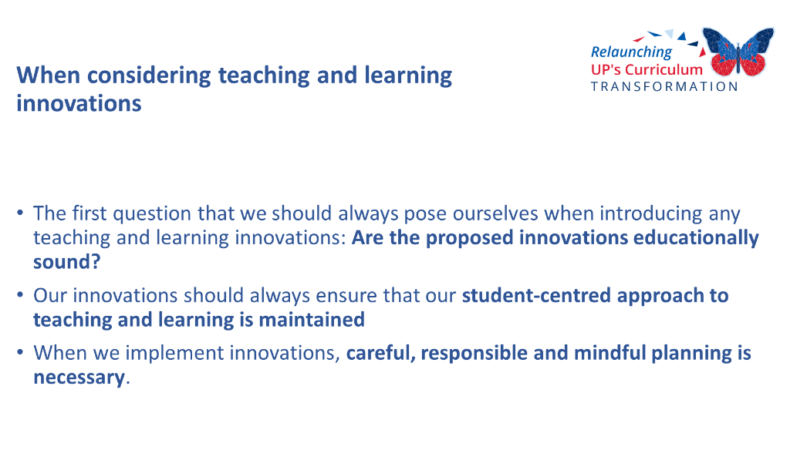
He added that ‘As UP embarks on our curriculum transformation endeavours we should remember the importance of the graduate attributes important for the 21st century, based on research output by Professor Gerrit Stols, Director of DEI.’

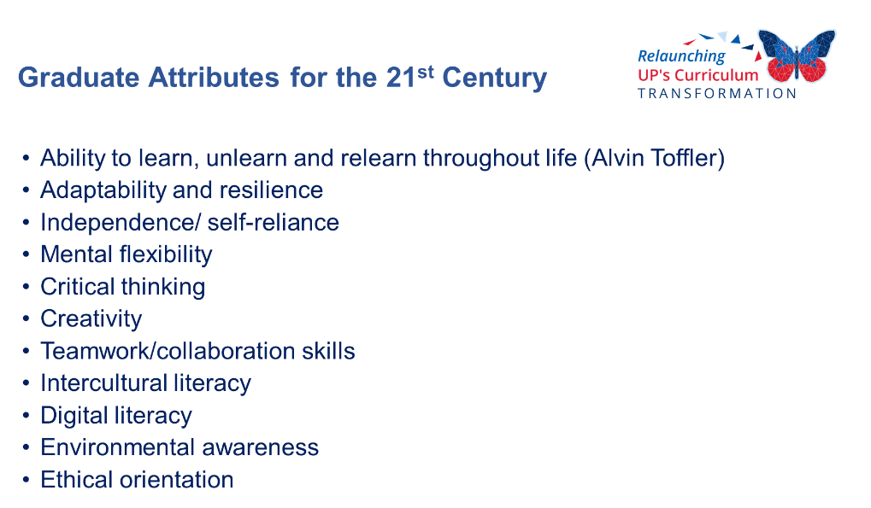

Duncan alerted faculties of their imminent assessments in terms of progress made and submission of their transformation plans for the immediate future. Detailed reports based on the 2016 policy should include ‘steps taken by the respective faculties and departments to address the imperatives of CT, and CT plans.’
In conclusion, Duncan reminded the audience ‘when considering teaching and learning innovations, the first question that we should always pose ourselves is if the proposed innovations are educationally sound? Our innovations should always ensure that our student-centred approach to teaching and learning is maintained. Also, when implementing innovations, careful, responsible and mindful planning is necessary.’
Framework for curriculum transformation by Prof Charles Maimela
At the onset of his presentation, Professor Charles Maimela expressed his appreciation to Professors Kupe and Duncan for their elucidation of UP’s Curriculum Transformation policy, their ideas, suggestions and the current and future changes and developments that must be taken into account by the 2021/22 work streams.
Maimela further informed the audience that ‘As set out in the 2016 policy document, over the past 27 years, some progress has been made in transforming South Africa into a democratic society based on the values of human dignity, equality, human rights and freedom. Nevertheless, exclusion, marginalisation, social injustice and poverty remain stark. In fact, Covid-19 has highlighted these injustices even more.’
He continued by stating that ‘Further, as an excerpt from the 2016 document reflects, the interlinked imperatives that have been identified include
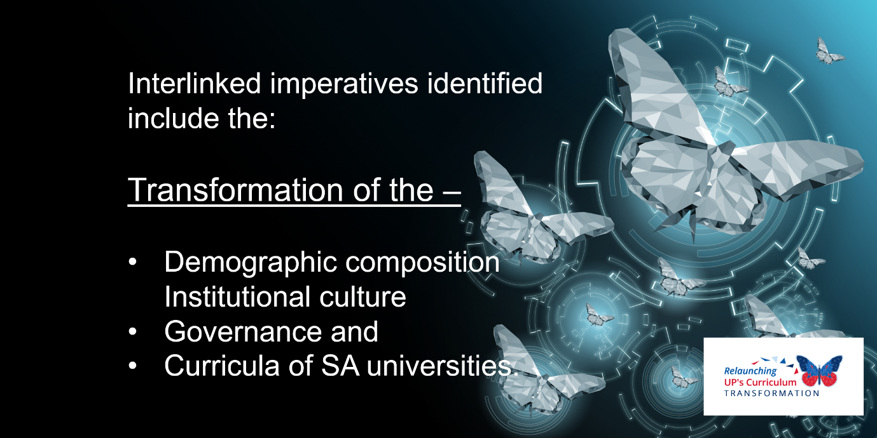

He emphasised that ‘The UP community shares a deep desire to move hastily to a just and equitable future. We acknowledge the conservative history and corrosive legacy of UP. It is of little use to remind each other of this fact if we do not actively do something about it.’ He stressed the urgency to transform, and to transform now!
He added that:
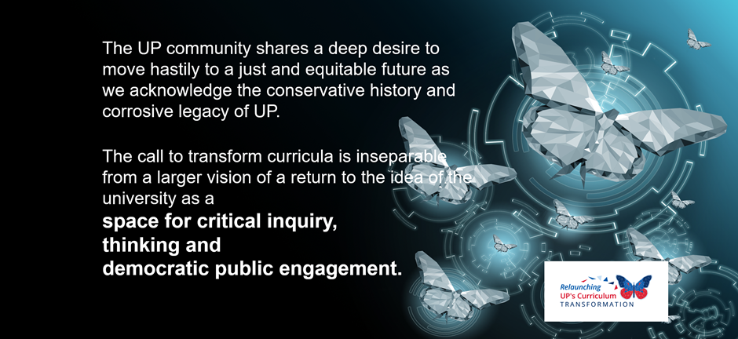

Maimela continued by emphasising that ‘As the policy states, “we are faced with the challenge of the corporatisation of universities, which undermines transformation.” The document further states that “A transforming curriculum resist corporatism and managerialism, including instrumentalist versions of internationalisation that merely service the academic, social and political objectives of the Global North to the detriment of local knowledges and objectives. It must be a curriculum that asserts and celebrates local capacity to produce cutting edge research with a global reach.”
As you have already heard, the 2016 work stream discussions identified four CT drivers, the purpose of which was to guide an inclusive process of engagement on what CT entails.
He stressed ‘that an inclusive approach means a climate in which everyone can endorse their knowledge and talents so that these can be used in the most efficient way and to the greatest benefit of all. In fact, inclusion is not a strategy to make people fit into existing systems and structures.’
Maimela continued that ‘The approach adopted in the 2016 document is cognisant of the differences in disciplines across UP’s nine faculties, including the respective requirements of professional bodies.
The point of departure remains that every field of study holds implications that either advance or deter human and non-human life. Thus, academic endeavour, prominently visible in curricula, must be in service of the public good and the actualisation of human potential.’
In conclusion, Maimela stated that he ‘also believe that all of us involved in CT must also realise and agree that innovative and leading teaching practices are essential components of CT, and best undertaken in an educational ecosystem where:
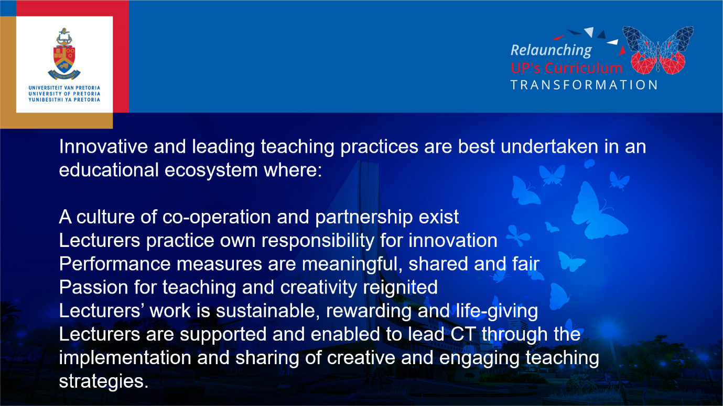

Maimela thanked the audience for their attention and introduced one of the architects of UP’s CTD, Professor Joel Modiri.
A more in-depth elucidation of the four curriculum transformation drivers by Prof Joel Modiri
Introducing his topic of discussion, Professor Joel Modiri said that ‘The impetus to transform the curriculum echoes calls made before in “postcolonial” African universities in the 1960s and in the movement towards multicultural curricula in the United States in the 1980s. In our particular context, a wave of student protests across South Africa – which have gained international traction - has placed CT, among other pressing issues, on the agenda.
He emphasised that ‘The UP CTF document was developed to guide the process of CT at UP to respond to students protests. It also includes the (1) basic scholarly imperative for a curriculum that is relevant to the local and global context; (2) reflects the diversity of knowledges, approaches and worldviews relevant to a particular discipline; and (3) produces appropriately skilled and broadly literate graduates. UP, as a space of knowledge, debate, thinking and ideas ought to constantly renew and refresh what is being taught in the classroom as well as how it is being taught.’
Modiri continued that ‘The CTF deliberately avoids a prescriptive or narrow definition of CT and instead adopts a broad and open-ended set of focus areas concerning teaching and learning. It is for faculties to give discipline-specific content to the CTF and thereby take ownership of the process.’ He said that it was ‘To this end that the CTF identifies four drivers or themes through which CT is to be reflected upon and implemented.
Next, he dealt in detail with the four drivers identified in 2016.
‘In the first place, Responsiveness to social context demands that the UP curriculum must prepare its graduates for the world and the context in which they will work and function. The specific political history, socio-economic conditions, political challenges and environmental and infrastructural factors that prevail in any given society, together with the effects of technology and globalisation, should inform the content and structure of the curriculum.
In South Africa, the legacy and material reality of oppression along the axes of race, class, gender/sexuality, religion and the disadvantages these have produced, including underdevelopment, poverty, disease, illiteracy etc. demand and require both technical and social-scientific solutions. Imperative to this is critical-theoretical knowledge that could contribute to development and transformation at all levels of South African society, the Africa continent and the world.'
Modiri concluded by stating that ‘The problems of an unequal society and developing nation need to be prioritised in teaching and learning.’
Secondly, Modiri addressed Epistemological diversity and said that it was imperative ‘to enable wide-learning, as a curriculum cannot be dominated only by knowledges, i.e. epistemological paradigms, emanating from the West or the Global North such as Europe, UK and USA.’ He further stated that ‘Instead, knowledges and cultural heritages in Africa and those from “the Global South” more broadly need to be incorporated in the curriculum.’ He stated that ‘A recurring complaint of students and scholars from the Global South is that present curricula represent an exclusively or predominantly Western worldview and understanding of reality that correlates most closely with a white, male, heterosexual, middle-upper class experience. This undermines the ways of life and ways of knowing of other groups, including the majority group of African students.’
He affirmed that ‘The curriculum therefore needs to represent the diverse knowledges, perspectives and experiences.’ He stressed that it was important to note that ‘The point is not to simply insert these different knowledges as “add-ons”, but to consider how they enable an overall reconceptualisation and redefinition of the relevant study area, field or discipline.’
During his elucidation of the third CT driver, Renewal of pedagogy and classroom practices, Modiri stressed the importance that ‘A transformed curriculum requires a transformed pedagogy, i.e. way of teaching. He stated that ‘Classrooms should be robust spaces of critical thinking and debate. They should be spaces that accommodate and embrace differences of identity and worldview. He also said that the ‘Focus must be on key skills of reading, writing, analysis, computer skills, communication and collaboration and assessments should encourage independent research.’ He stated that ‘This requires a move away from rote-learning, reciting formulaic textbooks and memory testing to an experimentation with different methods of teaching and assessing, and integrating technology.’
He stated further that ‘In rethinking how we teach and learn we must also provide students – coming as they do from diverse backgrounds - the support they need to cope with the demands of university life. Other impediments to learning including the biases and stereotypes concerning students’ abilities as well as other authoritarian and discriminatory behaviour ought to be removed from the classroom space.’
During his explication of the fourth driver, An institutional culture of openness and critical reflection, Modiri stated that ‘A curriculum contains not only the formal study material and content, but also the surrounding milieu in which learning takes place. The symbols, the staff complement and the institutional culture in UP play a powerful normative role in shaping learning and in defining who is welcome and who is not.’
He emphasised the fact that ‘It is therefore imperative that the entire UP becomes a space of learning, debate and ideas where knowledge and provocation are valued and enabled. The standards, cultures and traditions, from graduation to policies, that define UP must be constantly re-examined and interrogated.’
Modiri concluded his elucidation of the four drivers, by stating that ‘Whereas the first three drivers of CT address the question of what kind of student UP aspires to send out into the world, the fourth driver addresses the question of what kind of university UP must become in order to feel like home to this imagined student and to the academics that must produce them.’
The ideal UP graduate as envisaged in the framework document
Next Modiri, providing explication of what is meant by the ideal UP graduate, stated that ‘UP, through teaching and research, its facilities and extra-curricular activities, aims to deliver to communities, society, the continent and the world a graduate who is well-rounded, thoughtful, democratic in character and critically literate.’
He directed attention to the attributes and skills a UP graduate must possess upon leaving UP. According to Modiri, these factors are:
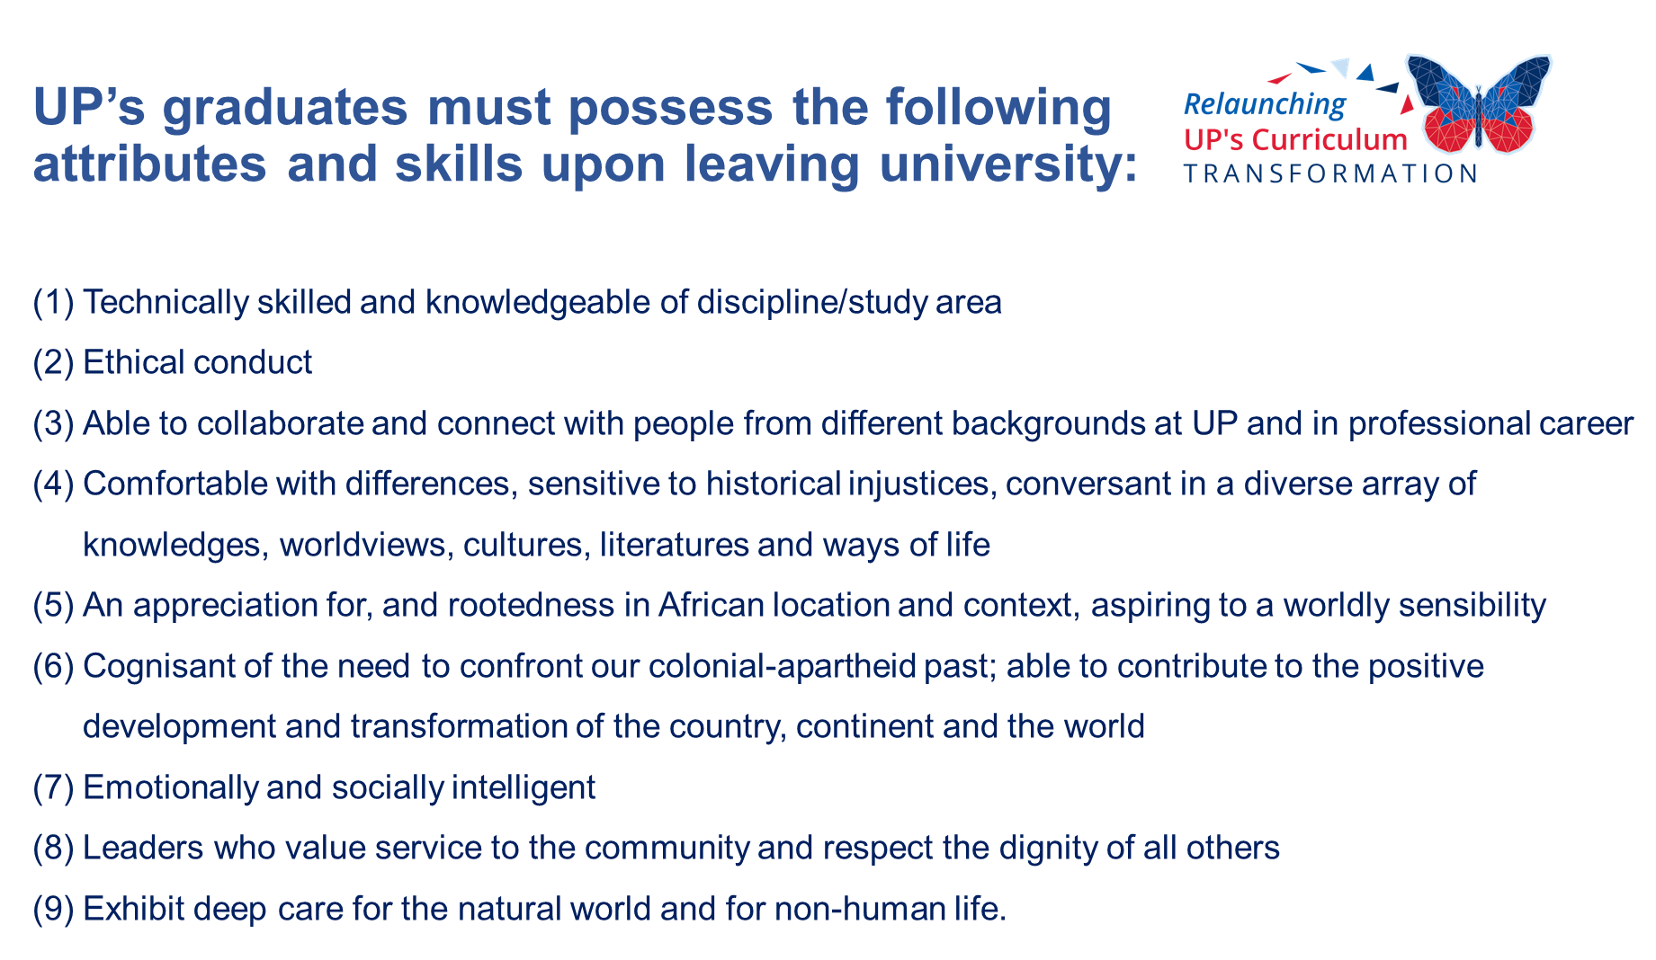
Modiri concluded by stating ‘that the ideal UP graduate is well-trained for the world of work, and is an educated and active citizen, imbued with the capacity to engage with public problems and to grasp and address societal and global challenges through innovative and critical thinking.’

Synopsis and conclusion
- All faculties, departments and business school were instructed to revisit and assess immediately their respective CT efforts and plans for renewal in 2021, eliminating archaic and outdated practices ranging from content, teaching and learning to assessment;
- As stakeholders, students must have the opportunity to engage in CT to ensure inclusivity, transparency, robustness and intellectual stimulation;
- CT is the responsibility of each member of the UP community;
- For the sake of growth and development, it is essential for UP to actively and without further delay discard archaic, outdated practices, processes and beliefs that hinder transformation at all institutional levels;
- The CT Committee, and more specifically Professor Charles Maimela, is looking forward to work with staff and students re the planned activities pertaining to relaunching CT starting today (13 May 2021) until the end of 2021;
- It is imperative that UP creates a true home where all students and lecturers feel at home and can thrive;
- The call for CT is inseparable from a larger vision of a return to the idea of UP as a space for critical inquiry, thinking and democratic public engagement;
- UP must move away from the question, 'What kind of student UP aspires to send out to the world?' to 'What kind of UP must we transform to in order to become a true home for our students, scholars and teachers?’;
- UP’s curriculum must represent the Global South's diversity, knowledge and experiences; and
- The Covid-19 pandemic has illustrated the vital importance of the continuous renewal and transformation of UP’s teaching and learning practices; and
- CT demands a mutual and cooperative approach, attitudes and process, with specific aims and attainment deadlines, with the objective to attain synergy, creating and producing impact that is far greater than the sum of the individual elements on UP’s campuses.
After an open Q & A session during which virtual attendees were afforded the opportunity to pose questions at the panel, Maimela expressed his appreciation to the panellists for their enriching contributions, and to the audience for their positive participation in the proceedings.

---
Compiled by
Elzet Hurter, Faculty of Law
On behalf of Deputy Dean Professor Charles Maimela, Faculty of Law
23 May 2021

