Programme

Annual Recognition of Achievement

for the

2019 Academic Year
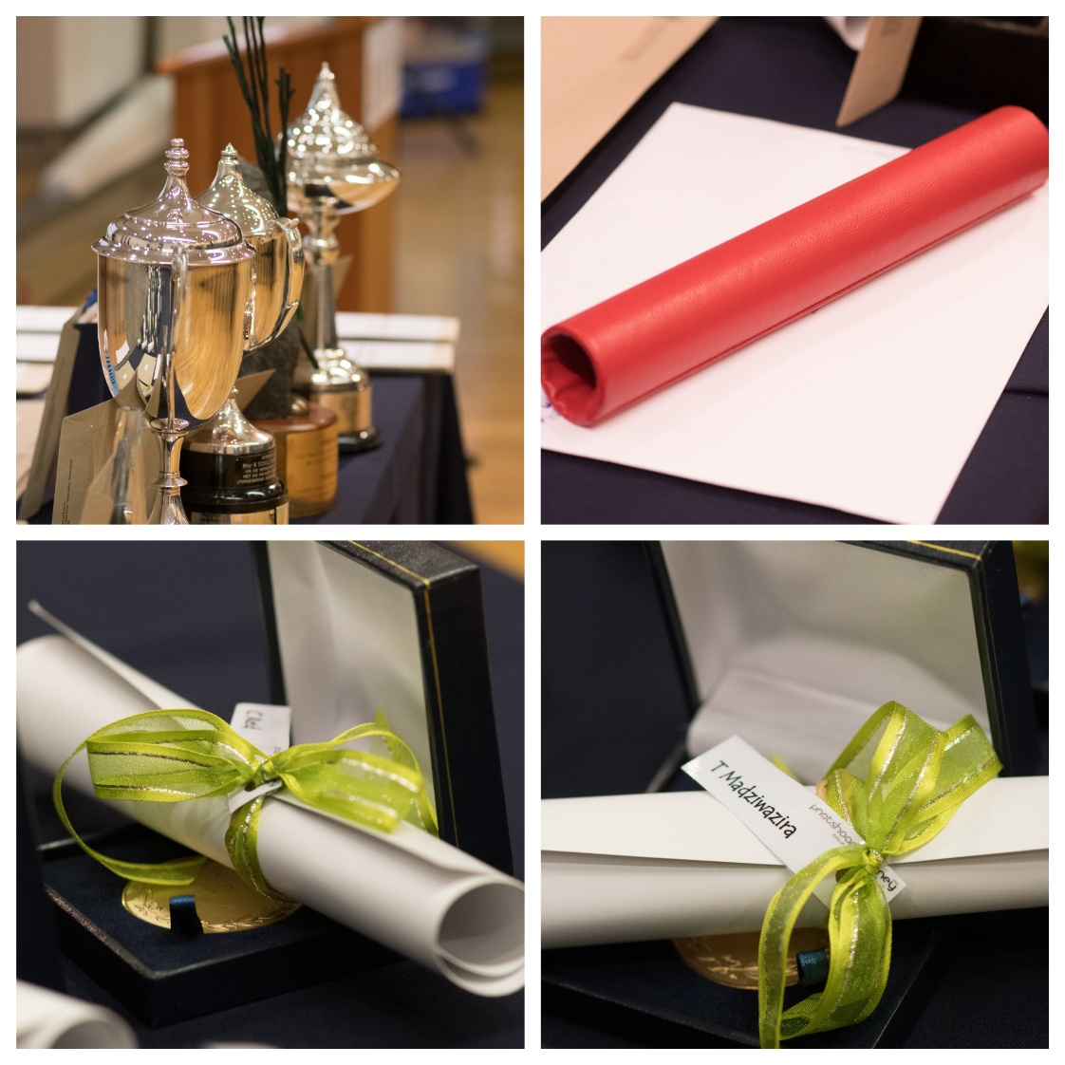

Awards, Prizes and Recipient(s) – 2019 Academic Year
Adams & Adams Prize
Student with the highest weighted average in the prescribed modules during all four years of the LLB degree programme, provided that the student was registered for the four year LLB degree and completed the degree within the minimum period of four years
Roxanne Westphal
Arthur Channon Inc Prize
Best student in Family Law 121 (FMR 121)
Felix le Roux
Absa Africa Book Prize
Best student in Law of Banking and Financial Institutions 410 (LBF 410)
Tbc
ABSA Legal Services Prize
Best student in Payment Methods 320 (VHD 320)
Daniella Ghillino
Bliss Prize donated by MacRobert Attorneys
Best student in Civil Procedure 400 (SIP 400) or Best student in Civil Procedure 410 and 420
(SIP 410 and 420)
Caitlin Petzer
Bookmark Prize
Best student in Jurisprudence 310 (JUR 310)
Felix le Roux
Bookmark Prize
Best student in Law & Transformation 410 (AMR 410)
Sohela Surajpal
Bookmark Prize
Best student in Law and the Community 420 (CLW 420)
Sohela Surajpal

Bookmark Prize
Best student in Jurisprudence 420 (JUR 420)
Tbc
Carpe Diem Prize
First year student registered for the four year LLB degree programme with the highest weighted average in the prescribed first year modules
Phokwane Makhubela
Chief Justice FLH Rumpff Floating Trophy and Prize
Best student in Public Law 410 and 420 (PBL 410 and 420)
Roberto Lopes Barreiro
Cliffe Dekker Hofmeyr Inc Prize
Best student in Specific Contracts 220 (KTH 220)
Christopher Williamson
Cliffe Dekker Hofmeyr Inc Prize
Best student in Consumer Protection 220 (VBB 220)
Bianca Coetzer
Couzyn, Hertzog & Horak Attorneys Prize
Best student in the LLM (Child Law) programme
M Breytenbach
De Swardt Myambo Attorneys Administrative Law Prize
Best student in Public Law 310 (PBL 310)
Daniela Erasmus
De Swardt Myambo Attorneys Law of Contract Prize
Best student in Law of Contract 211 (KTR 211) (shared)
Andrea Dolphin
Israel Shnketa
Christopher Williamson
Delport van den Berg Prize
Best student in Deeds and Notarial Practice (ANO 410)
Lucinda Strydom
DH van Zyl Prize
Best student in Roman Law 120 (ROM 120)
Bethany Forton
Fasken Footprint Prize
Student who meets the requirements of Fasken that include being Black according to the Employment Equity Act and having successfully completed his/her second year of the BA Law/BCom Law/LLB studies within two years and obtained an average of 70% or above for both years of study. The prize winner must be actively involved in community engagement projects and must portray leadership skills.
Tbc
Gildenhuys Malatji Incorporated Prize
Best student in Practical Law 400 (PWR 400)
Jarrod van der Heever
Grotius Medal
Final year LLB student with the highest weighted average in all the final year LLB modules, provided that the student passed all the prescribed modules at the first attempt.
Roxanne Westphal
Haasbroek & Boezaart Prize
Best student in Law of Succession 222 (ERF 222)
Samantha Whelan
Harold Galasko Prize
Final year LLB student with the highest weighted average in all the prescribed final year modules, provided that the student passed all the prescribed modules at the first attempt and was registered for the four year LLB degree.
Roxanne Westphal
Hogan Lovells Prize
Best student in Tax Law 310 (BLR 310) or Best student in Tax Law 310 or 410 (BLR 310 or 410)
Christopher Williamson
Johan Verloren van Themaat Prize
Best student in Public Law 200 (PBL 200) (shared)
Daniela Erasmus
Anita Marais
John Dugard Prize
Best student with the highest average mark core modules AIL 802 and MCL 801 in the subject International Law
MC Kabakisa
Juta Law Prize
Student with the highest weighted average in all the prescribed theoretical modules of an LLM degree by coursework, including the mini-dissertation (provided that the student completed the degree within the prescribed period of two years and passed all the prescribed modules at the first attempt).
Johan Jordaan
Kisch-IP Prize
Best student in Legal Practice 210 and 220 (RPK 210 and 220)
Christoph Berndt
LexisNexis Prize
Best student in Legal Pluralism 210 (RPR 210) (shared)
Takudzwa Matekwe
Jeanne Meyer
LexisNexis Prize
Best student in Law of Delict 320 (DLR 320)
Christopher Williamson
LexisNexis Prize
Final year LLB student who wrote the best essay (SKY 410)
Roxanne Westphal
LexisNexis Prize
Best student in Criminal Procedure 400 (SPR 400)
Bianca Balt
Medal of the Vice-Chancellor and Principal
For a candidate with outstanding undergraduate academic achievement during all the undergraduate years of study for any first Bachelor’s degree in a faculty
Roxanne Westphal
Norton Rose Fulbright Prize
BA Law II student with the highest weighted average in all the prescribed BA Law II modules, provided that the student passed all the prescribed modules at the first attempt.
Katelyn Mae Carter
Norton Rose Fulbright Prize
Best student in Legal Interpretation 210 (RVW 210)
Felix le Roux
Norton Rose Fulbright Prize
BCom Law II student with the highest weighted average in all the prescribed BCom Law II modules, provided that the student passed all the prescribed modules at the first attempt.
Mathew Henk de Bie
Norton Rose Fulbright Prize
Best student in Law of Persons 110 (PSR 110)
Jacobus Hudson
Norton Rose Fulbright Prize
Best student in Medical Law 410 (GRG 410)
Chrislie Thomas
PPS Prize
Best student in Trusts & Estates 410 (TBS 410) (shared)
Lara Colette Butler
Simoné van Schalkwyk
Private Law Prize
Best student in Law of Damages 410 (SGR 410)
Bianca Balt
Private Law Prize
Best student in Private International Law 410 (IPR 410)
Hiroki Malachizodok Mpolokeng
Private Law Prize
Best student in Private Law 420 (PVR 420)
Karien Prinsloo

RW Africa Prize
Best student in Public Law 320 (PBL 320)
Prishni Chetty
Rudolph Jansen Prize
Best student in Land and Land Reform 420 (GHR 420)
Tbc
South African Society for Labour Law Prize
Best student in Labour Law 410 (ABR 410)
Hiroki Malachizodok Mpolokeng
South African Society for Labour Law Prize
Best student in the LLM (Labour Law) programme
Maretha Mattheus
Savage Jooste & Adams
Best student in Alternative Dispute Resolution (AGF 420) (shared)
Chigo Mabila
Kyle Melville
Tshepo Twala
Schilz Prize
Third year LLB student with the highest weighted average in all the third year modules, provided that the student passed all the prescribed modules at the first attempt and is registered for the four year LLBdegree
Felix Schröder
Shadrack Mbonani Memorial Prize
Best student in Jurisprudence 110 and 120 (JUR 110 and 120)
Edgar Malomane
Spoor & Fisher Prize
Best student in Intellectual Property Law 320 (IGZ 320)
Anita Marais

SSLR Prize
BCom Law III student with the highest weighted average in all the prescribed BCom Law III modules, provided that the student passed all the prescribed modules at the first attempt
Amy Lynn Pawson
Supersport Prize
Best student in Sports Law 420 (SRR 420)
Stephanus Nortjé
Teresa Lister Prize and Trophy donated by Atterbury Trust
This prize and trophy/sculpture is awarded to the most multitalented female student who has completed her third year of LLB studies
Tbc
UNESCO Africa Chair in Education Law Prize
Best student in Law of Education 420 (ONR 420)
Tlhologelo Madalane
University of Pretoria Law Clinic Prize and Floating Trophy
Top achiever in the Practical Law module (PRR 400)
Jarrod van der Heever
University of Pretoria Law Clinic Firm of the Year Award
Students participating in the Law Clinic programme who are the top firm in each academic year (shared)
Chantel Carreira
Robina Veronica de Jesus
Jodi Hardy
Caitlin Jane O’Connor
Nadia Steyn
Jarrod van der Heever
Shereen Younis
VDT Attorneys Inc Prize
Best student in Law of Things 310 (SAR 310)
Prishni Chetty
VZLR Prize
Best student in Transnational Business Law (TBR 420)
Micaela Jones
Webber Wentzel Prize
Best student in Law of Evidence 300 (BWR 300)
Anita Marais
Werksmans Prize
Best student in Insolvency Law 310 (ISR 310) (shared)
Daniela Basso and Duane van Wyk
Werksmans Prize
Best student in Entrepreneurial Law 320 (ODR 320)
Daniella Ghillino
Willem du Plessis Prize
Second year LLB student with the highest weighted average in all the second year modules, provided that the student passed all the prescribed modules at the first attempt and is registered for the four year LLB degree
Dawn Khumalo
Final year LLB students who obtained the LLB degree with distinction
Phatshoane Henney Group Honour Medal
Bianca Balt Tatum-Lee Barnard Roberto Barreiro
Simon Botha Colette Butler Chantel Carreira
Ivana Cetinich Catherine Chen Cama Coetzee
Justin de Wet Kirsten Dempsey Devan Falconer
Jodi Hardy Matthew Ilsley Hugo Johnston
Carmen Jordan Jade König Catharina Krüger
Mabila Chigo Daniela Meireles Dias Kyle Melville
Malachizodok Mpolokeng Jaimé Myhill Blessing Oguntuase
Angela Paschalides Caitlin Petzer Kim Phillips
Jessie Phyffer Chantelle Pieterse Brandon Pinker
Jané Potgieter Ashleigh Potterill Elnette Schoonraad
Corbyn Selzer Nadia Steyn Lucinda Strydom
Sohela Surajpal Chrislie Thomas Tshepo Twala
Lisa van Blerk Jarrod van der Heever Melandri van der Westhuizen
Simoné van Schalkwyk Elani Vogel Roxanne Westphal
Allison Wright Shereen Younis
Final year LLB students on the Dean’s Merit List for outstanding academic achievement
Bianca Balt Barnard Tatum-Lee Barnard Roberto Barreiro
Simon Botha Colette Butler Chantel Carreira
Cama Coetzee Justin de Wet Kirsten Dempsey
Devan Falconer Jodi Hardy Matthew Ilsley
Carmen Jordan Jade König Catharina Krüger
Kelsey Lorentz Chigo Mabila Daniela Meireles Dias
Malachizodok Mpolokeng Jaimé Myhill Stephanus Nortjé
Aniel Opperman Angela Paschalides Caitlin Petzer
Kim Phillips Jessie Phyffer Brandon Pinker
Jané Potgieter Ashleigh Potterill Karien Prinsloo
Elisa Rinaldi Elnette Schoonraad Corbyn Selzer
Nomalanga Sinyoka Nadia Steyn Keagan Stokoe
Lucinda Strydom Sohela Surajpal Chrislie Thomas
Tshepo Twala Lisa van Blerk Jarrod van der Heever
Melandri van der Westhuizen Simoné van der Westhuizen Simoné van Schalkwyk
Elani Vogel Roxanne Westphal Allison Wright
Shereen Younis
Deputy Dean's Award
Award to a permanent academic staff member whose teaching approach methods and techniques were evaluated and assessed and, inter alia, included practices that showcased their approach to inquiry-based and hybrid learning.
Dr Jani van Wyk

Dean's Award
For the graduate with outstanding undergraduate academic achievement during the four-year LLB degree
Roxanne Westphal

“Education is the passport to the future,
for tomorrow belongs to those who prepare for it today.”
– Malcolm X

The Faculty of Law and law students
express their appreciation towards the
donors and prize givers for their continued support.

