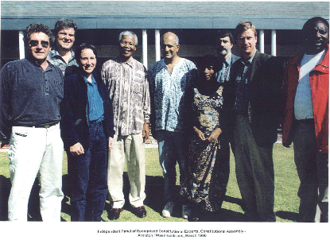
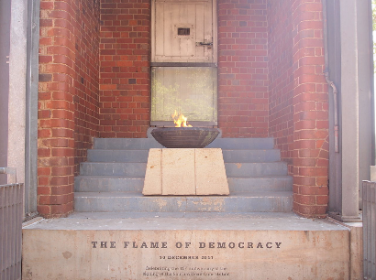
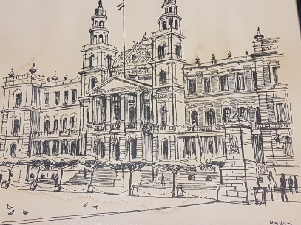
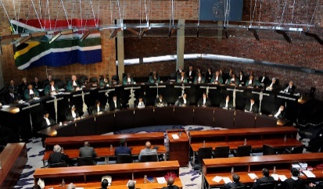
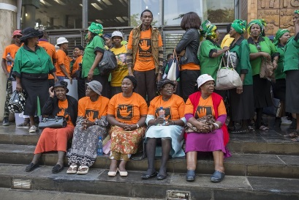
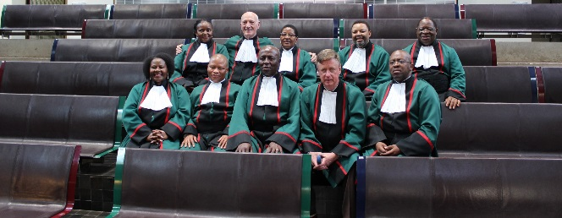
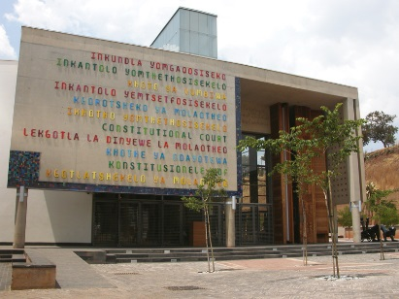

Faculty of Law
Department of Jurisprudence

LLB 493
Constitutional practice in law and life

Lecturer
The course will be taught by Professor Johann van der Westhuizen, who was a justice in the Constitutional Court of South Africa, a judge in the High Court and a professor in this faculty for several years. He is currently the Inspecting Judge of Correctional Centres.

Description of the course in yearbook
(a) Theoretical and philosophical approaches to law, human rights and constitutionalism
(b) Litigation as a tool to solve disputes; repair or break lives; and rule society
(c) How do judges decide?
(d) Good and bad lawyering; identifying, preparing and arguing a case
(e) Constitutional attitudes: from reluctant acceptance, via blind faith, to scepticism or rejection
(f) Selected topics from court cases, eg:
- Can the Constitution heal history?
- Language and labels in law
- Business, credit, contracts, tenders and the Constitution
- Poverty and the Constitution
- Constitution in the bedroom?

Further explanation
Based on the lecturer’s wide experience in legal theory, teaching, advocacy and judging, the course includes reading, stories and class discussions to enable students to–
- further bridge the gap between theory and practice;
- evaluate the law and courts as a tool to solve disputes, repair or break lives and rule society;
- gain insight to how judges decide and how important the difference between good and bad lawyering is;
- choose, prepare and argue a “good” case; and
- consider the role of the Constitution not only in the law, but in the lives of people.

Experts from outside the university, like judges, practising lawyers and the litigants in some cases, may give guest lectures or talks.

Selected topics for discussion include the question whether the Constitution and the law can heal history and guarantee a just future; the influence of the Constitution on business, tenders and other contracts; whether courts can be “economic freedom fighters”; how lawyers use language; and whether the Constitution and courts have a place in your bedroom.

Judgments and cases on truth and reconciliation; affirmative action; tenders (like the SASSA matter); contracts, land restitution; the Credit Act; the DA sms saying that the Public Protector’s report “shows how Zuma stole your money”; and gay and lesbian church ministers will be discussed, from an “inside” perspective (as far as possible and appropriate).

In the spirit of free academic expression, all views are welcome and the line between sanity and craziness not be too rigid; the only “term and condition” for class discussions being respect for the human dignity of all.

Assessment

- Class attendance and participation are extremely important and will influence marks.
- The semester mark is based on an assignment of no more than 3500 words; topics to be discussed in class.
- For the exam a number of questions will be provided during the course; some of these will be asked and from those asked two have to be chosen. The exam will be an open book take home exam, with 24 hours to complete.

