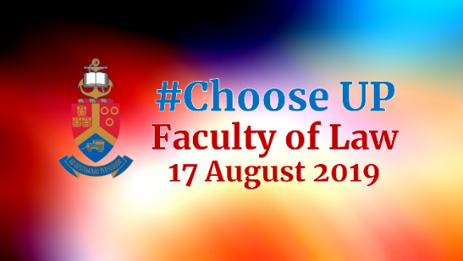

Dear Guests

It is an honour and privilege for the Faculty of Law to welcome our 2020 conditionally admitted students and families to the #Choose UP Day of the University of Pretoria.
Please feel free to attend one of the Dean’s sessions, observe a Moot Court session in progress, or attend one or two of our mock lectures as set out below.
You are welcome to take a stroll through our OR Tambo Law Library (entrance on the Ground Floor in the far west corner), or visit our UP Law Kiosk (access on the Ground Floor, middle of the Quads) to purchase something to eat or drink.
Please feel free to mingle with our staff and students and do not hesitate to ask questions.
Apologies for any inconvenience caused by renovations in and around the Law Building, but that is UP’s way of ensuring top class facilities for our students.
We trust that you will find your exploratory visit and reconnaissance of the Law Building a worthwhile experience.

Experience a law lecture*  Venues indicated below  [12 lectures, 20 minutes time slots, three venues]  Observers are welcome to enter and leave at will | Experience Moot Court peer training  Moot Court, Ground Floor, Law Building  [20 minutes time slots, one venue]  Observers are welcome to enter and leave at will
- 08:45 - 09:05 x 3 x 20 min sessions  - 09:15 - 09:35 x 3 x 20 min sessions  - 10:45 - 11:05 x 3 x 20 min sessions  - 11:30 - 11:50 x 3 x 20 min sessions | - 09:00 to 09:45  - 10:00 to 10:45  - 11:00 to 11:45  - 12:00 to 12:45

Lecturers, lecture topics and venues* - Observers are welcome to enter and leave at will
08:45 to 09:05 | Topics | Venues
Dr Charles Maimela | Customary Law | Graduate Centre 1-56
Adv Mayuri Pillay | Law of Contract | Graduate Centre 1-64
Prof Steve Cornelius | ‘Caster Semenya: Victim or Justified?’ | Graduate Centre 1-68
09:15 to 09:35 | Topics | Venues
Dr Charles Maimela | Customary Law | Graduate Centre 1-56
Adv Mayuri Pillay | Law of Contract | Graduate Centre 1-64
Prof Steve Cornelius | ‘Caster Semenya: Victim or Justified?’ | Graduate Centre 1-68
10:45 to 11:05 | Topics | Venues
Mrs Sophy Baird | Law of Persons | Graduate Centre 1-56
Prof Corlia van Heerden | Competition Law: ‘Collusion’ | Graduate Centre 1-64
Dr Willem Gravett | Criminal Law: ‘The Staircase’ | Graduate Centre 1-68
11:30 to 11:50 | Topics | Venues
Mx Busisiwe Deyi | Jurisprudence: ‘The illegal Black body’ | Graduate Centre 1-56
Dr Willem Gravett | Criminal Law: ‘The Staircase’ | Graduate Centre 1-68
Dr Llewelyn Curlewis | Legal Practice | Graduate Centre 1-64

