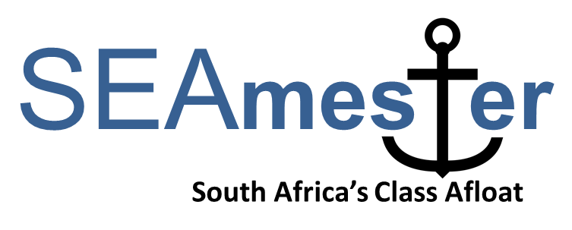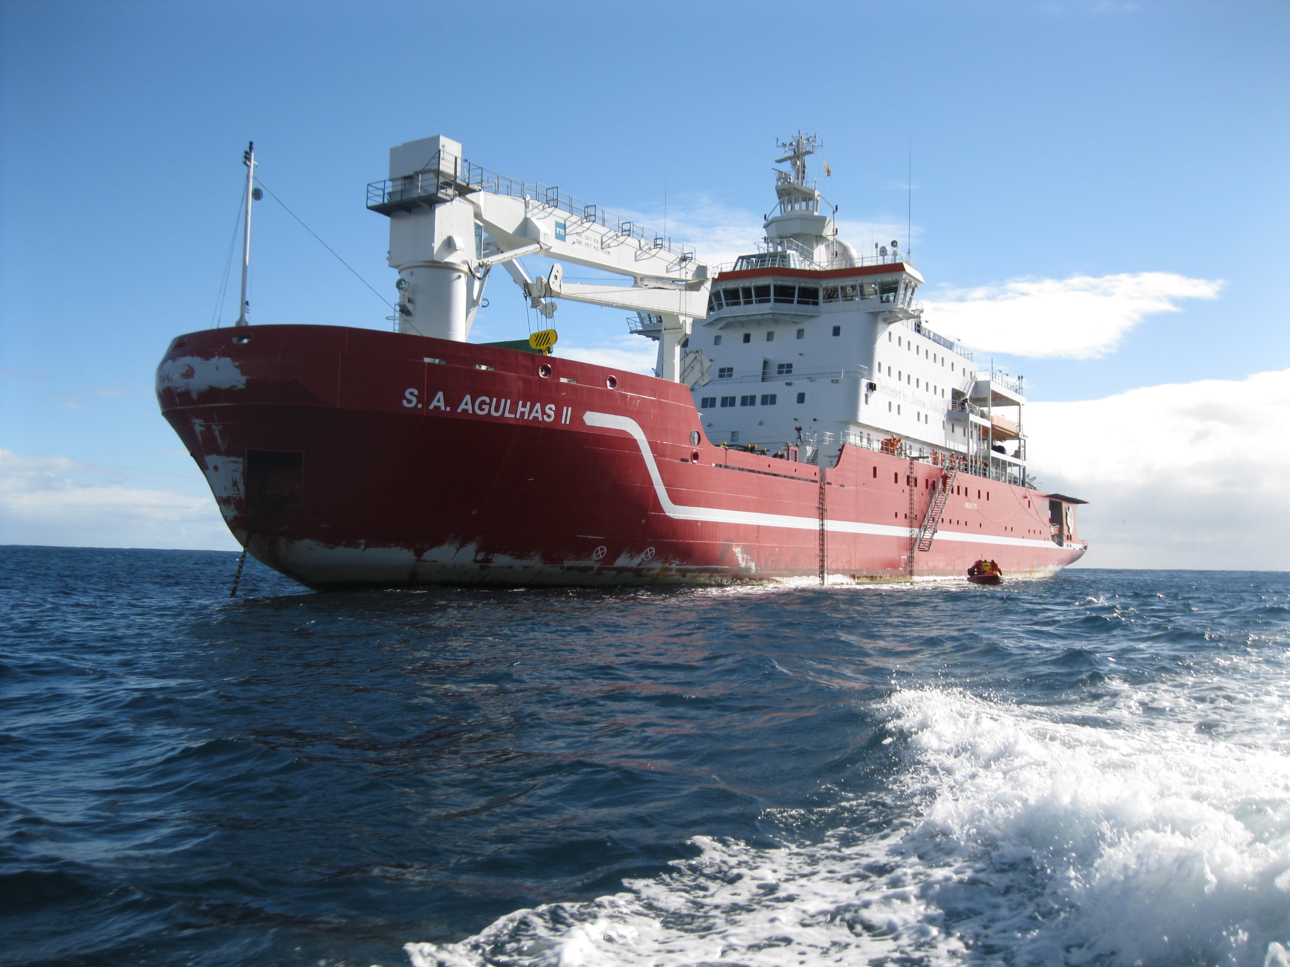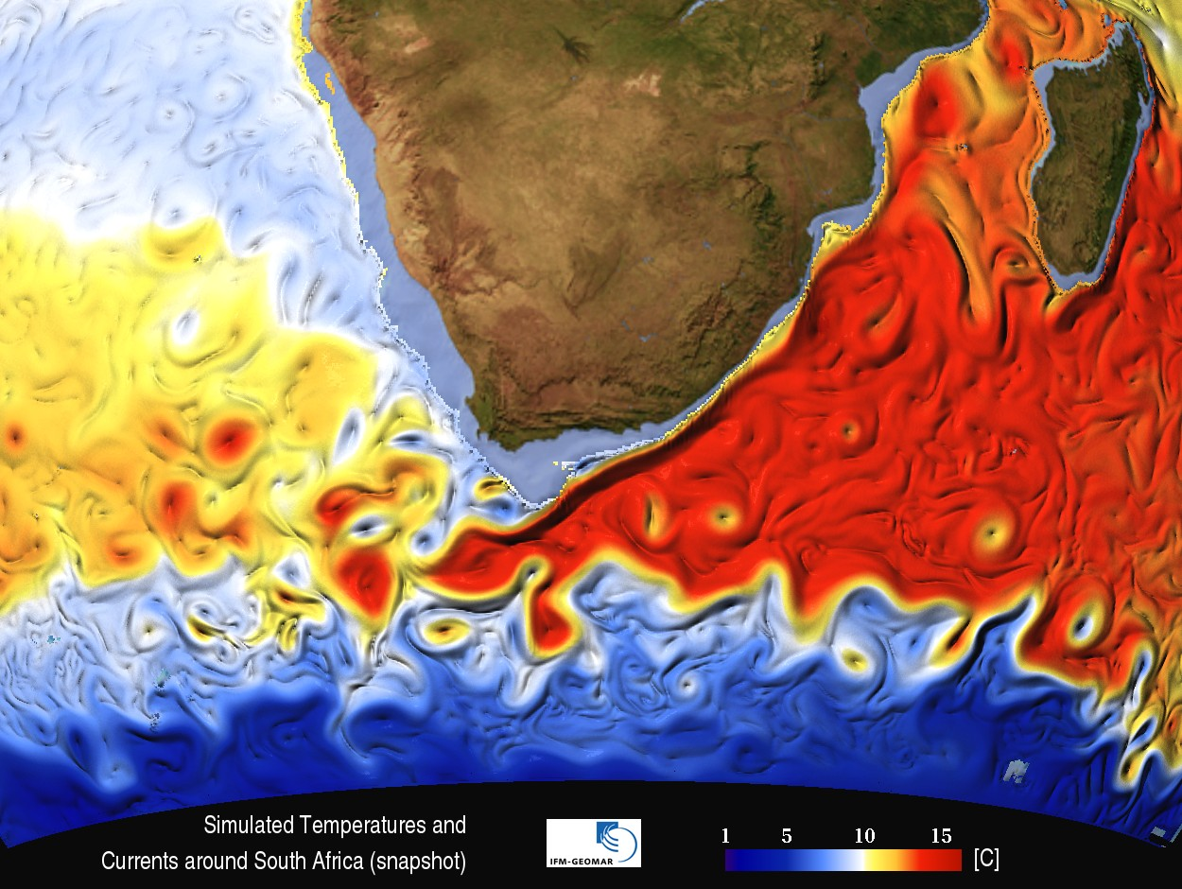

**APPLICATION FORM – please type in your details**

**To be returned to** [**Isabelle.Ansorge@uct.ac.za**](mailto:Isabelle.Ansorge@uct.ac.za) **by Wednesday 8th June 2016* Please label subject and pdf file (SEAmester and your Name and Institute) i.e. SEAmester-Ansorge–UCT** **You will be advised of the outcome on Friday 10th June 2016.**

**\* No late applications will be considered**

**A) Personal details**

|  |  |
| --- | --- |
| **First name** |  |
| **Last name** |  |
| **Gender** | * **Male** * **Female** |
| **Date of birth** |  |
| **Country of citizenship** |  |
| **Passport number (Essential)** |  |
| **Expiry Date** |  |
| **South African ID (if available)** |  |

|  |  |
| --- | --- |
| **Dietary requirements (if any)** |  |
| **Clothing size** | * **S** * **M** * **L** * **XL** * **XXL** * **XXXL** |

|  |  |
| --- | --- |
| **Name of contact person in case of any emergency** |  |
| **Relationship** |  |
| **Address** |  |
| **Email** |  |
| **Telephone/Mobile number** |  |

**B) Academic details**

|  |  |
| --- | --- |
| **Highest qualification achieved** | * **BSc/Btech** * **MSc/Mtech** * **Intern** * **Other _______________________** |
| **Name of awarding institution** |  |
| **Name of current institution and department** |  |
| **Current year of study** |  |
| **Target degree** |  |
| **Subject area** |  |
| **Title of degree thesis (if applicable)** |  |
| **Supervisor of current degree thesis (if applicable)** |  |
| **Email address of supervisor** |  |
| **Tick preferred stream (see SEAmester outline for examples of lectures)** | * **Option 1 – Oceans in a Changing World** * **Option 2 - Tools of the Trade** * **Either** |
| **How did you hear about SEAmester?** | * **Friend/Social media** * **HoD/Supervisor** * **University/Technikon Newsletter** * **SANCOR** * **Other _______________________________** |

**C) Previous sea-going experience (max 150 words). It is not compulsory for students to have had previous sea-going experience.**

|  |
| --- |
|  |

**D) Motivation - please include how you would benefit from this course (max 250 words)**

|  |
| --- |
|  |

**E) Endorsement from either HoD or Supervisor - (max 50 words)**

|  |
| --- |
| Acdemic Institute ________________________ Position ____________________________  Signature _______________________________ Date ______________________________ |

**F) Email address of HoD or Supervisor (signatory of E above). Your performance report will be emailed directly to this person**

|  |
| --- |
|  |

**G) Sign and date this application to indicate that you have read and understand the SEAmester programme and verify that all the information contained herein is factually correct**

|  |
| --- |
| Signature _______________________________ Date ______________________________ |

**Please prepare one pdf document and label file (SEAmester and your Name and Institute) i.e. SEAmester-Ansorge–UCT**

**CHECK LIST**

Please tick each box to ensure you pdf file contains all the necessary doucments

Included

* Application form
* Endorsement from HoD or supervisor
* Email address for your performance report to be sent to
* Proof of registration at current university or technikon
* Recent academic transcript
* Copy of valid passport
* Copy of valid ID

Understand

* That you have read all attached documentation
* That an incomplete application form will not be considered
* That the final deadline is 8th June 2016 and no late applications will be considered