Sabbatical leave
Applications for Sabbatical Leave must be submitted, ideally one year but no less than six months prior to the envisaged commencement date to ensure sufficient planning to prevent undue disruption to the academic programme and to assess the application.
Sabbatical leave plan
Click on “My Tasks”
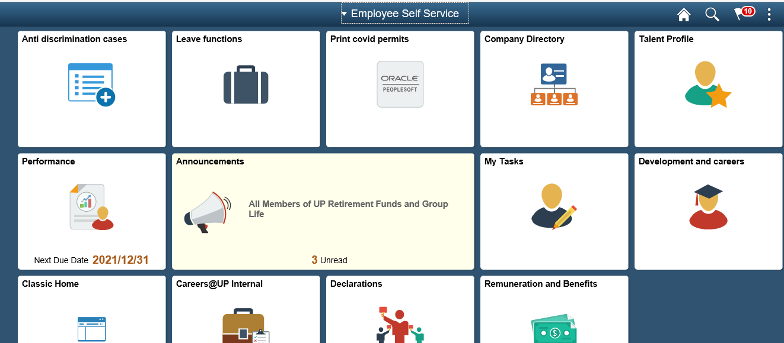
Click on sabbatical leave plan
Sabbatical Leave Plan refers to a detailed written plan which is specific, measurable, achievable and realistic and which sets out the objectives/goals, activities, outcomes and timeframes of a defined period of Sabbatical Leave.
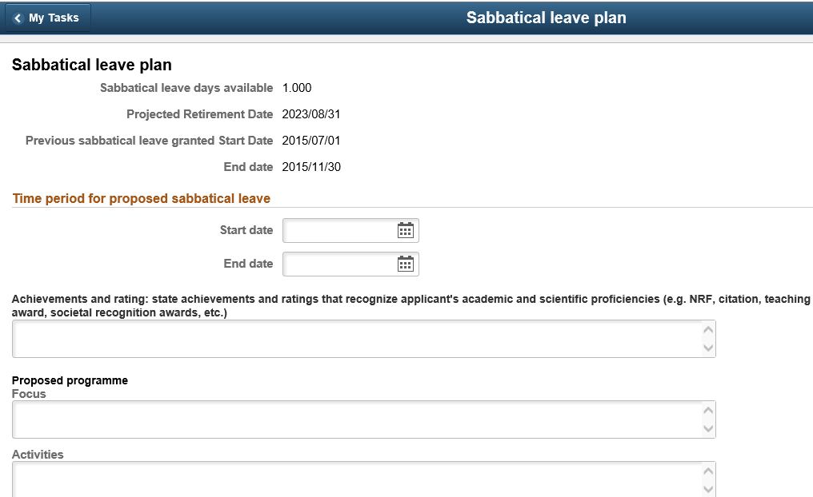
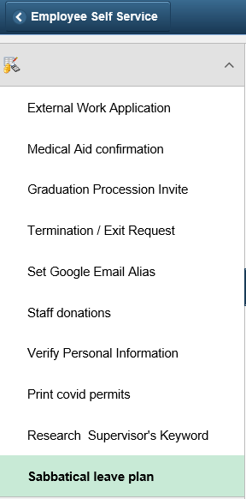

Applying for sabbatical leave
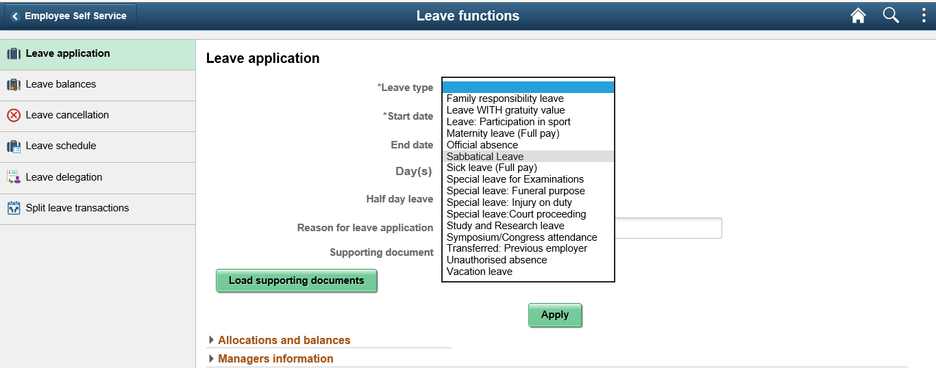
Leave balances
