2012 INTERNAL MOOT COURT FACT COMPLEX
[1] On the 9th of August 2010 Carla and Joe Cray’s baby boy, Alton, was born. Carla is the acclaimed editor of a fashion magazine in Pretoria. Joe is a semi-professional rugby coach for a private sports club in Pretoria. During early December 2011, Carla posted an advertisement on her church’s website, advertising the availability of a job for a full-day caregiver to look after baby Alton. The advertisement is attached. Note: Carla and Joe are part of the New Legalist Church of South Africa, which opposes, among other things, “homosexual misbehaviour”, and “inter racial relationships”.

CARE-GIVER URGENTLY NEEDED (FULL-TIME)
A loving family in Pretoria is looking for a full-time care-giver for their 16 month old baby boy. The salary is negotiable at around R12000 per month, depending on qualification and experience. Own transport is needed so that baby Alton can be rushed to hospital immediately if necessary, considering the fact that he has asthma problems.
We are inviting all ardent believers to send us their CVs or come through for a cup of tea where we can discuss this job opportunity, and that we can pray about this opportunity together. We are specifically looking for one of our own people to look after our child.
Warm Regards
Carla and Joe Cray
Email: carlacray@craymagazine.co.za

[2] On the 2nd of February 2012, Jade Pole contacted Carla via email to show interest in the advertisement. Carla soon responded and invited Jade for the cup of tea as mentioned in the advertisement, being very enthusiastic seeing that no one had yet applied for the job. Upon further communication, cell phone numbers were exchanged and Carla phoned Jade numerous times during the next week telling her that she was “excited to meet Alton’s new nanny”, and to make arrangements for this first meeting. Carla told her husband and friends that she thought that Jade sounded like “a decent lady with a soft heart” and “she reminds me of my grandmother”. In one of these phone calls, Carla told Jade that Jade would have a week to come and “sort everything out” and “hash out the formalities”. In another conversation via email, Carla asked Jade whether the price as advertised was reasonable, to which Jade responded, “It is better than any salary I have ever had before”.

[3] On the 8th of February 2012, Jade arrived at the Cray home. Carla asked what this person wanted, obviously not realising that this was Jade. Jade says that he could feel the same stare and glare which he had already become used to experiencing when people met him for the first time—being a black, homosexual, with alternative dress sense. Jade was dressed in what he calls “gender-neutral” clothing (an outfit simulating a v-neck t-shirt and skirt, all black), with his long braided hair tied back in a pony tail, and his nails painted black as was custom to his style, together with his tongue ring. When Jade introduced himself, Carla rolled her eyes, asked for the CV [which is attached to this fact complex] and told Jade that she would be in contact.
[4] A few hours later on the same day, Carla tweeted as follows:
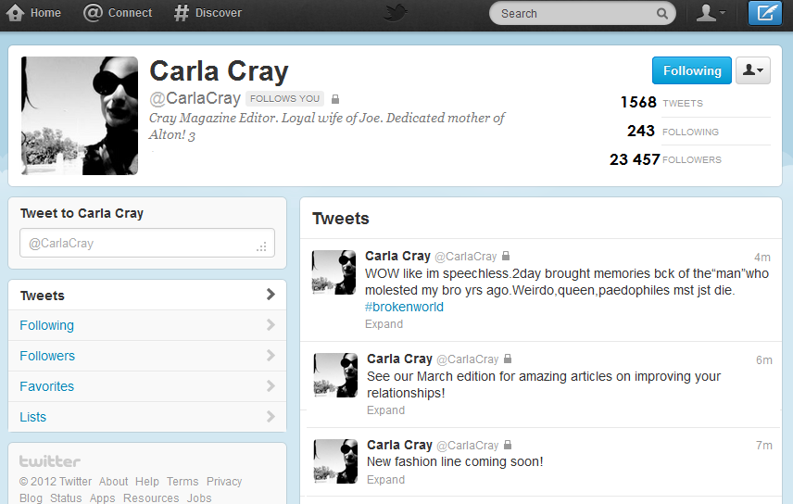
[5] Carla sends an email to Jade after publishing this tweet, informing him that his application for the job has been unsuccessful on the grounds of the overall lack of qualification and experience with regards to child care.
[6] Jade, feeling offended by the above sequence of events, complains to his boyfriend law student, Rostam, for advice. He consequently approaches the Labour Court after conciliation with the CCMA fails, where they pray for the following relief:
A1: The applicant has been unfairly discriminated against in terms of s 6 of the Employment Equity Act, on the specific grounds of gender, sexual orientation, and the unlisted ground of appearance. A claim for compensation is the remedy prayed for, the amount of which is not in dispute at the present moment.
A2: In the alternative, the applicant prays that the court declares that an option contract came into existence between the applicant and the respondent and that there is consequently breach of contract. A claim for damages is the remedy prayed for, the amount of which is not in dispute at the present moment.
R1: The respondent opposes prayer one on the basis that the inherent requirements of the job involved were not met, namely that the applicant did not have the relevant qualifications and/or experience, nor did he have the desirous religious affiliation.
R2: That no option contract came into existence and there can consequently be no breach.

CURRICULUM VITAE
JADE POLE
[Type your address][Type your phone number][Type your e-mail address]
JADE POLE
234B Gregor Street Pretoria 2034 083123456788 jadepole@gmail.com

OBJECTIVE
To become a full-time loving and caring nanny for the Cray family.

EDUCATION
Cynthia School of the Arts 2010 (up to Grade 11)
- Top student in Computer Application Technology (Grade 10)
- 3 month ICT Training certificate (Computer Literacy Course)
- 6 month course at My Lady Philadelphia Beauty School

EXPERIENCE
Barman at Nella’s Naughty Night Club December 2010 - February 2011

Floor Manager of Binky Bob’s Toy Emporium March 2011 – present
- Entertaining children who visit the store
- Stock taking
- Junior personnel administrator
SKILLS
- Great with children
- Computer literate
- Fluent in English, Afrikaans, and French
- Can cook well
- Drivers Licence, Code B

