Faculty of Health Sciences Research, University of Pretoria Ethics Committee’s requirements for consideration of protocols 2017 [Step 1, 2 & 3]
STEP [1]
Before submission
First Applications and submissions:
All Post-Graduate or Undergraduate students of the Faculty of Health Sciences: It is extremely Important & Necessary before submission to the Ethics Committee, you should as a rule have obtained written approval from a:
①Departmental Committee or ②Scientific or ③Academic Advisory Committee
[e.g.: MMed- Committee, PhD-Committee, MSc-Committee, MPH Committee approval, MCur-Scientific Committee]

For the First Time Submission on the RIMS, you must get a Username and Password a few days before submission deadline

RIMS is online again from June: https://rims.up.ac.za [use Chrome or Internet Explorer]
To get a Password and Username, send an E-mail to Mrs. Carika Swart at fhsethics@up.ac.za
Full names :
Surname :
Mr/Mrs/Miss/Dr/Prof:
Gender :
UP Card number :
Department :
Current E-mail address :
Cell number :
ID no:[IF YOU ARE EXTERNAL – NOT AFFILIATED TO THE University of Pretoria]
Name of external
Institution :
To access the Tswellopele Building at door 2-64 [next to the Canteen] and door 4-57 you need to ask to get access from Elmarie.DeBeer@up.ac.za with your UP Card. Reason: To hand in Research documentation for the next Ethics Committee Meeting.

Step[2]
Go to the U.P. Faculty of Health Science .Web Address
www.up.ac.za/healthethics
[ Ctrl + Click on this web address ]
To download all the relevant documents for the Ethics Committee - follow the green arrows

Step[3]
To do the Electronic Application go onto the RIMS Web Address
https://rims.up.ac.za
[ Ctrl + Click on this web address ]
[Use Chrome or Internet Explorer]
To log in & fill in the Electronic Application & upload all the relevant documents on the Electronic Application for submission to Ethics Committee on the RIMS SYSTEM - follow the red arrows

Finally, please submit 1 hard copy of all new application-documents [new Studies/Amendments/SAEs/PR/Administrative] uploaded electronically on the RIMS system to the Ms. Manda Smith at Faculty of Health Sciences Research Ethics Committee, Tswelopele Building, level 4 room 59 [opposite the BMW building] as soon as possible after electronic submission to enable her to put it on the next agenda.
No E-Mail will be accepted.

Investigators/Students/Supervisors/study coordinators are requested to strictly adhere to the deadline dates of handing in and uploading a submission on RIMS, as no “late-submitting” will be considered.

All “response to recommendation” must be submitted electronically on the RIMS site and 1 hard copy to be handed in at Mrs Deepeka Behari. No E-Mail will be accepted.

Administrator: Faculty of Health Sciences Research Ethics Committee

www.up.ac.za/healthethics
https://rims.up.ac.za

Administrator: Faculty of Health Sciences Research Ethics Committee
Manda Smith

Web Address: www.up.ac.za/healthethics and https://rims.up.ac.za
Name | Title | Tel | Room | Building | Dept/Division | E-mail | Fax
Manda Smith | Mrs | 012-356 3085 | 4-59 | Tswelopele Bld | Faculty of Health Research. Ethics Committee | manda.smith@up.ac.za | None

PHYSICAL: Tswelopele Building, opposite the BMW Building, on level 4, room 4-59. Northern direction in Beatrix Str, turn left at Annie Botha Road into Dr Savage Road, [ C/O Dr Savage Road & Baphelo Street ] At the first traffic light, turn left (L) to go at the University parking [boom gate] and park in the allocated parking area.
To access the Tswellopele Building at door 2-64 [next to the Canteen] and door 4-57 you need to ask to get access from Elmarie.DeBeer@up.ac.za with your UP Card. Reason: To hand in Research documentation for the next Ethics Committee Meeting.
Updated 02/10/2017
Calendar 2018
Month | Submission deadline | Prelim Com. Meeting | Full Committee Meeting
January | 5 Jan | 17 Jan | 31 Jan
February | 2 Feb | 14 Feb | 28 Feb
March | 1 Mar | 14 Mar | 28 Mar
April | 26 Mar | 11 Apr | 25 Apr
May | 2 May | 16 May | 30 May
June | 31 May | 13 Jun | 27 Jun
July | 29 Jun | 11 Jul | 25 Jul
August | 31 Jul | 15 Aug | 29 Aug
September | 31 Aug | 12 Sept | 26 Sept
October | 27 Sept | 10 Oct | 24 Oct
November | 25 Oct | 7 Nov | 21 Nov

Investigators / Study Coordinators / Students / Supervisors
are requested to strictly adhere to the deadline dates
of handing in and uploading a submission on RIMS,
as no “late-submitting” will be considered.
_{updated 01/11/2017 RS}
You are requested to strictly adhere to the deadline dates

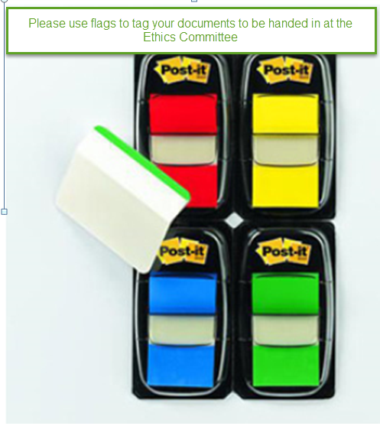
RIMS – HELP DESK
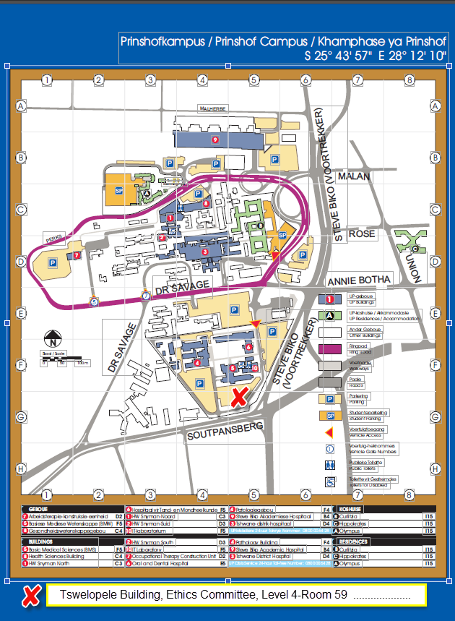

All Post-Graduate or Undergraduate students of the Faculty of Health Sciences:
It is Extremely Important & Necessary befóre submission to the Ethics Committee,
you shòúd as a rule have obtained written approval from a
①Departmental Committee or ②Scientific or ③Academic Advisory Committee
[MMed- Committee, PhD-Committee, MSc-Committee, MPH Committee approval, MCur-Scientific Committee]
To access the Tswellopele Building at door 2-64 [next to the Canteen] and door 4-57 you need to ask to get access from Elmarie.DeBeer@up.ac.za with your UP Card. Reason: To hand in Research documentation for the next Ethics Committee Meeting.

All Post-Graduate or Undergraduate students of the Faculty of Health Sciences:
It is extremely Important & Necessary befóre submission to the Ethics Committee,
You shòúd as a rule have obtained
written approval from a
①Departmental Committee or
②Scientific or
③Academic Advisory Committee
[e.g: MMed- Committee, PhD-Committee, MSc-Committee, MPH Committee approval]

Step[2]
U.P. FHS.Web Address
1
www.up.ac.za/healthethics
To download all the relevant documents for the Ethics committee

Click on – Research Ethics Committee
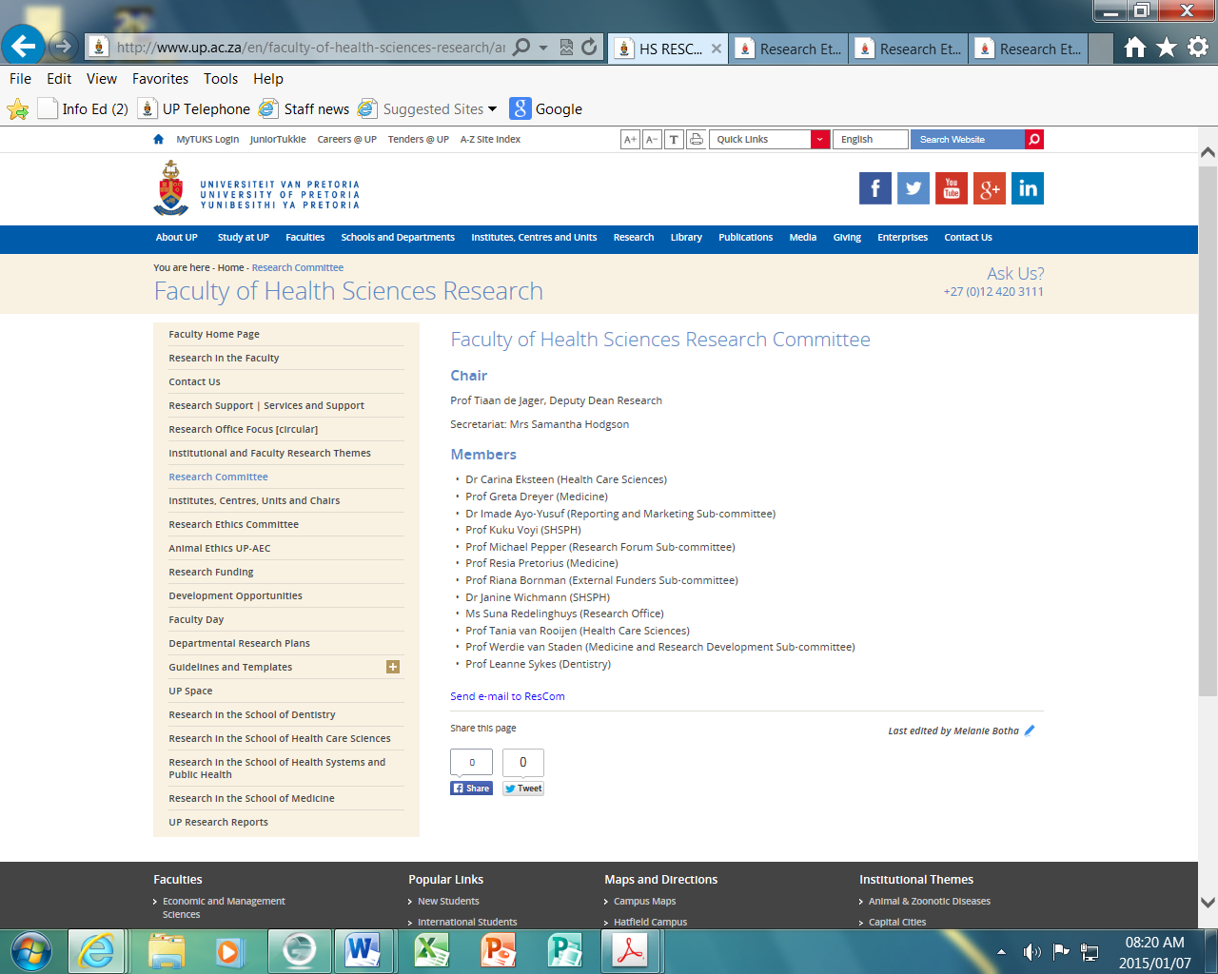
2
Click on – First Application & Submission
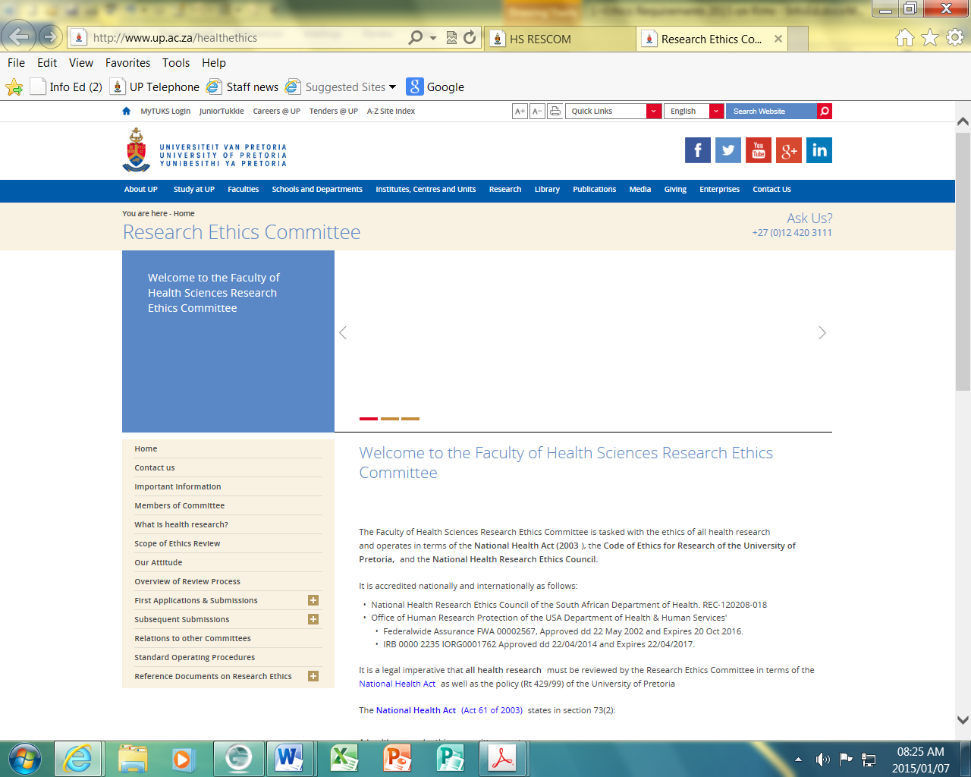
3

Click on – Which document
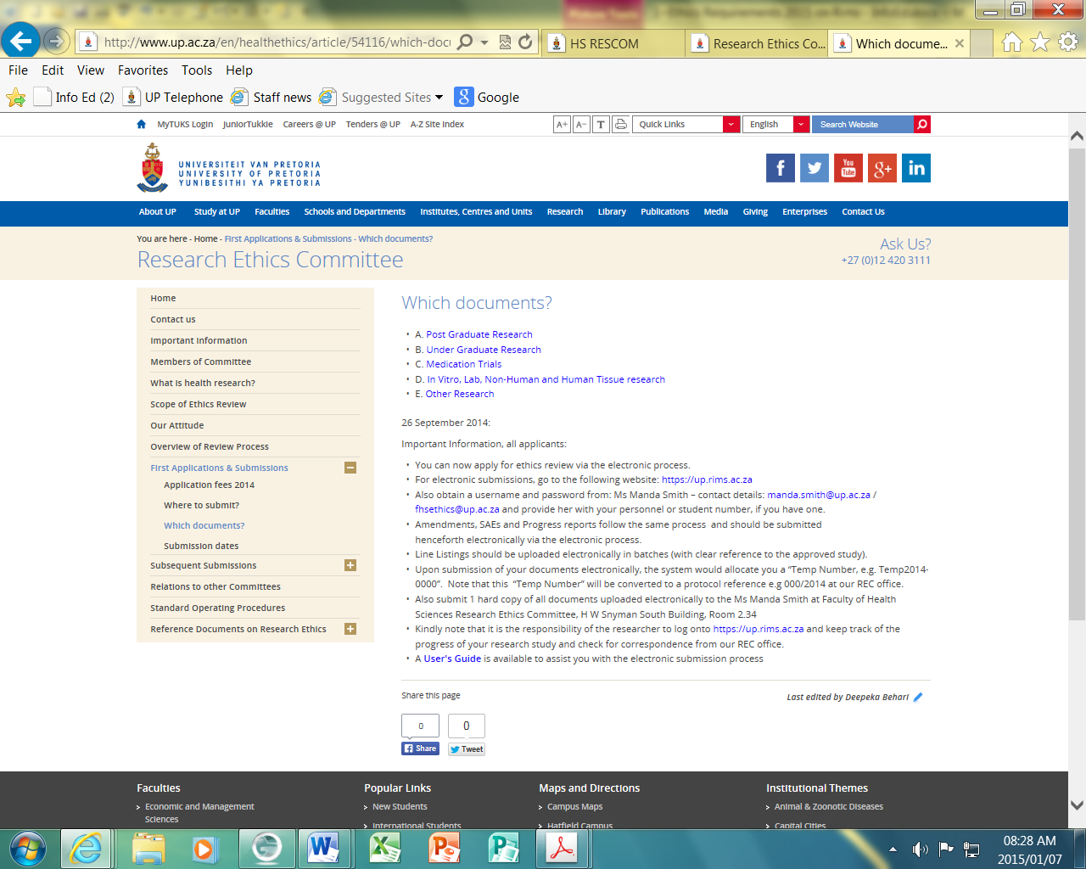
4
5 Choose here

Click on – Templates available
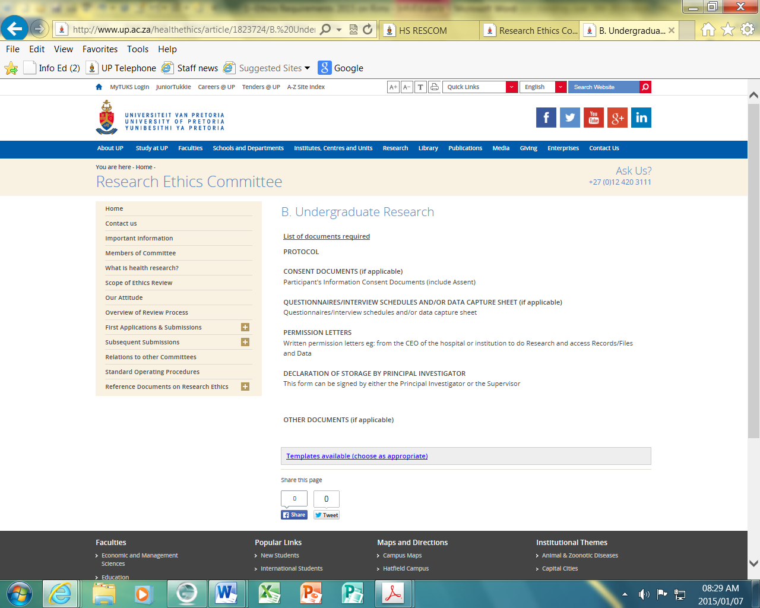
6

Click on – Templates to choose from
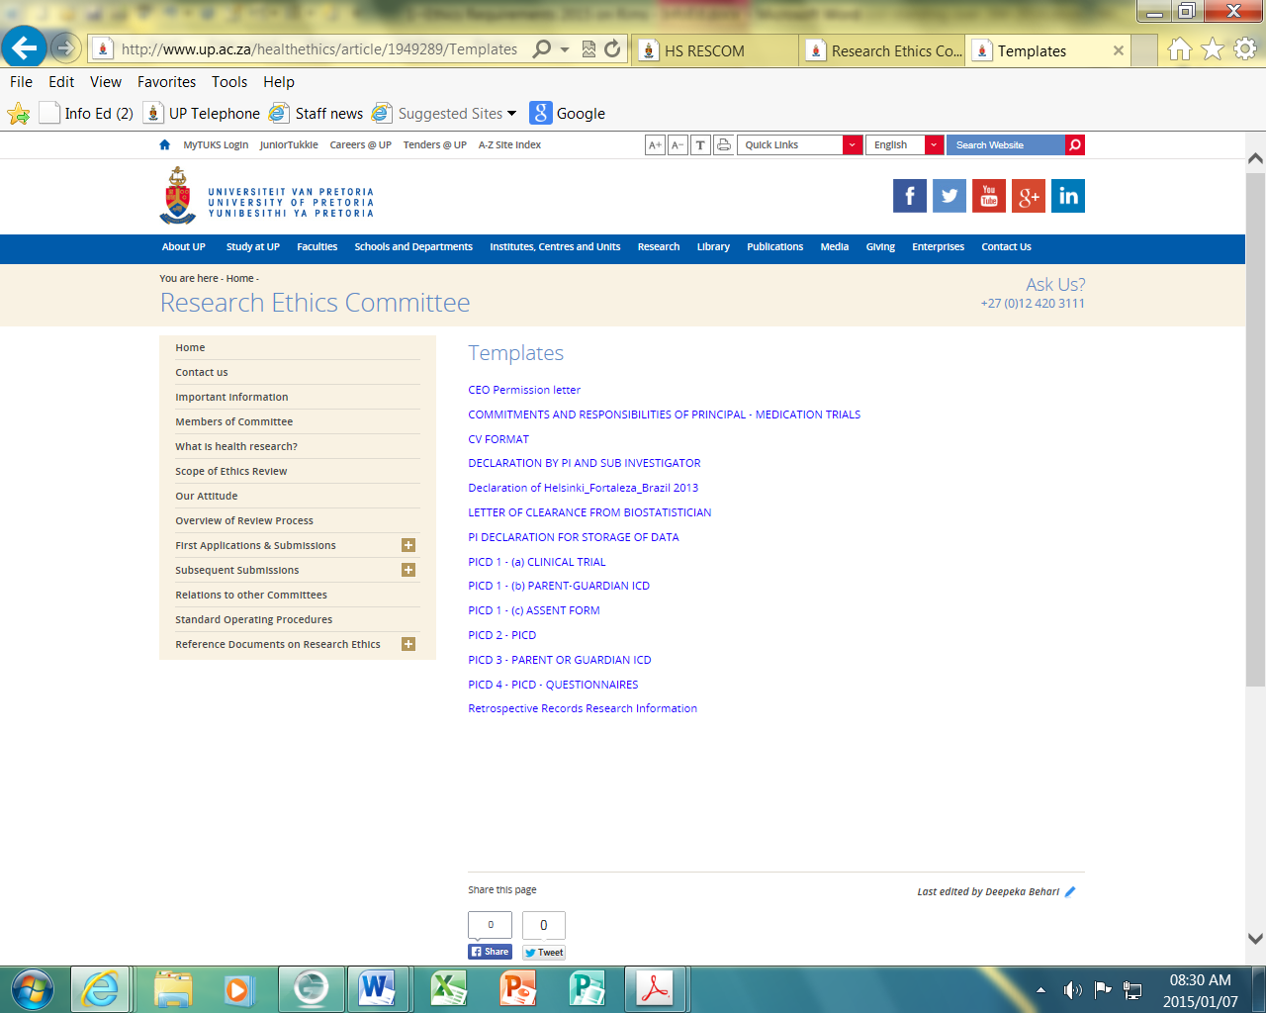
7. This documents must be downloaded to your computer
- Chairperson : Prof CW van Staden.
- Deputy Chairperson: Prof T Rossouw / Prof A Nienaber / Dr R Sommers.
- Office Administrators: Mrs D Behari / Mrs M Smith.
Telephone: 012 356 3085
E-Mail: Deepeka.Behari@up.ac.za & manda.smith@.up.ac.za
Building: Tswelopele Building
Level: 4nd Floor
Room: 4-59
Please
Submit [1] hard copy [with flags/tags]
Of all documents uploaded electronically to Ms. Manda Smith at the Faculty of Health Sciences Research Ethics Committee office, Tswelopele building, Room 4-59
As soon as possible after electronic submission on RIMS.
Only then Manda can allocate your study to the next Agenda.
To access the Tswellopele Building at door 2-64 [next to the Canteen] and door 4-57 you need to ask to get access from Elmarie.DeBeer@up.ac.za with your UP Card. Reason: To hand in Research documentation for the next Ethics Committee Meeting.

All Post-Graduate or Undergraduate students of the Faculty of Health Sciences:
It is Extremely Important & Necessary befóre submission to the Ethics Committee,
you shòúd as a rule have obtained
written approval from a
①Departmental Committee or
②Scientific or
③Academic Advisory Committee
[MMed- Committee, PhD-Committee, MSc-Committee, MPH Committee approval, MCur-Scientific Committee]

Step [3]
Please follow the numbers 1 to 14
To do the Electronic Application go onto the RIMS Web Address
https://rims.up.ac.za
[ Ctrl + Click on this web address ]
[Use Chrome or Internet Explorer]
To log in & fill in the Electronic Application & upload all the relevant documents on the Electronic Application for submission to Ethics Committee on the RIMS SYSTEM - follow the red arrows
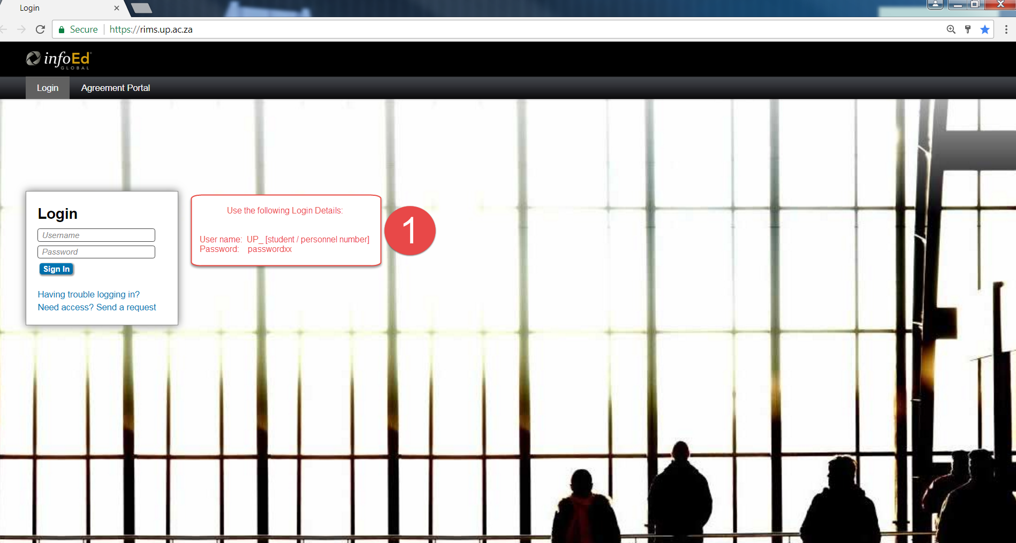
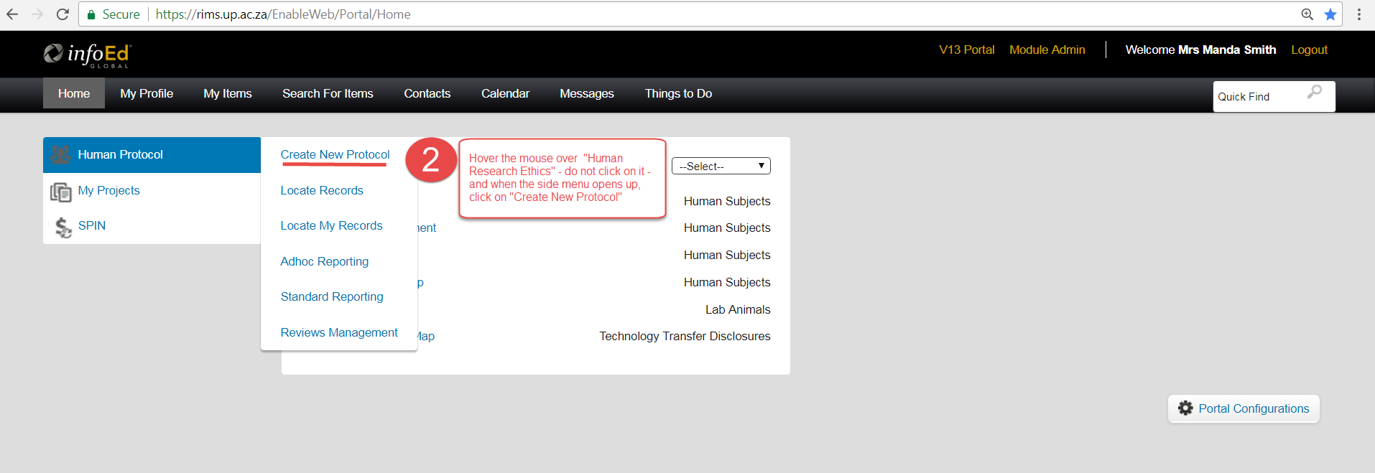
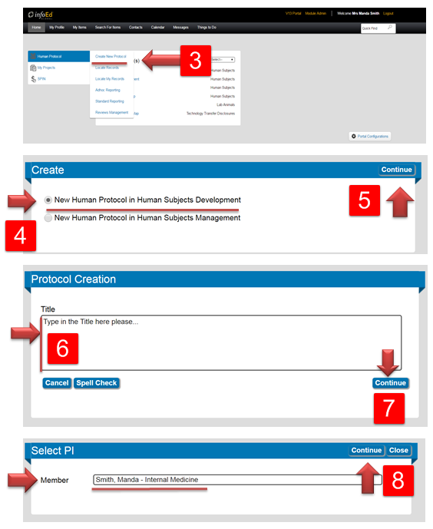
The PI [Principal investigator] must be selected here. The PI is the person/student who’s project it is and who is mainly responsible for this protocol
Very Important: the name of the person’s profile that is being used to create the application will automatically appear here, If you are filling in the application on behalf of a student who is the PI, then you must delete ALL of the text in the edit box so that your name no longer appears. You must then type in the PI’s Surname followed by a comma and a space and then the FIRST Name and select that person for the list. Then click on “Continue”
Click on “Continue”
Copy and Paste your Title in here
Click on “Continue”
Click on “Continue”
Click on “Create New Protocol”
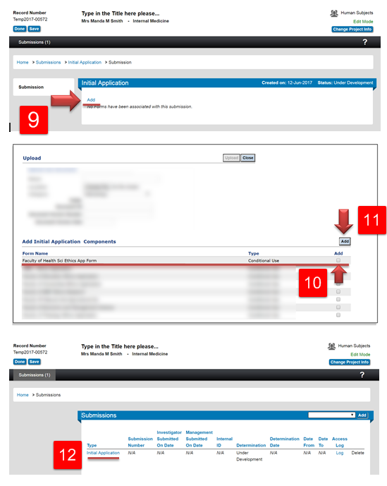
Write down the Temp2017- Number
Click on “Initial Application”
Click on the blue link to open the Ethics Clearance Application E-Form

Click on “Add”
Click on the blue link to select the Ethics Clearance Application E-Form

Tick “Add”
Click on “Add”

Read through the E-Form carefully, answer all of the questions and click on the “Save” icon after completing each section

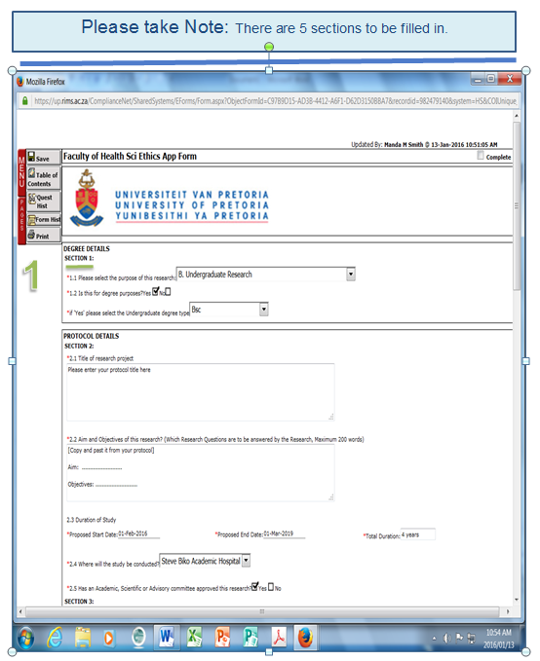
Click on the drop down arrow and select from the list that drops down
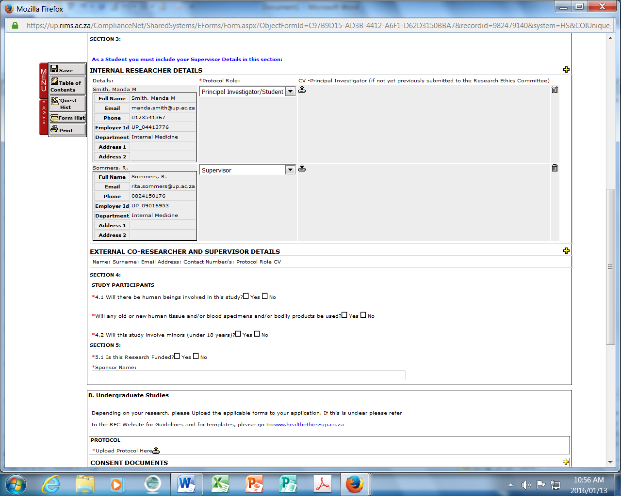
If No – type in “None”

4
3
CEO
IC+Q
Protocol
5
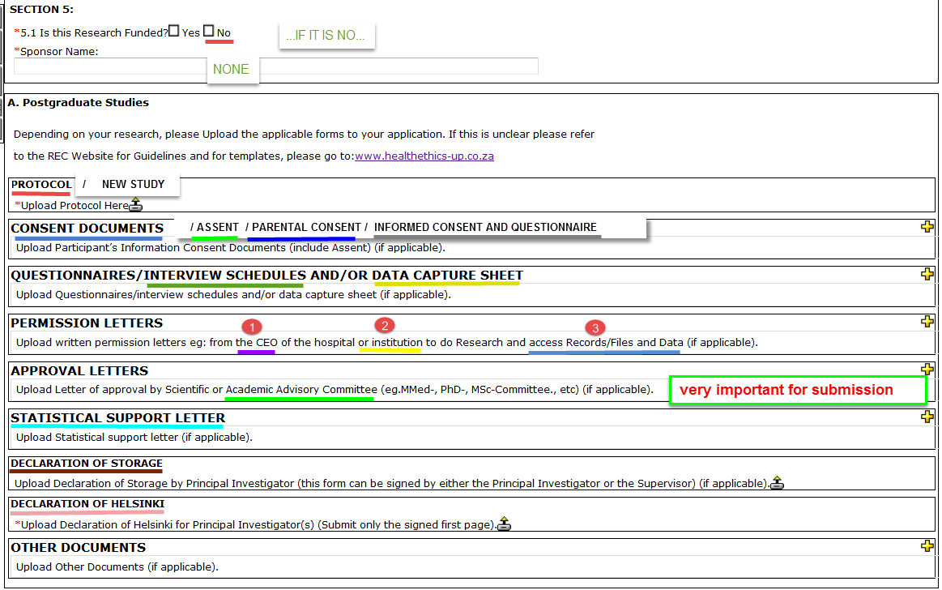
All documents must be uploaded here.
ICONS Explained: The yellow plus icon’s function is to open up a new line in the
E-Form in which documents can be uploaded
5

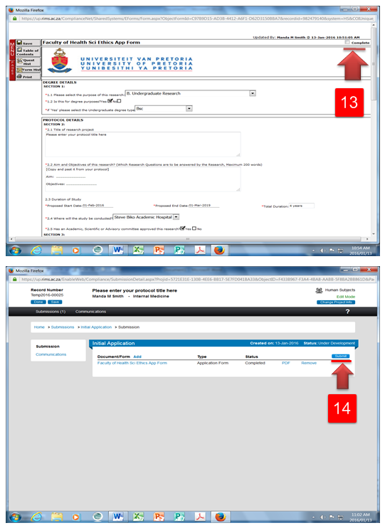
Click on “Submit”
- You will now notice that your whole application is completed, all that is left to do is to SUBMIT your application.
- Click “SUBMIT” to do so. The steps that you have to take after clicking on SUBMIT is EXTREMELY IMPORTANT as it will determine when your application ends up going on the AGENDA for review
- Hand in one Hard Copy to the Ethics Office A.S.A.P. Tswelepele Building, Room 4-59
After completion of Section 1 to 5 you need to go back to Question 1 and tick the “Complete” button ↓

3. Click

All Post-Graduate or Undergraduate students of the Faculty of Health Sciences:
It is Extremely Important & Necessary befóre submission to the Ethics Committee,
you shòúd as a rule have obtained
Written approval from a
①Departmental Committee or
②Scientific or
③Academic Advisory Committee
MMed- Committee, PhD-Committee, MSc-Committee, MPH Committee approval, MCur-Scientific Committee

