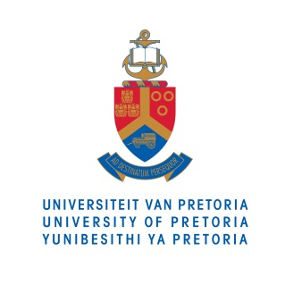

MEDIA RELEASE

25 August 2015

__________________________________________________________________

BANKSETA awards R5 million grant to University of Pretoria

The University of Pretoria (UP) and BANKSETA signed a grant agreement on Tuesday, 25 August 2015, that will provide full-cost bursaries to 40 South African students who require support to complete their 2015 academic year in the field of information technology.
BCom (Informatics) at UP is the only such degree in Africa that is ABET accredited, a USA accredited body that sets the global standard for programmes in applied science, computing, engineering and engineering technology.
Prof Alta van der Merwe, Head of the Department of Informatics at UP, says this grant addresses the national student funding crisis and is specifically aligned to the scarce and critical skills in the inclusive banking sector, as well as the broader banking sector. ‘We are very proud of this partnership with BANKSETA as this grant is a great start to what we hope will be an ongoing relationship. Partnerships with industry and SETAs are an ongoing focus of the University. We cannot address skills shortages in isolation. There is a national shortage of skills in information technology in South Africa and training skilled BCom (Informatics) graduates will help South Africa to be more competitive in an increasingly technological world.’
The BANKSETA bursaries are targeted at second- and third-year BCom (Informatics) students who meet BANKSETA's minimum requirements. The funding will go towards the students’ registration fees, tuition fees, meal fees and required text books or technological devices (such as notebook computers).
BANKSETA CEO, Mr Max Makhubalo says, ‘BANKSETA has taken on the role of collaborating with public higher education institutions to introduce students to the world of work. Our mandate is to share the career opportunities available to these students early on in their studies by connecting them with potential employers upon completion of their qualifications. With the rapid pace of technological development within the banking and micro finance sector, developing skills in information and communications technologies is identified as a key priority area.
‘Many of the positions within the information technology sphere are currently filled by imported talent and the focus of this partnership is to build local skills for local placement opportunities. The success of this project will see 40 young vibrant students join the workforce with knowledge and skills in analysing and managing information efficiently, thereby supporting economic growth.’
Dorcas Kgonyane, one of the bursary recipients, says: ‘Not only is the BANKSETA funding a financial relief, it is an emotional relief too. I don’t have to worry about my debts once I finish my degree and I can begin my working life with a clean slate.’

END

For more information on the University of Pretoria, please contact:

Liesel Swart
Department of University Relations
University of Pretoria
Cell: 082 672 0067
Email: liesel@roundtree.co.za

