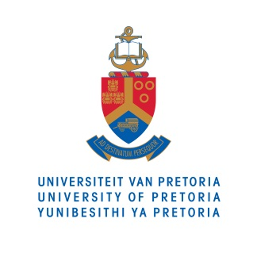

MEDIA RELEASE

24 APRIL 2015
____________________________________________________________

Renowned engineer honoured at University of Pretoria

One of the most cited authors in the field of engineering, Prof Adrian Bejan, received an honorary doctorate in science from the University of Pretoria.

Prof Bejan holds a PhD degree in mechanical engineering and has pioneered numerous original methods in thermal science. His research covers a wide range of topics in thermodynamics, heat transfer and fluid mechanics. He is the author of 28 books and over 600 peer-reviewed articles.

He is a member of the Academy of Europe and an honorary member of the American Society of Mechanical Engineers, the Romanian Academy and the Academy of Sciences of Moldova. At present he is a professor of Mechanical Engineering at Duke University, USA. The honorary doctorate is bestowed on Professor Bejan in recognition of the enormous scope of his work and the tremendous contributions he has made in the fields of thermodynamics, heat transfer and applied physics.

Prof Bejan describes engineering as a field of science that allows creativity, which can result in the creation of things that do not exist as yet. He describes science as ‘a story that evolves to become better’.

‘As we come to know more, we become reliant on our knowledge to predict what will happen if we make a decision. With science, we predict the future, we design it, build it and walk into it with confidence,’ he said.

He encourages graduating engineers to be inquisitive and eager to know more. ‘Knowing how to formulate questions is of paramount importance throughout science and society. For you to be able to get answers to your questions requires persistence and discipline, and discipline means objective clarity. I urge you to rise and make a difference in the world and [to] improve life.’

For more information on the University of Pretoria, please contact:

Sanku Tsunke
Media Liaison Officer
Department of University Relations
University of Pretoria
Tel: 012 420 2276
Fax: 012 420 4269
Cell: 071 008 0187
Email: sanku.tsunke@up.ac.za

