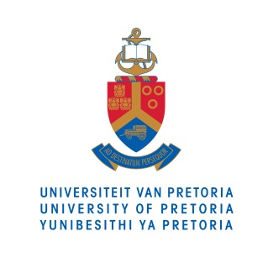

Opinion piece

22 July 2015

__________________________________________________________________

UP’s Centre for Child Law obtains High Court judgement protecting separated asylum seeker children
Children fleeing from war-torn countries are often brought by their aunts or uncles because their parents have died in the war. They are referred to in law as ‘separated children’ and are not included in the asylum seeker permits of the relatives they accompany. This means that the children have no papers and therefore struggle to get access to education and health services.
Dr Ann Skelton, Director of the Centre for Child Law, argued the case brought by the Centre and Lawyers for Human Rights on behalf of eight separated asylum seeker children from the Democratic Republic of Congo. The case sought relief for them and for other children in similar situations.
On 9 July 2015 the North Gauteng High Court in Pretoria declared that all children who enter the country with a relative who qualifies to apply for asylum should be treated as a ‘dependent’ of that relative, in the same way that biological children are treated. This gives the children immediate protection and ensures that they are not separated from people with whom they have a relationship.
The Department of Home Affairs argued that all such children must be treated as children in need of care and protection, because there is a risk that they are being trafficked. The Court acknowledged this, but stated that the risks to a child who is undocumented are greater. The judgment is a step forward in the protection of the rights and wellbeing of asylum seeker children.
END

For more information on the University of Pretoria, please contact:

Prof Ann Skelton
Tel: +27 12 420 4502
Fax: +27 12 420 4499
E-mail: centreforchildlaw@up.ac.za

