Creative problem solving
Purpose
This tutorial focuses on creative problem solving. The father of creative problem solving, Alex Osborn, already provided us with the basic skills and steps in the 1950s. Over the years, the skills and steps have been defined and redefined. The process is sometimes given new buzzwords that are popular for a while. Today, we hear about ‘Solutions architecture’, a term used primarily in the IT field. The skills applied, however, are general and applicable to any problem a person could face from time to time.
In this tutorial, we shall
- describe the skills and steps required to find solutions to problems and challenges that you might encounter in the workplace or in your career.
- provide you with a system of skills and steps to follow when confronted with a problem.
This problem could be of a personal nature, or it could be a problem faced at work. It will help you analyse the problem you face, then access your creativity and imagination to come up with innovative solutions to the problem.
You will find that problem solving can be a fun process that will give you skills that you can apply again and again. Each time you will become more comfortable with managing problems and challenges.

Learning Outcomes
You will be able to demonstrate an understanding of the use of divergent and convergent thinking skills consciously to solve problems creatively.

Key Points
This tutorial explores the following topics:

Definitions
Noted creative problem solving educator and practitioner, Ruth Noller, described creative problem solving as the sum of its parts:
- ‘Creative’ specifies elements of newness, innovation, and novelty.
- ‘Problem’ refers to any situation that presents a challenge, offers an opportunity, or presents a troubling concern.
- ‘Solving’ means devising ways to answer, to meet, or to satisfy a situation by changing yourself or the situation.
Noller also produced a creativity formula: c=f_{a}(K,I,E) (to be read as ‘creativity is a function of attitude and the combination of knowledge, imagination and evaluation’):
K (knowledge) – obtained through our life experiences. [or formal study]
I (imagination) – one’s ability to generate ideas or make connections.
E (evaluation) – examining the advantages and disadvantages of a particular idea or situation.
(http://russellawheeler.com/learning_zone/creativity_formula/, Accessed 19 December 2019)
For a departure point and a frame of reference, we could thus define creative problem solving as follows:
Creative problem solving is the cognitive process of searching for a new and novel, creative solution to a problem, a solution that is original and unusual. Emotions play an important and supportive role.
Divergent as well as convergent thinking are used.
Divergent thinking: This approach makes use of a wide variety of different perspectives from multiple sources and stakeholders, sometimes contradictory at the start but in the end producing a rich background from which to identify the real problem and potential solutions.
‘Divergent thinking is the process of coming up with new ideas and possibilities—without judgment, without analysis, without discussion. It is the type of thinking that allows you to free-associate, to ‘go big’ and to discuss possible new ways to solve difficult challenges that have no single/right/known answer’, explains Anne Manning, Founding Partner of Drumcircle LLC and Instructor at Harvard University. (Boogaard, K. 2018. Convergent Thinking vs. Divergent Thinking: Why Planning Isn’t Always the Right Thing to Do, https://www.wrike.com/blog/convergent-thinking-vs-divergent-thinking/, Accessed 19 December 2019).
Convergent thinking: This approach follows traditional thinking patterns based on strict planning and analysis.
‘Convergent thinking is associated with analysis, judgment, and decision-making. It is the process of taking a lot of ideas and sorting them, evaluating them, analyzing the pros and cons, and making decisions’ Manning explains. (ibid).
It is actually considered useful nowadays to use both processes, first divergent to gather the widest pool of ideas and then convergent to narrow them down to the best option(s). If you have time to read Boogaard’s entire blog post from which the Manning quotations are abstracted, you will find that it clarifies the approaches very well.
We discuss both a convergent process and a design-thinking process in this tutorial to illustrate the difference in approach.
Two important prerequisites for successful problem solving are an open mind and a positive attitude to add to Noller’s knowledge, imagination and evaluation.

The basic process
The creative problem solving process is as follows:
- Step 1: Identify the Problem;
- Step 2: Cause Analysis;
  - Step 2A: Identify the Causes;
  - Step 2B: Define the Real Problem;
- Step 3: From Problem to Challenge;
- Step 4: Solution Exploration;
- Step 5: Solution Selection;
- Step 6: Implementation Strategy.
We are going to unpack each step in the process.
First, you have to get a number of tools ready. You will need
- a few clean A4 pages or a journal with clean pages;
- colour pens or pencils;
- a few quiet minutes to go through the first few steps to get the process going.
NOTE: The reason that we recommend coloured pencils is that they stimulate creativity. In a contact session you might also use different coloured stick-it notes. You might add sketches, diagrams like mind maps, etc. In a contact session you would use brainstorming; on paper, you need to use a free flow of ideas, capturing all of them before evaluating them.

Step 1: Identify the problem
This step is quite easy. We are not providing a problem. You have to decide what the problem is that you need to face, and you can easily name the problem as you experience it. You are welcome to let your intuition, your emotions, as well as your mind assist you in loosely formulating the problem. This is not a very objective process, as you just want to have something to focus on. It is all right to be subjective. Write the problem on a clean A4 page in any colour you want. Allow your mind, emotions, and intuition decide which colour you use.
Step 2: Cause analysis
It is important to focus on only one problem at a time. Sometimes when we are faced with a problem, we get so overwhelmed that we struggle to think clearly. You should thus try to distinguish different parts of the problem so as to focus on a single problem or a simple part of a problem. Using Step 2A will assist in breaking down the original problem into parts and identify different elements or different problems you are currently seeing as one.
Step 2A: Identify the causes
Take a new sheet of your A4 paper and try to analyse all the causes of the problem. The Japanese have developed the method of root-cause analysis to an art. The Japanese method of asking ‘Why?’ until you are at the bottom of the problem is a simple method of becoming more objective and finding the root cause. Working with the root cause from this point will ensure that you do not try to solve symptoms but, instead, find solutions to the real problem.
Look at the problem you formulated in Step 1 and ask: ‘Why is this a problem to me?’. The answer will be followed again by: ‘Why is this a problem to me?’ Then, ‘Why is that a problem?’ and so on until you get to the root cause. It is sometimes called the five ‘whys’ as after five rounds you are normally close to the root problem.
What you are actually doing is:
- Separating the symptoms from the cause;

- Sifting through the information and discarding what is irrelevant;
- Sifting and refining until a single problem worms its way up from the pile.
What is the problem, the real problem?
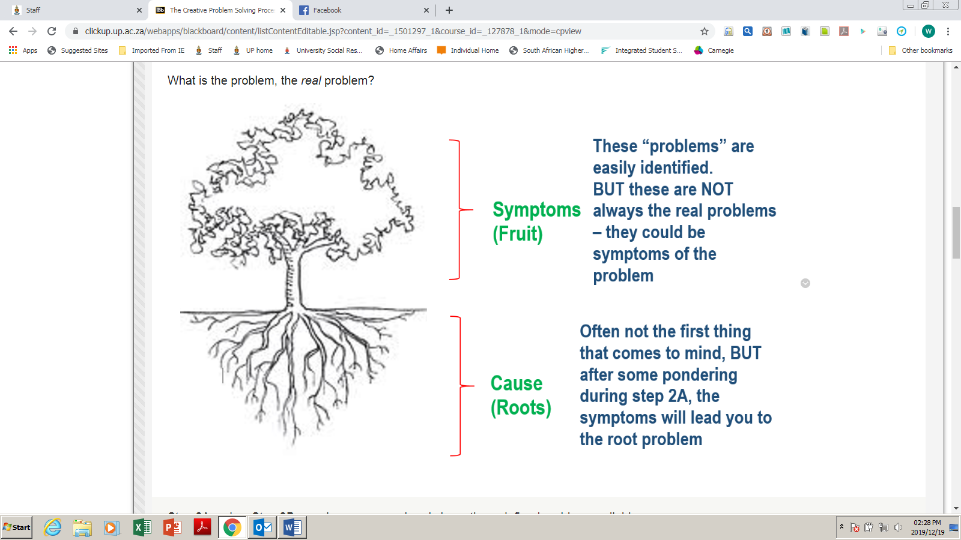
Figure 1 (Source???)
Step 2A makes Step 2B easy because you already have the redefined problem available.
Step 2B: Formulate your redefined problem
‘Okay, my problem actually is ...’
Step 3: From problem to challenge
It is interesting that the word ‘problem’ has a totally different influence on the mind than the word ‘challenge’ does. This is how the mind responds to the different thinking processes that takes place when focusing on a problem v a challenge:
Table 1
Problem | Challenge
- The mind sees it as a limiting obstacle;  - Energy is funnelled towards repairing something that has gone wrong;  - It disempowers. | - Creates an open, positive mental attitude and frame of mind;  - Instead of trying to repair a malfunction, it encourages us to recruit our inner resources to make positive changes;  - We view the situation as a new opportunity;  - It empowers.
It is thus a good idea to change your ‘problem statement’ to a ‘challenge statement’.
Take a clean sheet of A4 paper and write your problem statement as a challenge statement. Use one of the following or create your own:
- ‘Wouldn't it be great if ...’
- ‘I wish ...’
- ‘It would be nice if ...
- ‘I dream of ...’
Now that you feel more energised to solve your problem because you see it as a challenge, you are ready to use your creativity to find possible solutions.
Step 4: Solution exploration
This step could take a while. The reason is that we cannot switch our creativity on and off as needed.
Here are a few steps to prepare you to be open to new ideas. Make sure you have achieved each stage before you move to the next one. Before you start with this process, take note of the following preparations:
- Take a clean sheet of A4 and get your colour pens ready. You are going to jot down creative ideas as they come. You are going to use different colours. Do not write the ideas in a linear fashion. If you put them in linear fashion, you will stimulate linear thinking. The different colours stimulate more creative ideas.
- Do not judge any ideas; for now, accept all of them. Latej convinced that you are creative, you can focus on step 2;
- Find a time in your day where you can be uninterrupted. Ensure that you are very relaxed. Maybe you need to listen to music with a slow flow or music without a beat. When you are certain that you are very relaxed, you are in a state where your subconscious mind is ready to provide you with creative ideas;
- Look at your challenge and ask your creative subconscious mind for ideas. Allow wild, crazy, out of the box ideas, even bizarre ideas. Laugh about them, but don't discard them. Be silly, be impractical – you never know what can come of it eventually. Don't stop after a few ideas – quantity is important.
- After filling your page with wild, wonderful, wacky ideas, consult friends, colleagues, family, or even professional people and start asking them for ideas. Do not discard or judge any idea. Accept them all and put them on a new page, again using colours and again all over the page.
- Sometimes it is necessary to wait a few days and start the whole process of idea exploration again. Sometimes the subconscious mind provides those ideas only later.
Step 5: Solution selection
When you are certain that you have all possible ideas available, you can start to analyse them.
- First read them all through. Still, do not discard any one of them before you have considered its possibilities.
  - Take weird, wild, and wacky solutions and first see if you cannot change them to become usable;
  - Improve and make changes to the ones that show possibility;
  - Make combinations;
  - Eliminate the non-relevant ones.
- Select your five best solutions and analyse them in terms of consequences, possibilities, etc.;
- Then from that list of five, select your best three;
- Now decide on the best one. Sometimes you will actually use more than one or combine some.
Step 6: Implementation strategy
In designing an implementation strategy, you will have to answer some of the following questions:
- When am I going to do it or start doing it?
- Who will be involved?
- Who needs to be convinced?
- What will be the first step?
- When am I going to be finished with step 1?
- What will be step 2?
- When am I going to start with step 2? And so on.
- How will I know when my original challenge is met? What will be the signs?
- What am I going to do to celebrate the change?
- Who will I thank for their support?
Celebrate your creativity and your ability to solve problems. Next time you will find it easier, as you will become used to the process.

Design thinking
A major contemporary approach to creative problem solving is design thinking. It is based on Theory U (Otto Scharmer). Look at the letter below:
Solution
Problem
U
Scharmer holds that moving across the U at the top from problem to solution using tried and tested methods is unproductive and does not lead to innovative or meaningful solutions. You need to go from one side to the other by taking a ‘deep dive’ down the left side of the U, learning all you can from a variety of sources including stakeholders and users and deciding (when you get to the bottom of the U) what of your old thinking you are going to let go. You then have to decide what new ideas you are going to let come and go up the right side and prototype and test them with users or the client quickly.
There is an excellent video based on this process as implemented at IDEO, a design firm in California. It was first viewed on the programme ABC News programme, Nightline. It demonstrates how a diverse team implements the model to design a different shopping trolley – yes, one of those carts you see every time you go to the supermarket.
ABC News. (1999). The deep dive. (22:01). https://www.youtube.com/watch?v=2Dtrkrz0yoU, Accessed 20 December 2019.
As you watch, note
- the steps in the process;
- the make-up of the eclectic design team;
- the stakeholders consulted;
- the inter-disciplinary methodology (It is not about engineering only – anthropology figures in the consultation with users, for instance.);
- the use of creative stimuli such as coloured sticky notes, drawing, setting up ideas on a large board for all to see, brainstorming and so on
- divergent thinking practices;
- how they moved over to convergent thinking (using a smaller team of ‘adults’ to focus the ideas).
If you read a few of the comments below the video, you will see some scepticism because the solutions have never been implemented. However, the company was obliging the broadcaster by demonstrating its process and spent far less time on the project than it normally would have and did not go that extra step of implementing some of the feedback and designing a final product. Some of their innovations that were taken up in the market are mentioned in the video.
David Leed (2014) sums up some of the points you need to note in the IDEO video:
- The members of the design team were not product experts, but were experts in the process of design.
- The project leader is chosen based on her or his ability to work with groups.
- The design team members are from a wide-range of fields. This results in different perspectives and solutions to a project.
- There should not be a hierarchy system in an innovative culture.
- The design team speaks with product experts (people who use, make, and repair the product) because it is faster than learning about the product yourself.
- ‘Enlightened trial and error succeeds over the planning of the lone genius.’ – Peter Skillman
- ‘Fail often in order to succeed sooner.’ – One of IDEO’s mottos
- Recipe for Innovation = Lot of hours + Open mind + Leader who demands fresh ideas be corky + Teamwork + Belief chaos can be constructive
Here are some of IDEO’s mantras that they post around their workspace:
- One conversation at a time
- Stay focused on the topic
- Encourage wild ideas
- Defer judgement
- Build on the ideas of others
(https://davidleeedtech.wordpress.com/2014/05/11/ideos-innovation-and-design-process/, Accessed 20 December 2019).
Does design thinking work with production, only? No. It has been used successfully in major community transformations with dozens of stakeholders in the room.
You can read about the five stages commonly seen in a design thinking process – empathise, define, ideate, prototype and test – at the following site.
Dam, R. and Sian, T. (2019). 5 Stages in the Design Thinking Process. Interaction Design Foundation. https://www.interaction-design.org/literature/article/5-stages-in-the-design-thinking-process, Accessed 20 December 2019.
As you read, make notes on what is described under each stage. Try to link the activities you observed in the IDEO video to each stage. Maybe draw a mindmap with the five stages and link the ideas in the reading and the IDEO activities to those stages. You could once again use your coloured pencils to do this activity.
Did you note that design thinking is regarded as a human-centred, non-linear approach to creative problem solving?
If you want to learn more about this approach, you will see at the end of the article that there is a link to the Foundation’s beginners’ guide. You could also search MOOC (massive open online course) platforms such as Coursera, EdX or Open Learn to find free online courses to provide you with a deeper understanding of this process.
Is design thinking applicable to all types of problems? No. Some really require a stock response.
Example
If you have a problem with DSTV and you phone their call centre, someone there will guide you through a method to solve your problem so that you do not need to call in a technician: press the back button till the green light blinks, press options, press all channels and there you go, problem solved.
However, what are called ‘wicked problems’, very complex problems, possibly unique and difficult to explain, that are difficult to solve from one perspective only or by one person only, or that require transformation or process re-engineering, can benefit from a design-thinking approach.
You could also read a short history of the development of design thinking:
Dam, R. and Sian, T. (2019). Design Thinking: Get a Quick Overview of the History. Interaction Design Foundation. https://www.interaction-design.org/literature/article/design-thinking-get-a-quick-overview-of-the-history, Accessed 19 December 2019.

Assessment
Answer the following questions.

Question 1
Which of the following problems would require a more creative problem-solving approach?
- The failure of the air conditioning system in a building
- Global climate change
- One child’s obesity v obesity in a nation
Question 2
Why is knowledge an important factor in creative problem solving?
- The people who know the most about a phenomenon can identify the real issues.
- The best solutions are based in science and knowing what you are doing.
- Expert knowledge is generally acknowledged as the basis of all development.
Question 3
What type of knowledge is important?
- Knowledge of the field
- Knowledge of the process
- Technical and human knowledge
Question 4
Which stage of the six step process focuses on converging of ideas?
- Identify the problem
- Cause analysis
- Define the real problem
- Solution selection
- Implementation strategy.
Question 5
Which stage of the design thinking process focuses on convergence of ideas?
- Empathise
- Define
- Ideate
- Prototype
- Test

MEMORANDUM
Question 1
b)
Question 2
a)
Question 3
c)
Question 4
d)
Question 5
c)

