Tuks Cycling Race report

2014 USSA National Student cycle championships

2014

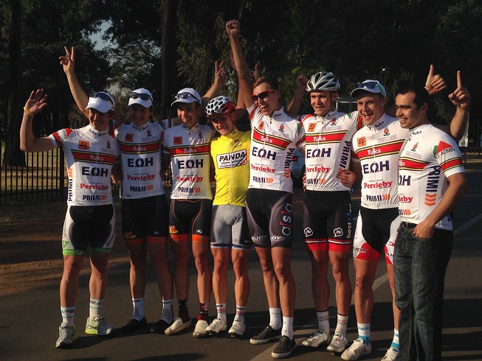

**Foreword**

We have done it once again. The University of Pretoria cycling team have secured the USSA National Student cycling championships for the second year in a row beating other top universities like Nelson Mandela Metropolitan University, University of Johannesburg and North West University.

Firstly I would like to thank each and every sponsor for all of your effort, money and time that was so selflessly devoted to our team. Without the help from you we would not have been able to compete in this event. Secondly I would like to thank all of the support staff and people that helped behind the scenes, without your help we would have struggled to keep our level of professionalism during the event. I would like to also thank Tyron Beeker, who stepped in as manager for the team. He proved his worth this tour and we really appreciated all of his efforts and sacrifices to help us.

Lastly I would like to say thank you to all of our riders, guys we started this year with a single goal… to defend the yellow jersey title on our home ground and we have delivered! Each and every one of you gave your best and sacrificed yourself to help us achieve this great accomplishment and we thank you.

Jacques Horn

**Race reports**

**Stage 1a (Rooiwal, 72km Road race)**

Stage 1 consisted of 3 laps which would be a total of 72km. The course is tricky since there isn’t really any classified climbs and the wind did not really influence the race.

During the first lap we decided to just watch the competition on any moves that they would make so we can see which teams are feeling confident and which riders we should watch out for and since we would be working for Kevin Patten to win the tour we would help Kevin to gain time where he can and make sure that he does not lose any time.

During the first lap there was a King of the Mountain and Hot Spot which would effluence the race. Kevin came 2nd at the Hot Spot and 3rd at the King of the Mountain. There were no classified points up for grabs on the second lap but Stephan Reyneke broke away closer to the end of the second lap and managed to stay away until the early stages of the 3rd lap. During the third lap there was another Hot Spot and King of the Mountain points up for grabs. The Hot Spot was within the first few kilometers of the lap so the team tried to help Kevin who came third at that Hot Spot. Since the other teams were so focused on Kevin they forgot to watch the other Tuks riders so straight after the Hot Spot I decided to attack while the riders were more concerned about Kevin.

I managed to get a bit of a gap and I could see the bunch was not chasing me so I knew the other riders would eventually chase me down or I’ll end up winning the stage which will be a bonus for me and the team as they don’t have to chase. So I dug deep and managed to stay away until the end which put me in the yellow jersey and the green jersey and I won the King of the Mountain Points for the third lap.

1st Thomas weeks

3rd Kevin Patten

6th Jacques Horn

Written By Thomas Weeks

**Stage 1b (Individual Time Trail, 20km)**

The second stage took place during the afternoon and was also held at Rooiwal. The individual Time Trial was an out-and-back route and comprised of one small climb just before the turn around point. This promised to be a very fast 20km effort and the team was ready to defend the yellow that we secured during the first stage in the morning. Kevin Patten rode an amazing Time Trail to secure first place and also took over the yellow jersey lead from teammate Thomas Weeks. Tuks cycling once again proved dominant with 3 riders placing in the top10.

1st Kevin Patten

7th Thomas Weeks

7th Jacques Horn (Same time as Thomas Weeks)

Written by Jacques Horn

**Stage 2 (Boschkop, 135km Road Race)**

The stage consisted of 3 laps of the 45km Boschkop circuit. It was to be a tough stage and required immense teamwork to control the race in order to defend the lead of Tuks rider Kevin Patten in the yellow jersey competition. The race started off very controlled and Kevin Paten placed his Tuks team on the front of the bunch to just keep things together and make sure that no serious breakaways managed to slip of the front. The Tuks team controlled the race exceptionally well and covered all of the early attacks. Kevin Patten and fellow Tuks rider, Thomas Weeks, lay in 1st and 2nd on GC at the start of the stage and this played into our favor since the other teams would have to make the racing.

Towards the end of the first lap one rider from the University of Johannesburg got away. He would stay away until the start of the third lap. After the end of the second lap, most of the Tuks team had spent themselves and left the pace making to the remaining Tuks riders left in the bunch. As soon as our riders started dropping off the bunch the other teams took this as I sign and started attacking. We still had Thomas Weeks and Kevin Patten in the main bunch together with two team mates, thus making a total of 4 Tuks riders in the front group. These remaining Tuks riders kept a close eye on the rival riders and continued to cover the attacks.

Towards the end of the race a move of two riders managed to get away and since they were no threat to the lead of Kevin Patten they were allowed to ride clear. In the final 3 kilometers all of the Tuks riders had been dropped after doing their job exceptionally well throughout the long day. A Select group of 15 riders remained and decided to group together to put pressure on Kevin Patten since he had no team mates left. Kevin Patten used this to his advantage and together with the determination to defend the yellow jersey he sprinted clear of the bunch to take 3rd place on the stage.

It was a great team effort and with the help from all of the Tuks riders we were able to defend the yellow jersey.

3rd Kevin Patten

Written by Kevin Patten

**Stage 3a (Voortrekker Monument, Hill Climb)**

Stage 3a took place at Voortrekker Monument and comprised of quite a challenging hill climb. The final battle for top honors in the General Classification was set to take place on the climb. Kevin Patten, the team leader for the Tuks, stamped his authority on the 2014 race and won his 2nd stage for the 2014 tour. This secured his lead in the tour taking the time gap out to over 1 minute on his closest rivals. The team had a good performance with Thomas Weeks claiming 4th place on the stage, narrowly missing out on his second podium position for the 2014 tour. All that lay ahead now was to defend the yellow jersey in the final stage that afternoon.

1st Kevin Patten

4th Thomas Weeks

Written by Jacques Horn

**Stage 3b (Lc de Villiers campus, Criteruim race)**

The final stage of the 2014 USSA National Student championship was a short 600m technical circuit in the parking lot of the LC De Villiers Sports grounds. This course promised to challenge the riders and make for a very spectacular finish to the tour. They crowds were lining the circuit and every rider was ready to give their all to defend the yellow jersey of Kevin Patten.

The race started very aggressively and even in the neutral lap riders were making their intentions clear. Kevin Patten started the race with a 1 and a half minute lead on GC and kept himself near the front of the race. As the race started to unfold Kevin Patten saw an opportunity to open a gap on the main field and decided to attack them going into one of the very technical corners. Kevin Patten managed to get away from the bunch and after 2 laps he was joined by one rider from Nelson Mandela Metropolitan University. Kevin Patten was forced to drive the break since Nelson Mandela Metropolitan had to riders in the bunch behind with yellow jersey aspirations. As the race went on Kevin Patten settled into a rhythm and kept pushing and extending his lead.

As the race drew to an end, the break still consisting of Patten and the rider from Nelson Mandela Metropolitan University had increased their lead considerably. There were now only 5 riders left in the chasing bunch.

Kevin Patten had secured enough sprint points during the final stage to place himself second overall in the green jersey competition. Since he knew he had already secured the yellow jersey he decided to make the most of the opportunity and lifted the pace. Going into the final corner of the stage he attacked the rider from Nelson Mandela

Metropolitan University and managed to secure his third stage win in the 2014 tour. With this emphatic victory he also managed to win the green jersey classification.

1st Kevin Patten

Written by Kevin Patten

**Summary**

The Tuks Cycling team continued their domination of the USSA National Student Championships started in 2013 with some marvelous results once again. The following is a breakdown of results achieved at the 2014 Championships:

* We won 4 out of the 5 Stages
* We Achieved Top 3 result on all 5 Stages
* We achieved 6 podium positions combined on all 5 Stages
* We achieved 11 x top10 positions during the 5 stages
* We won the overall individual classification (Yellow jersey competition)
* We won the overall individual points classification (Green jersey competition)
* We placed second in the overall teams classification
* We placed 3rd in the Mountainbike race
* Tuks rider Kevin Patten was crowned South African Student Champion and received National colors

The Tuks cycling team showed great determination and drive. They worked well together as a unit and made sure that the required results were achieved. Sponsors were talked about on social media and the branded wear (cap, cycling shirt and banners) were shown off with great pride!

We are looking forward to working with all of our sponsors again in 2015 when the USSA National Student Championships will be held in Stellenbosch. We will definitely be aiming to defend the title for the third year in a row, a feat that has not been accomplished in many years.

Once again thank you to all our sponsors

Jacques Horn

Tuks Cycling Chairperson