2015 USSA National Student Cycle tour Report

Hosted by the University of Stellenbosch

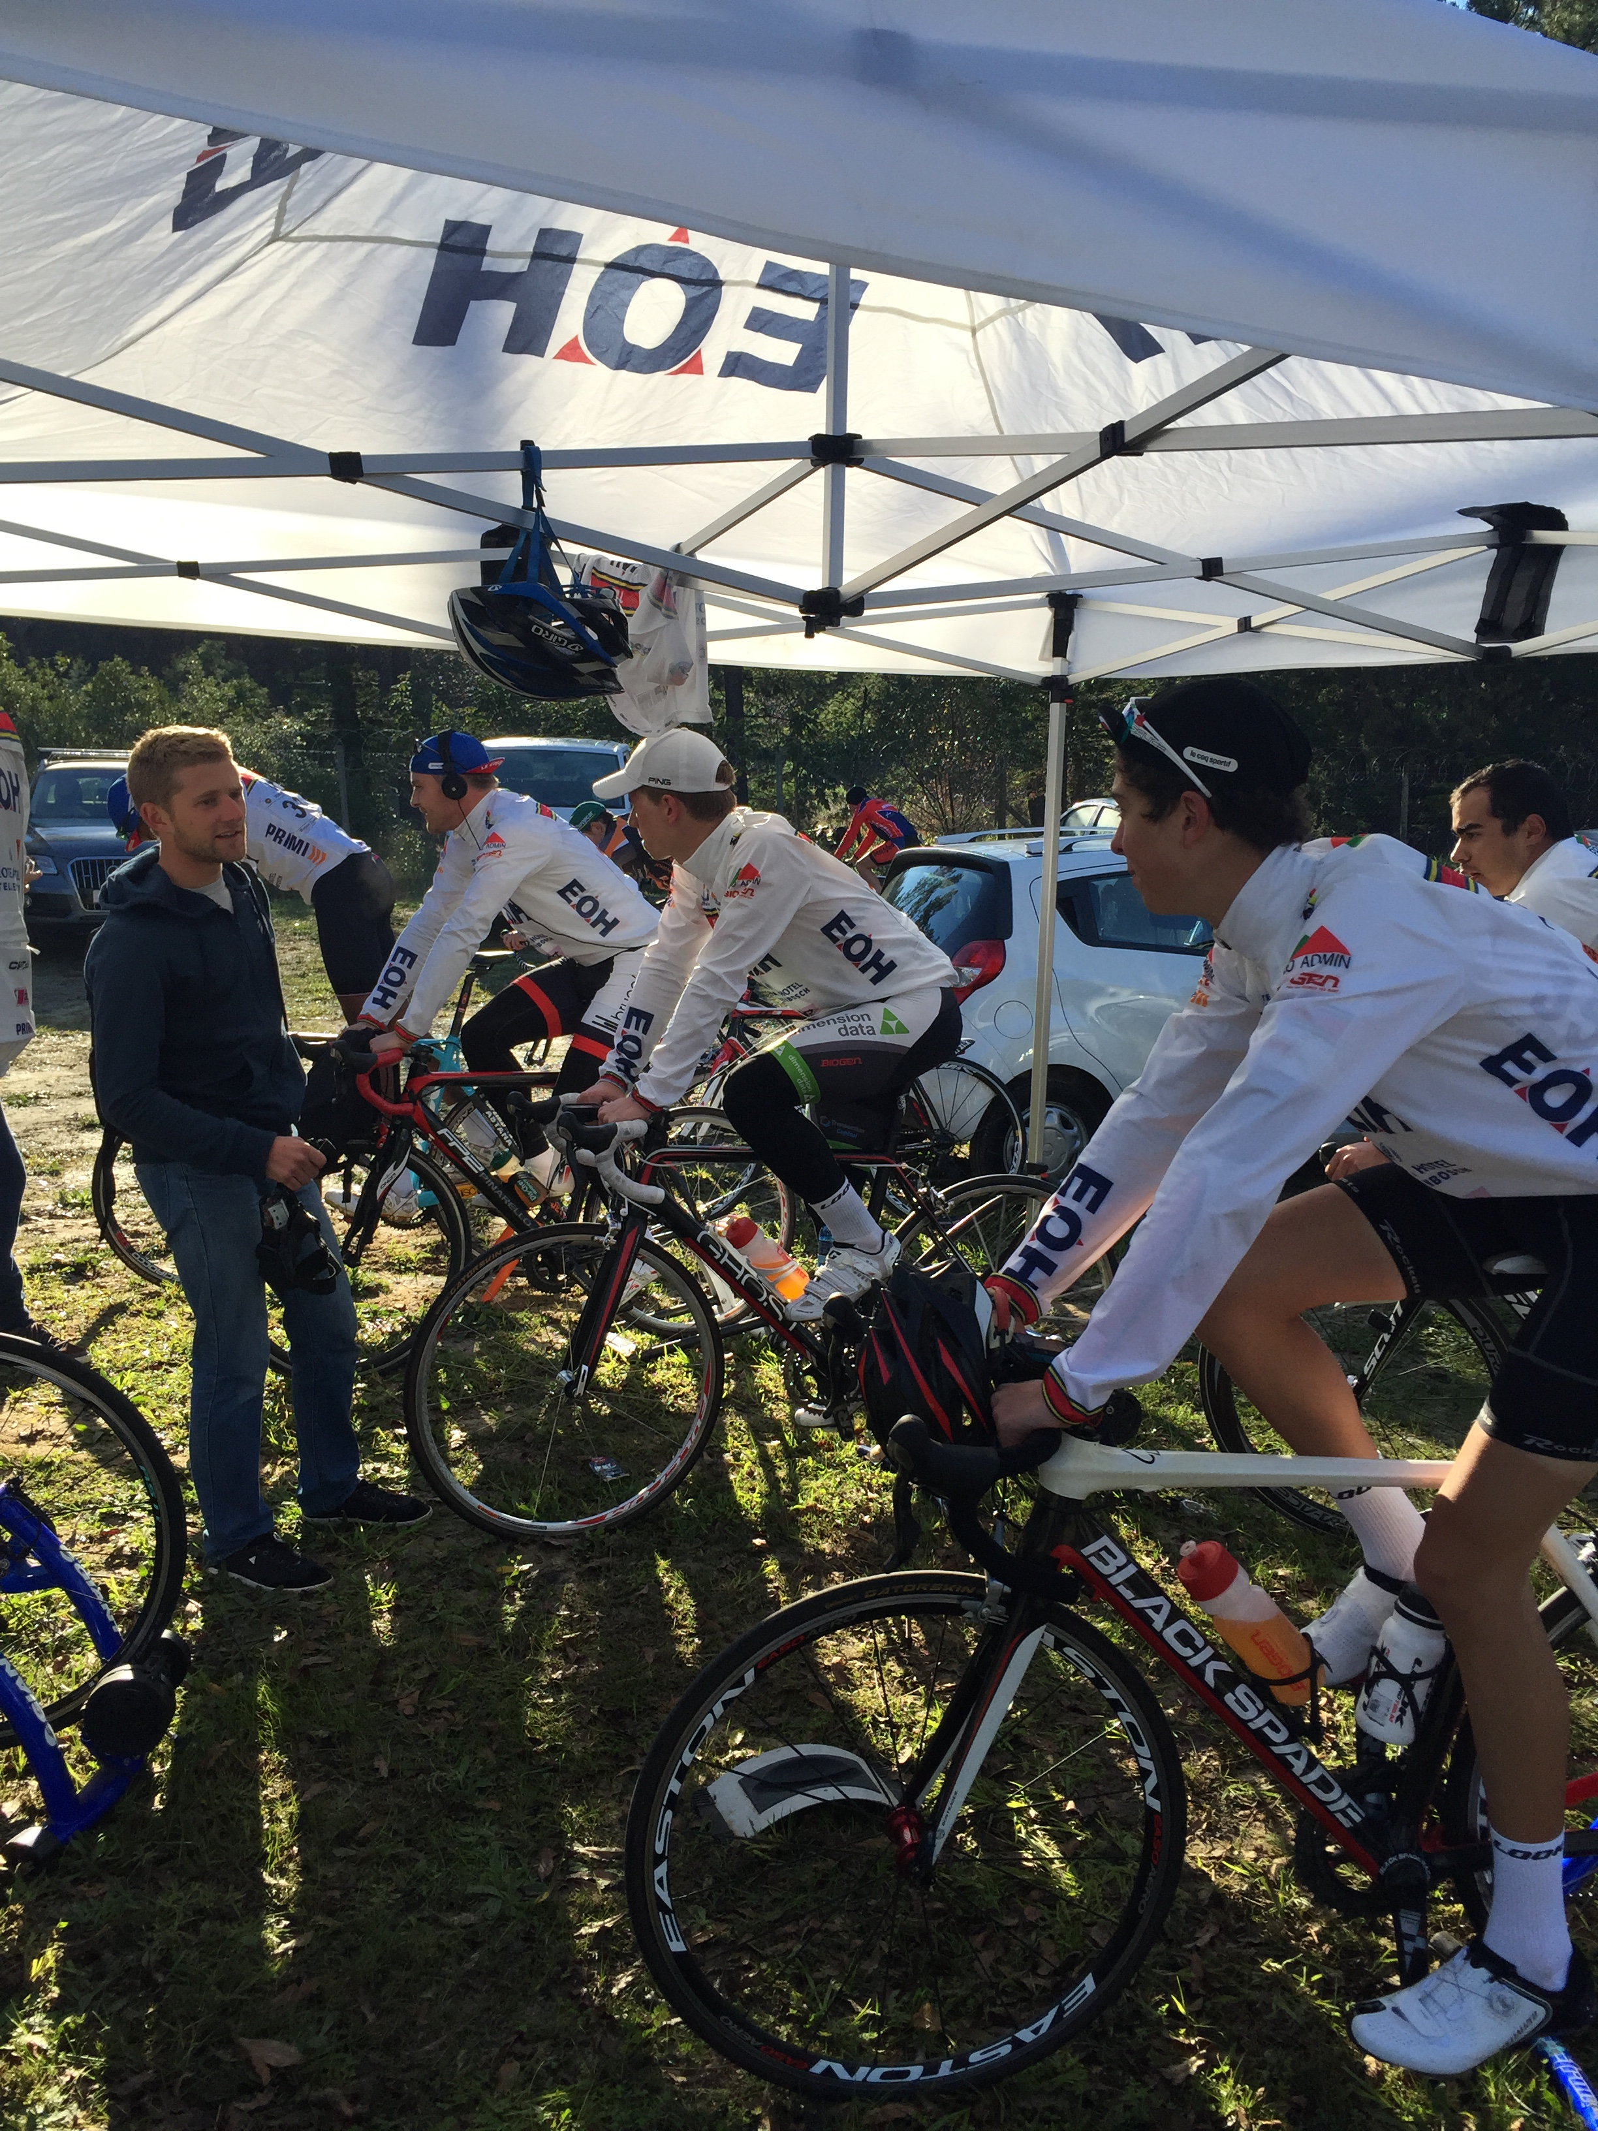

Compiled by Jacques Horn

Contents

**Foreword** 2

**Race Reports** 3

**Stage 1: (Short road stage, 72km Men and 52km Ladies)** 3

**Stage 2: (Individual Time Trail, 9.4km for Both men and ladies)** 4

**Stage 3: (Long road stage, 116km for men and 82km ladies)** 5

**Stage 4: (Criterium race, 60min for men and 45min ladies)** 6

**Stage 5: (Hill climb, 2.6km for both men and ladies)** 7

**Results** 9

**Conclusion** 10

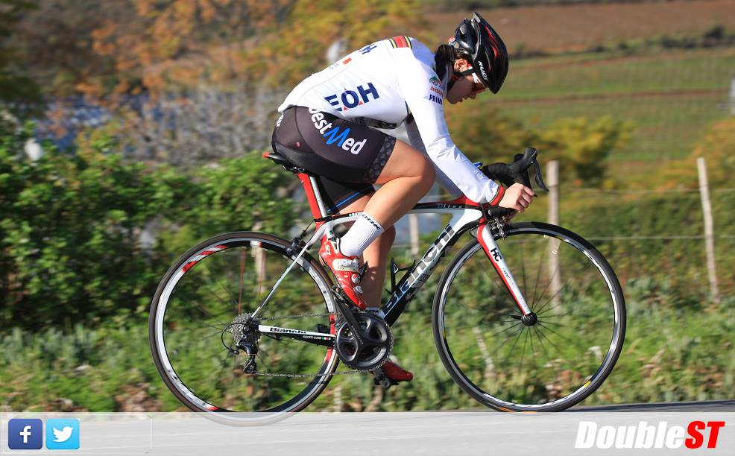

# **Foreword**

The 2015 cycling year was much anticipated by all of the riders at the University of Pretoria cycling club. It was announced during 2014 that the University of Stellenbosch would be the proud hosts of the 2015 USSA National Student Cycle tour and mountain bike event. With the thought of racing through some of the most breathtaking scenery the Western Cape has to offer we set out to defend our South African Student title.

The 2015 USSA National Student Cycle tour saw a growth spurt with a host of new riders from across the country traveling down to the Championships to try and achieve what all of the other riders most wanted, the covenant yellow jersey and South African Student Champion title. The quality of riders and the level of racing has definitely never been as high as with this year’s edition of the Championships. I see a very bright future for the USSA National Student Cycle tour and hope that this event will grow from strength to strength.

Tuks Cycling was once again very fortunate this year for the amount of help we received from each and every sponsor that formed part of the 2015 Tuks Cycling tour team. We approached the 2015 Championships with very high hopes and expectations and although the men’s team did not manage to realize the particular goals we set out for, they handled themselves in a professional manner and salvaged the situation with great effect. The Tuks Cycling Ladies tour team was without a doubt the highlight of the 2015 Championships and made known to all of the other Universities present that they are a force to be reckoned with.

Tuks Cycling was also very fortunate to have 1 rider from the men’s team and 2 riders from the ladies team included in the South African Student team chosen to represent South Africa at the Student World Cycling Championships.

To draw a very brief conclusion from the experiences at the 2015 USSA National Student Cycle tour. Tuks Cycling continued to show its dominance in the cycling discipline and also showcased that we have more to offer than just a men’s team. Congratulations to all of our riders and a very warm thanks goes out to all of our sponsors. Without you none of these performances would have been possible.

Kind regards

Jacques Horn

# **Race Reports**

## **Stage 1: (Short road stage, 72km Men and 52km Ladies)**

**Men:**

The 2015 USSA Tour kicked off with a 72km road stage held on the outskirts of Wellington. The race comprised of 6 laps of the circuit for the men and 4 laps for the ladies. The weather was forecasted to be wet and cold but luckily on our arrival the weather had cleared up and the sun made its appearance. The racing started off with quite a number of little attacks from various riders but nothing was able to stay away as the main contenders had sent their teams to the front to make sure the group stayed together. As we approached our second lap Tuks rider, Hein Badenhorst, put in a big effort and managed to get a reasonable gap over the main field. With Tuks having a rider in the break the pressure was taken off the rest of the team. Just before we started the third lap Hein Badehorst was brought back and the attacks resumed. Tuks Cycling made sure we had a rider in every move but none of the moves would stick in the end. The stage finish was contested by the bunch and it was Jonathan Van Gesselleen (Maties) who managed to beat the rest of the field to take stage honors and the first Yellow Jersey of the 2015 Championships

Results:

* 1st Jonathan Van Gesselleen (Maties)
* 6th Christoff Dames (Tuks)
* 9th Edwill O’Neill (Tuks)
* 10th Jacques Horn (Tuks)

**Ladies:**

For the ladies, the stage required riders to race 4 laps of a 12,3km circuit. With a group of 10 ladies at the start of the tour it was game on! The first lap seemed to be more of a neutral lap however. The ladies from TUKS then started the racing in lap 2 after having sized up our competition during the first lap. Our first two attacks, coming from Jessica Smith and Liezel van Niekerk, had quick responses from the ladies of UCT and Stellenbosch, however they could not respond to the third attack from Angie de Boer allowing her to make a solo break away from the group. From this break away she was able to claim the points for both the green and polka dot jersey and ride herself into pink. It was teammate Elmari de Wet who claimed second in a sprint finish to put TUKS in a 1, 2 on the podium after stage one.

Results:

* 1st Angie de Boer (Tuks)
* 2nd Elmari de Wet (Tuks)

## **Stage 2: (Individual Time Trail, 9.4km for Both men and ladies)**

**Men:**

The second stage of the 2015 Championships was an individual Time Trial held just outside Stellenbosch. The route was undulating and promised to make the riders work for their results. We had a very strong team and hoped to place within the Top 5 on the stage. With the weather still nice and warm the riders set out to conquer the 9.4km course.

Results:

* 1st Arno du Toit (Varsity College)
* 5th Jacques Horn (Tuks)

**Ladies:**

For most of the ladies this was their first ever time trial and proved to be the toughest 9,4km of the tour for many. The course seemed to be a gradual climb to the turnaround point, making the way back to the finish fast but not as easy as one would think it would be. Elmari de Wet performed with precision and claimed a very well deserved 2nd place behind Robyn Williams from Stellenbosch. Angie de Boer managed to hold on to her lead she had gained on the rest of the field during Stage 1 earlier in the day and thus remained in the Pink Jersey (Overall leader)

Results:

* 1st Robyn Williams
* 2nd Elmari de Wet

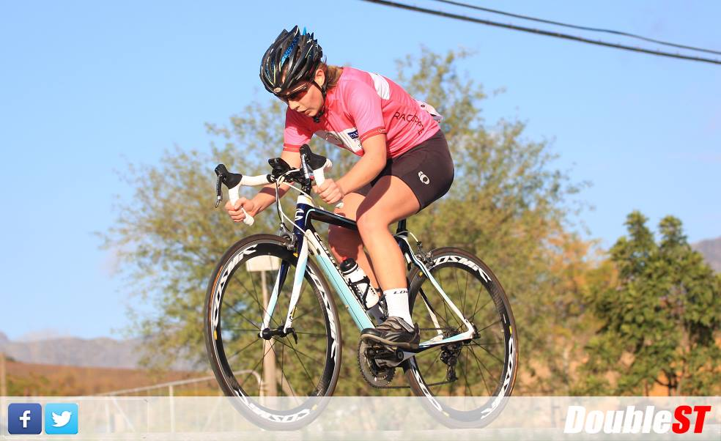

## **Stage 3: (Long road stage, 116km for men and 82km ladies)**

**Men:**

The long road stage promised to be a very tough challenge for all of the riders after a very hard two stages the day before. The long road stage took place close to wellington and comprised of 3 laps of a very undulating circuit for the men and 2 laps for the ladies. The weather once again was perfect for racing with the sun warming the riders as the day progressed. The start was delayed for 45min after some issues had to be sorted out with the routes. This gave the Tuks Cycling team some time to relax and refocus for the start of the stage. The racing got underway in fierce fashion with many riders trying their luck to escape from the main group. After 45 minutes of full out racing a break of 2 riders (Both UCT) managed to escape. Since all of the other universities had no riders in the break the bunch controlled the gap and managed to bring the break back on the last lap. It was a brave effort from all of the Tuks Cycling riders to help protect team leader, Jacques Horn, and make sure that he was well looked after during the stage. The Tuks cycling riders was also very active in attacking the main bunch but unfortunately none of these moves managed to stay away. With 30km to go Christoff Dames (Tuks) put in a huge effort and managed to cross over to the break that formed. The remaining Tuks Cycling riders made their presence known in the bunch and made sure that they were present in all moves trying to bridge over to the now established break of 5 riders. The break was reeled in with less than 15km to go but a sneaky attack from Maties saw that their rider in the break had slipped off the front. He went on to win the stage and claim the lead in the yellow jersey competition. We had Jacques Horn contest the bunch sprint

Results:

* 1st Hans-Werner Heuer (Maties)
* 14th Jacques Horn (Tuks)

**Ladies:**

Stage 3 consisted of 2 laps of 37,5Km circuit with Queen of the Mountain points and Sprinters points available in both laps. This meant that there was going to be no neutral lap this time and the racing would have to start right from the the gun. After Jessica Smith was forced to abandon the race because of flu the evening before, meant the Tuks Cycling Ladies were down one woman, and had to change tactics. After the previous day’s attacks the ladies were watching us carefully, making it hard for us to make any big attacks. Soon after the Queen of the mountain the group split, the pace increased and tactics were needed. Being new to road racing and a little misunderstanding on Angie’s behalf, the tactics were not working as planned so the race continued as a group effort from all teams. The race ended in a sprint finish with Elmari de Wet coming second in a very close sprint with Robyn Williams (Maties). It was a great learning curve for all of the Tuks Cycling Ladies and because of the great teamwork done by the Tuks Cycling Ladies Angie de Boer was able to keep her lead and remain in the Pink jersey.

Results:

* 1st Robyn Williams
* 2nd Elmari de Wet

## **Stage 4: (Criterium race, 60min for men and 45min ladies)**

**Men:**

The fourth stage was set to be the real decider for the mens race with the yellow jersey classification top 10 separated by less than a minute. The criterium race (crit) is a race where the riders race laps around a short circuit. The men did 60 minutes of racing followed by a final lap of the circuit. Stellenbosch hosted the criterium race and made sure that the route was challenging enough for even the toughest competitors. With the weather being quite chilly Tuks Cycling started their warm up and watched the ladies race unfold. The start of the mens race saw quite some action with Jacques Horn having a mechanical on the first lap. After rejoining the main bunch the racing started in earnest. With the time gaps in the overall standings being so marginal none of the attacks were allowed to gain a gap on the field. This made for some very high paced racing. Tuks Cycling once again showed that they are right up there with the strongest of university riders and made sure the pace stayed high. After 40minutes of racing a break consisting of CP van Wyk (Maties) and a UCT rider managed to slip away and outraced the main bunch. CP van Wyk took the victory in stage 4 and claimed the yellow jersey. Maties would end up winning the tour after CP van Wyk managed to beat the field by more than 40 seconds.

Results:

* 1st CP van Wyk (Maties)
* 6th William Mokgopo

**Ladies:**

The ladies race consisted of 45 minutes of racing around the circuit ending off with a final lap after the 45 minutes had passed. Again, this was a very new format of racing for many of the ladies but all enjoyed the fast racing format of the criterium. The pace was high from the start and again tactics were needed to tire the competition. With a perfectly planned sprint lap 30min in, Elmari de Wet claimed the 3 points and extended her lead in the green sprinters jersey competition. A breakaway of two riders formed in the last 2 laps of the race and consisted of Angie de Boer (Tuks) and Celeste Renaud (UCT). The finish was a sprint between the two with Celeste pulling a gap on Angie in the final corner giving her a well-deserved stage win. The sprint for third was contested by the rest of the main bunch behind the two breakaway riders. Elmari de Wet managed to outsprint the rest of the remaining riders in the main bunch to cliam 3rd on the stage. Angie de Boer retained her lead in the Pink Jersey classification and with only one stage to go the lead she had pried open looked sure to seal overall victory for the first time Tuks Cycling rider.

Results:

* 1st Celeste Renaud (UCT)
* 2nd Angie de Boer (Tuks)
* 3rd Elmari de Wet (Tuks)

## **Stage 5: (Hill climb, 2.6km for both men and ladies)**

**Men:**

The last and final stage of the 2015 USSA Championships took place just outside Stellenbosch. The hill climb event is a very tough stage with riders having to ascend a hill on their own as fast as they can. The overall victory was already decided with CP van Wyk (Maties) gaining a considerable margin on the rest of the riders after his breakaway win in Stage 4 earlier.

Results:

* 1st Max Sullivan (Maties)
* 6th William Mokgopo (Tuks)

**Ladies:**

A short, quick and hard final stage to round off an excellent three days of racing. The hill started off deceivingly with what can be called as a gradual climb, however around the corner beyond what one could see from the start, the real challenge lay. A 10% gradient to test what last little bit of strength we had in our legs. An opportunity to either gain or lose time that was up to you. Celeste Renaud (UCT) proved to be the fastest up the hill followed by Elmari de Wet (Tuks) and Robyn Williams (Maties). Angie de Boer managed another exceptional performance and managed to hold on to her lead. This meant Angie de Boer (Tuks) would win the overall leaders jersey at the 2015 USSA National Student Championship and be crowned South African Ladies Student champion 2015/2016

Results:

* 1st Celeste Renaud (UCT)
* 2nd Elmari de Wet (Tuks)

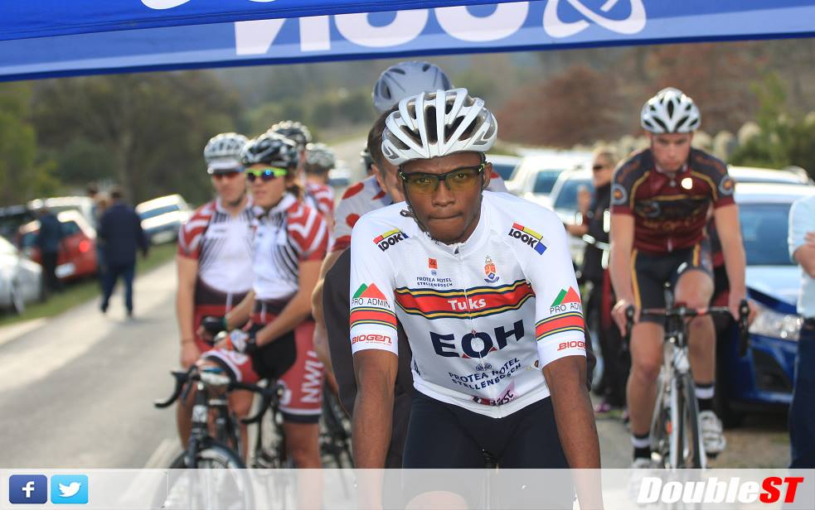

**Mountainbike race (Stellenbosch, Cross country format)**

The 2015 USSA Mountain bike race took place in Stellenbosch behind the main sports complex. The course was in pristine condition and with the course being used for National events it made sure that the riders were treated to top class mountain biking. The favorite for the title was Arno du Toit from Varsity College and our own William Mokgopo. The racing was fierce with Arno du Toit breaking away from the pack right from the start line. William Mokgopo (Tuks) fought back bravely and kept Arno du Toit from extending his lead to more than 2 minutes. In the end William Mokgopo (Tuks) took a very well deserved second place. Tuks Cycling also had Edwill O’Neill racing in the event. Edwill O’Neill (Tuks) continually fought his way back and managed to secure a 5th place.

After a late replacement for Clintin Cogzell (Tuks), Christoff Dames decided that he would also try his hand at the Mountain biking event. Christoff Dames (Tuks) kept his cool and raced to a very respectable 8th place.

Results:

* 1st Arno du Toit (Varsity College)
* 2nd William Mokgopo (Tuks)
* 5th Edwill O’Neill (Tuks)
* 8th Christoff Dames (Tuks)

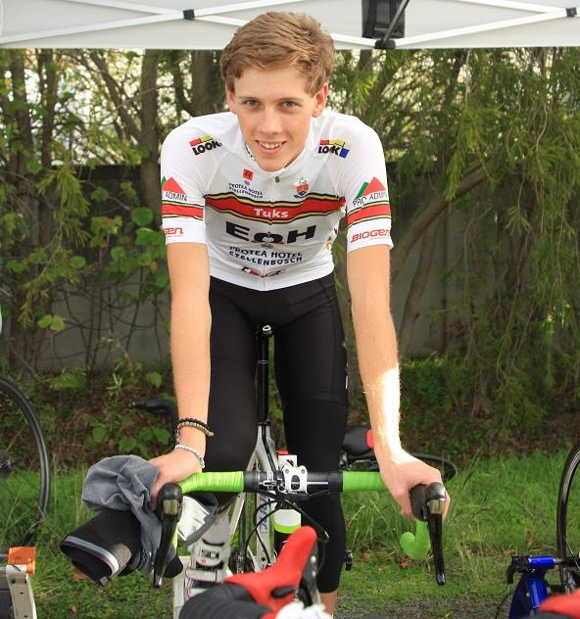

# **Results**

1. **Race winners (Pink and Yellow jersey)**

**Men:** **Ladies:**

1st CP van Wyk (Maties) 1st Angie de Boer (Tuks)

9th Jacques Horn (Tuks) 3rd Elmari de Wet (Tuks)

21st Edwill O’Neill (Tuks) 8th Liezl van Niekerk (Tuks)

22nd William Mokgopo (Tuks) DNF Jessica Smith

23rd Christoff Dames (Tuks)

26th Ewald Meyer (Tuks)

27th Hein Badenhorst (Tuks)

DNF Clintin Cogzell

1. **Best Sprinter (Green jersey)**

**Men:** **Ladies:**

10th Christoff Dames (Tuks) 1st Elmari de Wet (Tuks)

1. **Best Climber (Polka dot jersey)**

**Men:** **Ladies:**

1st Elmari de Wet (Tuks)

1. **Team classification**

**Men:** **Ladies:**

4th University of Pretoria 1st University of Pretoria

1. **South African Student Team**

**Men: Ladies:**

Jacques Horn (Tuks) Angie de Boer

Elmari de Wet

# **Conclusion**

All said and done, the 2015 USSA National Student Cycle tour was once again a great success for the Tuks Cycling team. The Tuks Cycling Ladies performed exceptionally well and proved all of their critics wrong. Ladies cycling throughout the world of cycling is drastically improving and with performances such as these seen above from our own ladies team I can only see bigger and better things to come in the future. Tuks Cycling is also very proud to have 3 riders being selected to represent South Africa at the upcoming World Student Cycling Championships. It will be a great honor to see our very own Tuks Cycling members competing against the best in the world.

The biggest word of thanks has to go out to all of our very generous sponsors. Without each and every sponsor none of these incredible results would have been able. Tuks Cycling is very privileged to have such a great team of sponsors powering and helping each and every rider excel in the sport of cycling. The help that our sponsors provide ensures that each rider can perform at their outmost best and create memories to last a life time.

From all of the riders and support staff at Tuks Cycling we would like to give a big round of applause and thanks to all of our sponsors.

Jacques Horn

Tuks Cycling Chairperson