

Student Supervisor

Head of Department

**ETHICS APPLICATION & APPROVAL SYSTEM**

**Table of Content**

1. How to Login to the Ethics System 3

2. How to use the system 4

3. How to add a new application 5

4. View an application to approve 6

a. View Application Form 7

b. Print / Download the Application Form 8

c. View Comments 8

d. View Documents for this application 9

5. To Refer an Application back to the applicant 10

6. To Cancel an Application 11

7. To Add a Comment to the Ethics Committee 12

8. To Approve an Application 13

9. Functions NOT available 15

# How to Login to the Ethics System

Login to UP Portal ([www.up.ac.za](http://www.up.ac.za)  / MyTUKS Login)

On the UP Staff Portal, UP Student Portal and UP Guest Portal, find the “Research Grants & Ethics” section.

Click on the Research Grants & Ethics link, see below:

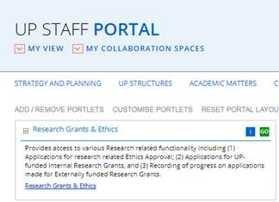

On the Homepage, click on the “Ethics Application & Approval” tile:

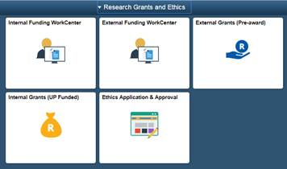

# How to use the system

According to your role, a help page will open to navigate you through your functions

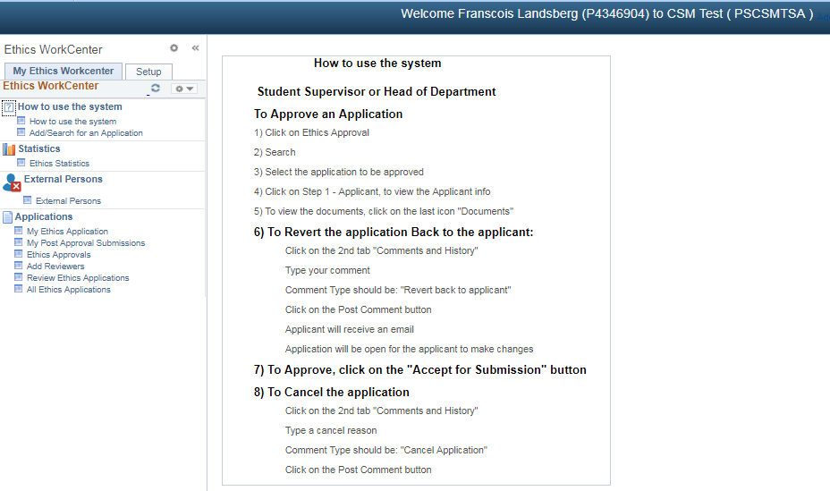

# How to add a new application

A help page for adding a new application

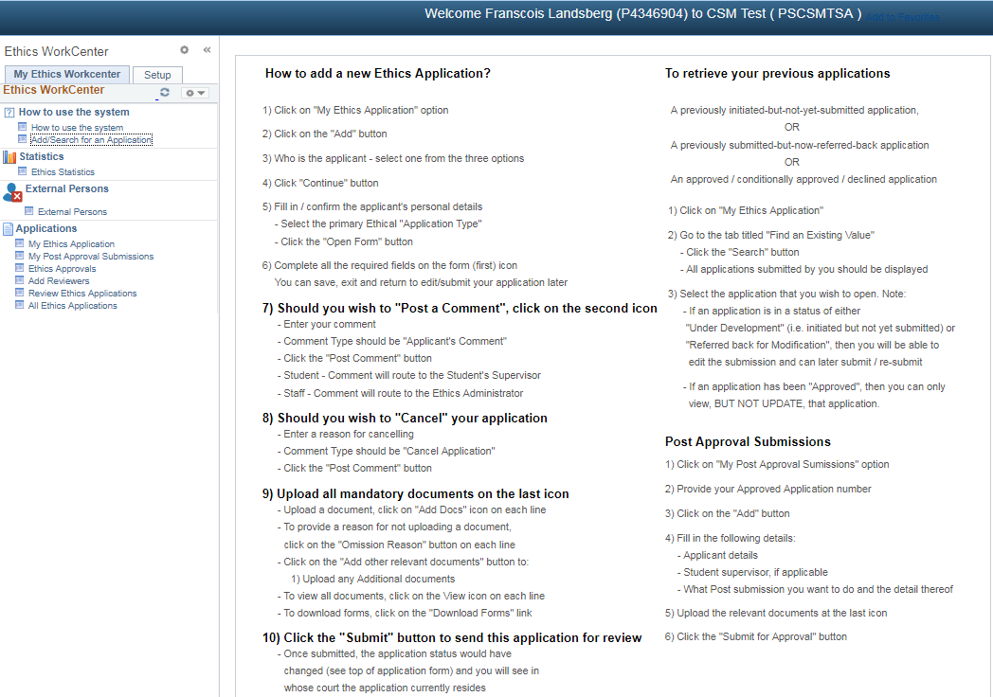

# View an application to approve

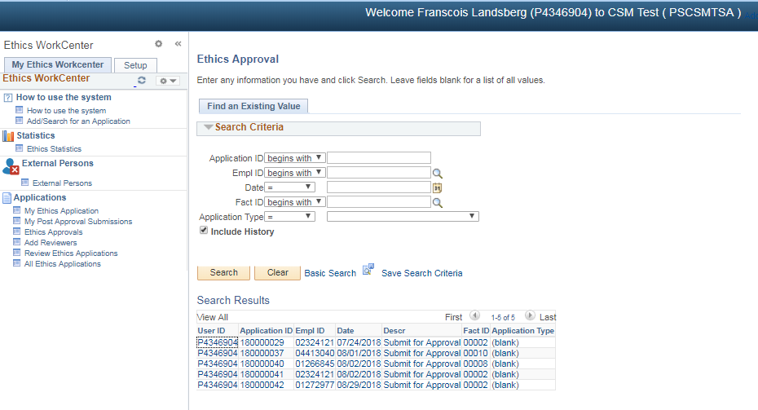

* Click on Ethics Approvals
* Click on the Search button
* If only one application, it will open the application
* If more than one application, a list of all applications need approval will display.
* Select one by one and approve

## View Application Form

The application form will open, scroll down to view the application

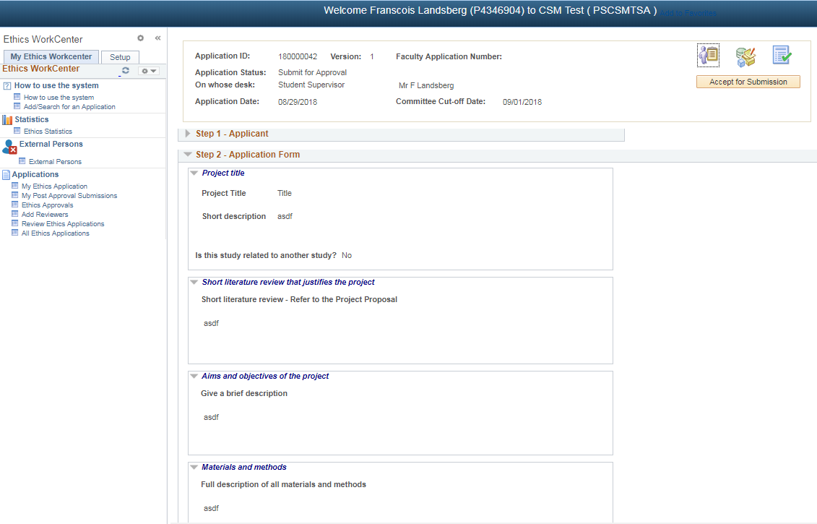

## Print / Download the Application Form

To print or download your application form, click on the “Print/Download” button

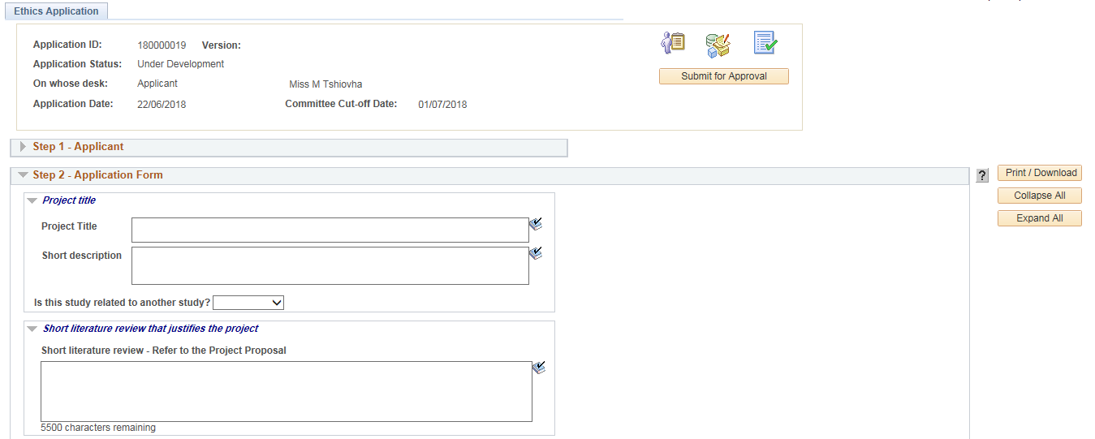

* Please make sure that the Pop-ups is not disabled.

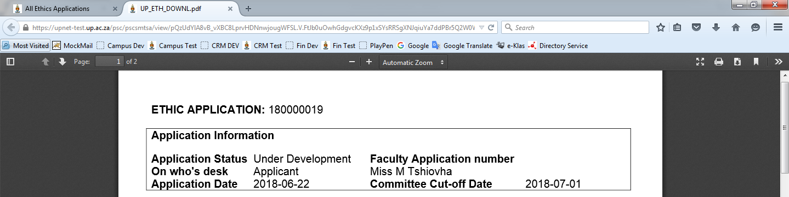

The form will open as a .pdf document.

You may print or download the form by clicking on the desired button.

## View Comments

Click on the 2nd icon to view the Comments and History.

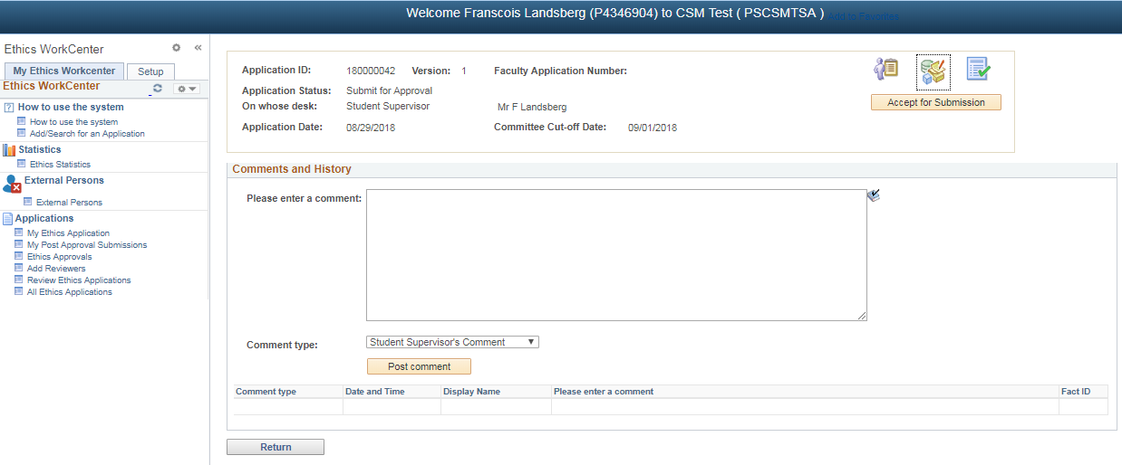

## View Documents for this application

Click on the 3rd icon to view the documents

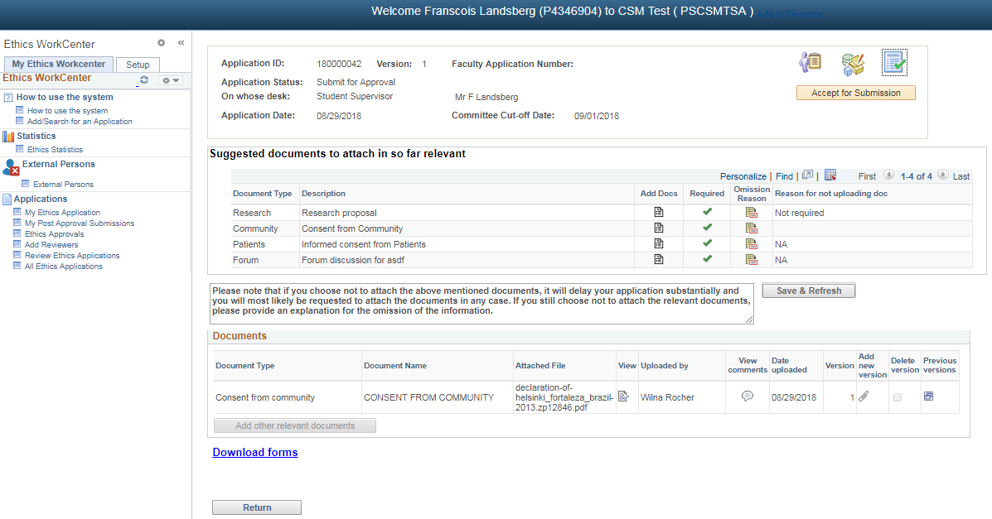

Click on the View icon on the document line to view the specific document

# To Refer an Application back to the applicant

Click on the 2nd icon – Comments and History

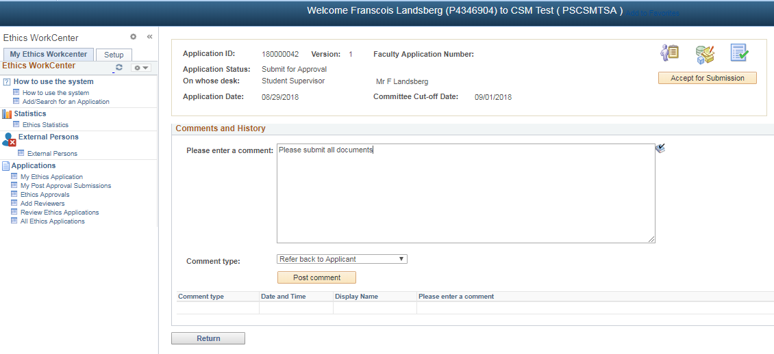

Please make sure that the form was filled in correctly and that all documents was uploaded. If not, please refer the application back to the applicant for amendments.

* Type a comment for the applicant
* Comment type should be “**Refer back to Applicant**”
* Click on the **Post comment** button

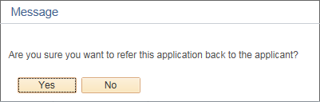

Click “Yes” – an email will be send to the applicant and the applicant will be able to change the application form.

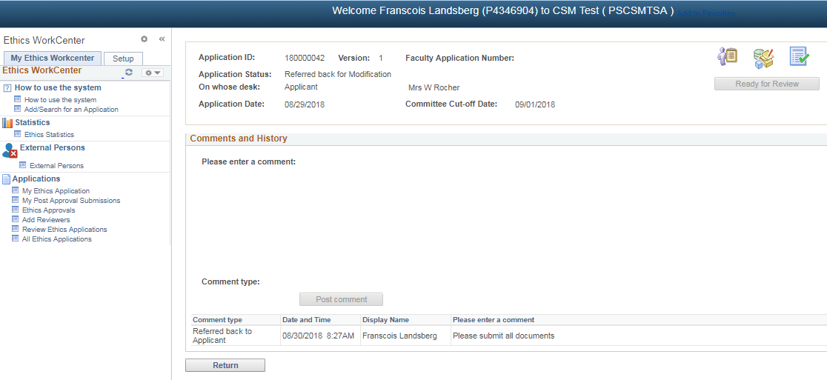

# To Cancel an Application

Click on the 2nd icon – Comments and History

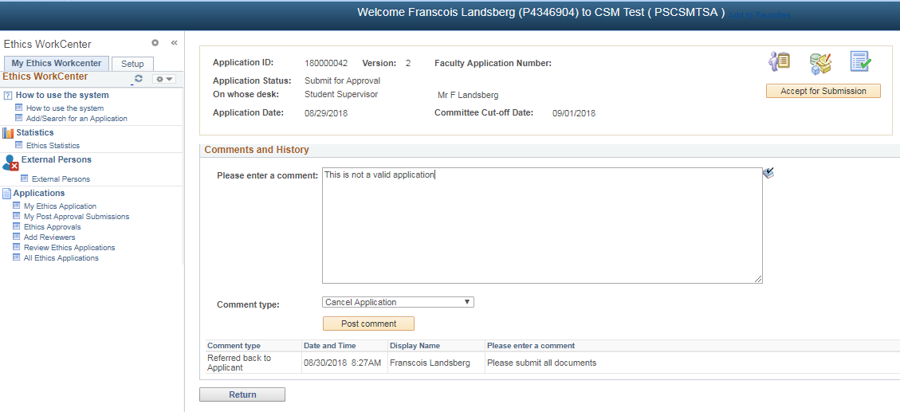

* Type a cancel reason
* Comment type should be “**Cancel Application**”
* Click on the **Post comment** button

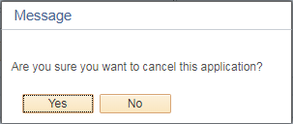

Click “Yes” – an email will be send to the applicant

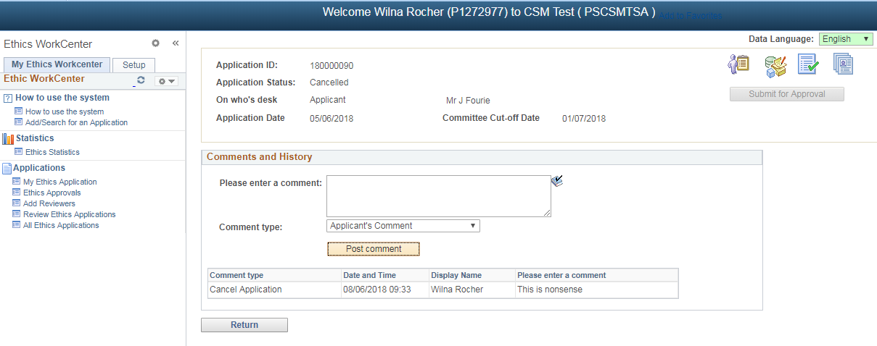

# To Add a Comment to the Ethics Committee

Click on the 2nd icon – Comments and History

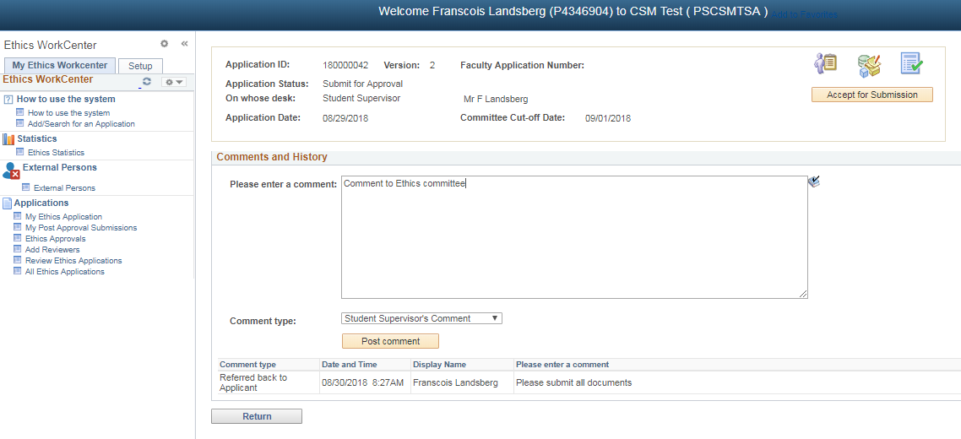

* Type a comment
* Comment type should be “**Student Supervisor’s Comment**”
* Click on the **Post comment** button

# To Approve an Application

Click on the **Accept for Submission** button

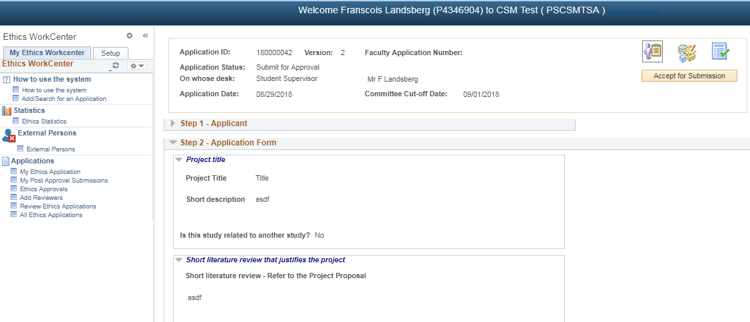

If Student Supervisor:

* An email will be send to the Head of Department
* The Head of Department will be able to view the application

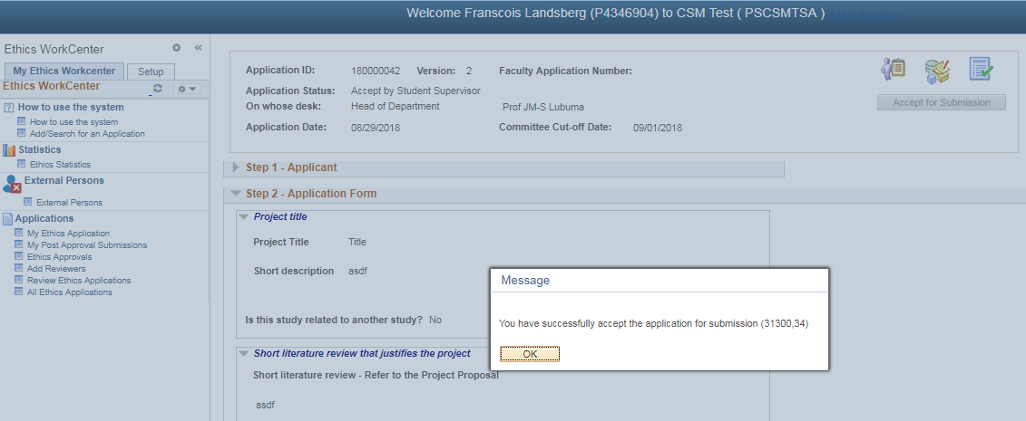

If Head of Department:

* An e-mail is send to the Ethics Administrator (if they choose to receive an e-mail)
* The Ethics Administrator will be able to view the application

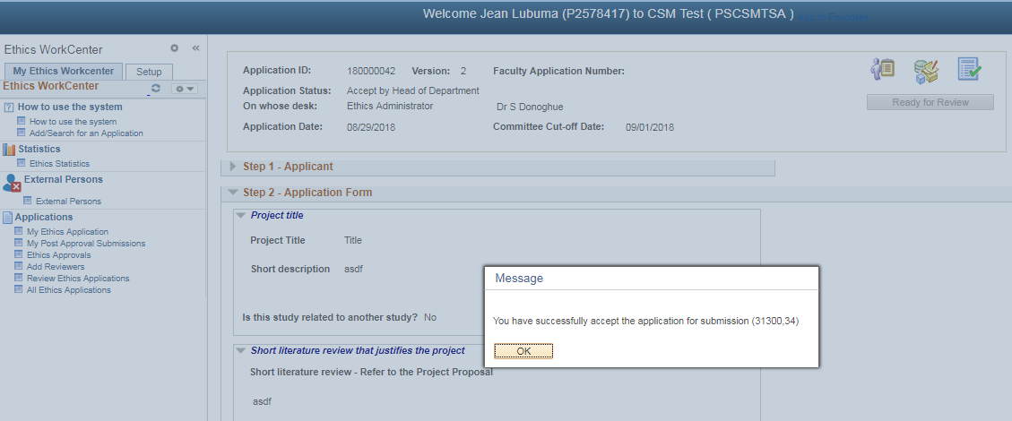

# Functions NOT available

The following functions show on your menu but is NOT available to you:

* Ethics Statistics
* Add Reviewers
* Review Ethics Application
* All Ethics Applications
* Setup