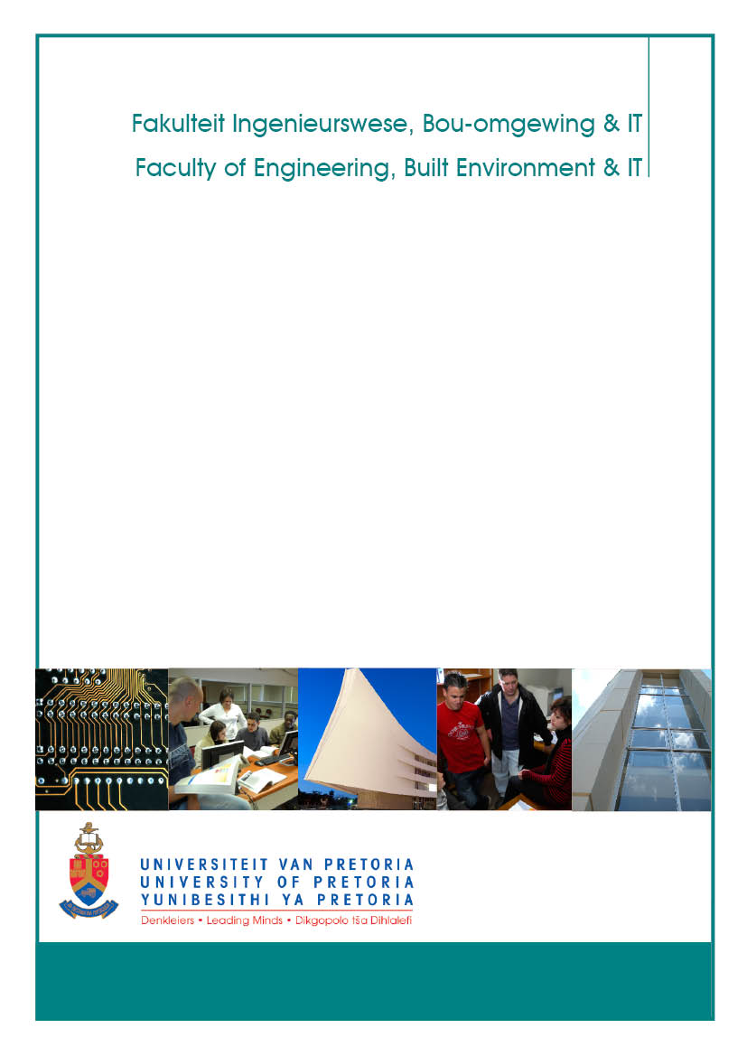

School of Engineering

Department of Materials Science and Metallurgical Engineering

Industrial Training NPY 416
Revision 2
Jan 2017
Wynand Roux

Table of contents

ORGANISATIONAL COMPONENT 1
1. General Premise and Educational Approach 1
2. Module Coordinators and Consulting Hours 1
3. Rules of Assessment 1
STUDY COMPONENT 2
1. Module Objectives, Articulation and Learning Outcomes 2
1.1 General objectives 2
1.2 Prerequisite learning and articulation with other modules 2
1.3 ECSA Outcomes addressed in this module 2
2. ECSA Documents 4

ORGANISATIONAL COMPONENT
1. General Premise and Educational Approach

During or at the end of the third year of study, students in Metallurgical Engineering undergo at least six weeks of prescribed training in the industry. A satisfactory report on the practical training must be submitted to the department within one week of registration.
2. Module Coordinators and Consulting Hours
Module coordinator: Wynand Roux
Room: 3-40 Mineral Sciences
Tel: 012 420 3192
e-mail: wynand.roux@up.ac.za
Lecture times and venues: No Contact Dates

3. Rules of Assessment

All students must submit a report on their vacation training to the University at the start of the next academic year. The report must be concise and to the point, focusing on the project which the student handled (rather than giving a general description of the plant where they worked).

To pass the module:
- The report must be signed by the students supervisor
- The supervisor must complete the Supervisors Report and the ECSA External Examiners Acceptance Report and it should be attached to the work report
- The module coordinator must approve the reports to ensure that it complies with the required ECSA DLO’s

The outcome of assessment will be “attendance satisfactory” or “attendance unsatisfactory” after assessment.

In the repost students must demonstrate that all of the ECSA outcomes, discussed in section 1.3, were addressed.

STUDY COMPONENT
1. Module Objectives, Articulation and Learning Outcomes
1.1 General objectives
We regard vacation training as an integral part of the training of students in Metallurgical Engineering. The vacation work serves to cover that part of the training which, for practical reasons, cannot be offered at the university. We hence rely on the industry to provide sensible exposure of students to industry practice.
The aim of this guideline is not to prescribe the exact contents of the vacation training programmes. Rather, we welcome the diversity of the industries which offer vacation work, and their unique approaches to metallurgical processing. What we do request is that this period be considered to be part of a formal training programme, which means that serious attention needs to be given to the formulation of an appropriate programme of work for each vacation work student.
The aim of vacation training can be summarised as follows:
- To familiarise students with the industrial environment; this requires exposure to the organisational, human and economic facets of production.
- To familiarise students with technical aspects – the operation of equipment, processes, and plants.
- To give students the opportunity to apply in industry the theoretical knowledge and experimental skills which they have gained at university.
Ideally, each student should be entrusted with a vacation work project which engages all three of these aspects. It is essential that the nature of the project ensures a degree of responsibility and involvement in the plant, rather than passive observation.
Since students who have completed the third year of study have covered all the basic aspects of metallurgical engineering, they should be able to complete tasks which require a greater degree of innovation. Tasks such as routine investigations, problem solving and smaller research assignments are appropriate. It must be recognised that these students have limited practical experience and little knowledge of process technology (which is covered in the final year of study). Hence frequent contact and supervision by plant personnel would be very valuable.

1.2 Prerequisite learning and articulation with other modules
This module articulates with Industrial Training NPY316
1.3 ECSA Outcomes addressed in this module

DLO 2: application of scientific and engineering knowledge
Apply knowledge of mathematics, natural sciences, engineering fundamentals and an engineering speciality to solve complex engineering problems.

Level descriptor: knowledge of mathematics, natural sciences and engineering sciences is characterized by:
- a systematic, theory-based understanding of the natural sciences applicable to the discipline;
- conceptually-based mathematics, numerical analysis, statistics and formal aspects of computer and information science to support analysis and modelling applicable to the discipline;
- a systematic, theory-based formulation of engineering fundamentals required in the engineering discipline;
- engineering specialist knowledge that provides theoretical frameworks and bodies of knowledge for the accepted practice areas in the engineering discipline; much is at the forefront of the discipline.
Mathematics, natural science and engineering sciences are applied in formal analysis and modelling of engineering situations, and for reasoning about and conceptualizing engineering problems.

Criteria of assessment
In a written repost students must demonstrate the use of scientific and engineering knowledge to give insight into the project the student has worked on.

DLO 5: Engineering methods, skills and tools, including Information Technology
Demonstrate competence to use appropriate engineering methods, skills and tools, including those based on information technology.

Range Statement: A range of methods, skills and tools appropriate to the disciplinary designation of the program including:
1. Discipline - specific tools, processes or procedures;
2. Computer packages for computation, modelling, simulation, and information handling;
3. Computers and networks and information infrastructures for accessing, processing, managing, and storing information to enhance personal productivity and teamwork;
4. Basic techniques from economics, business management;
5. Health, safety and environmental protection appropriate to the discipline;
6. Risk assessment and management;
7. Project management

DLO 6: professional and technical communication
Demonstrate competence to communicate effectively, both orally and in writing, with engineering audiences and the community at large.

Range statement: material to be communicated is in an academic or simulated professional context. Audiences range from engineering peers, management and lay persons, using appropriate academic or professional discourse. Written reports range from short (300-1000 word plus tables diagrams) to long (10 000 to 15 000 words plus tables, diagrams and appendices), covering material at exit-level. Methods of providing information include the conventional methods of the discipline, for example engineering drawings, as well as subject-specific methods.

Criteria of assessment
The student executes effective written communication as evidenced by:
1. Uses appropriate structure, style and language for purpose and audience;
2. Uses effective graphical support;
3. Applies methods of providing information for use by others involved in engineering activity;
4. Meets the requirements of the target audience

DLO 7: impact of engineering activity
Demonstrate critical awareness of the impact of engineering activity on the social, industrial and physical environment.

Range statement: the combination of social, workplace (industrial) and physical environmental factors must be appropriate to the discipline or other designation of the qualification. Comprehension of the role of engineering in society and identified issues in engineering practice in the discipline: ethics and the professional responsibility of an engineer to public safety; the impacts of engineering activity: economic, social, cultural, environmental and sustainability

Criteria of assessment
The student identifies and deals with an appropriate combination of issues in:
1. The impact of technology on society;
2. Occupational and public health and safety;
3. Impacts on the physical environment;
4. The personal, social, cultural values and requirements of those affected by engineering activity

2. ECSA Documents

These documents must be signed by internal & external examiner and HoD. Documents must be sent with signed final marks list to admin and kept on file by each lecturer. The acceptance report is sent with the paper to the external examiner (the HoD must be copied on this communication) prior to the examination. Attach the signed report to the exam paper distributed to students as proof that it has been approved.
EXTERNAL EXAMINER’S ACCEPTANCE REPORT
Module |  |  |  | NPY 416
Student Name
Examination type |  |  |  | Report
Date of examination
External Examiner(s)
Compliance with ECSA Exit Level Outcomes (ELOs)/Development Level Outcomes (DLOs)  Are the expected ECSA ELOs or DLOs for this course reflected in the study material, the tests, the class problems, the examination paper(s) and the practicals and their reports and are they adequately assessed? |  |  |  |  |  |  |  |  |  |  |  |  | Yes/No
DLO/ELO’s |  | DLO Description |  |  |  | Where is the DLO assessed? |  |  | How is the DLO assessed?
DLO 2  Application of scientific and engineering knowledge:  Apply knowledge of mathematics, natural sciences, engineering fundamentals and an engineering speciality to solve complex engineering problems. |  | In a written repost students must demonstrate the use of scientific and engineering knowledge to give insight into the project the student has worked on. |  |  |  | In a written report |  |  | Does the student show the use of Scientific and engineering Knowledge
DLO 5  Engineering methods, skills and tools, including information technology:  Demonstrate competence to use appropriate engineering methods, skills and tools, including those based on information technology |  | The student demonstrates in a written report  - awareness of the use of the tools for information retrieval,  - competence to use engineering methods, skills and tools as appropriate to the projects executed  - Basic project management skills
DLO 6  Professional and technical communication:  Demonstrate competence to communicate effectively, both orally and in writing, with engineering audiences and the community at large. |  | The student executes effective written communication as evidenced by:  1. Uses appropriate structure, style and language for purpose and audience;  2. Uses effective graphical support;  3. Applies methods of providing information for use by others involved in engineering activity;  4. Meets the requirements of the target audience |  |  |  | In a written report |  |  | Is the report on exit level standard
DLO 7  Impact of Engineering activity:  Demonstrate critical awareness of the impact of engineering activity on the social, industrial and physical environment. |  | The student identifies and deals with an appropriate combination of issues in:  1. The impact of technology on society;  2. Occupational and public health and safety;  3. Impacts on the physical environment;  4. The personal, social, cultural values and requirements of those affected by engineering activity |  |  |  | In a written report |  |  | Does the student address the issue of impact of engineering activity
Comments on any ELO or DLO of the question paper:
External Examiner |  |  | Date |  |  |  | Internal Examiner |  |  |  |  | Date
Department Head |  |  | Date

- Supervisors Report

Universiteit van Pretoria  Skool vir Ingenieurswese  Verslag oor vakansiewerk:  Metallurgiese Ingenieurswese |  |  |  |  | University of Pretoria  School of Engineering  Report on vacation training:  Metallurgical Engineering
Naam van student:
Name of student:
Student(e)no: |  |  |  |  | Merk asb:  Please tick: | NPY316 |  |  | NPY416
Naam en adres
van werkgewer:
Name and address
of employer:
Tydperk van werk:
Period of work:
Werk verrig / Tasks performed |  |  |  |  |  |  |  | Aantal dae  Number of days |  | Paraaf van toesighouer  Initials of supervisor
Opmerkings van toesighouer:
Remarks by supervisor:
Datum:  Date: |  |  |  | Handtekening van werkgewer:  Signature of employer

