About Clickers for Students

Revision history
Notes: | Author | Version | Date
Document created | David Wilson | 1.1 | 4-Dec-13
Updated for 2015 | David Wilson | 1.2 | 1-Dec-14
Updated for 2016 | Sven Leisegang | 1.3 | 06-Jan-16

About Clickers for students
The Participate Technologies ResponseCard Clicker is an easy-to-use response system that obtains immediate feedback from every student in a classroom.
Clickers will be used in a variety of ways in class. Some ways that your instructor might use clickers are:
- Create interactivity among students in large classes
- Create an interactive environment for group activities in class
- Deliver in-class surveys or quizzes with immediate feedback
- Take attendance
* Not all classes require a clicker. You will be notified by your instructor if a clicker is required for a particular class.
* You only need one clicker. The same clicker can be used for multiple classes in a semester and may be used in all the years your study or until you leave the University of Pretoria.

Purchasing a clicker
You may purchase a new or used clicker from participating campus bookstores and an online retailer:
- Bookmark
- Bookit/Kourse Publishing
- Wizebooks
- The Learning Warehouse - www.learningwarehouse.co.za

There are 2 models available:
- New QT Device (recommended retail price R795.00 excl. vat)
- New ResponseCard Clicker RFLCD ( recommended retail price R595.00 excl. vat)
The ResponseCard RFLCD is also sold in limited refurbished stock:
- Refurbished ResponseCard Clicker RFLCD ( recommended retail price R445.00 excl. vat)

* Eduloan have conditionally approved the purchase of clickers.
* Pricing may differ at each bookstore.
* Note the number of refurbished clickers available is limited.
* Some bookstores may offer a buy back if you no longer need it.

Warranties
Participate Technologies warrants its new devices for a period of twelve (12) months and refurbished devices for a period of three (3) months for any material or workmanship defect in the product as well as for any failures related to normal product use. This warranty does not extend to batteries or any product component that has been subject to misuse, deliberate destruction, or alteration.

Frequently Asked Questions for Students
- What are ResponseCard Devices / Clickers?
- How do I know if my instructor is using clickers in class?
- How much does a clicker cost?
- Where can I buy a clicker?
- What is the return policy? Can I return my clicker if I drop the course?
- Can I resell my clicker?
- Can I use the same clicker in multiple courses?
- I am having problems with my clicker, what do I do?
- Where do I register my clicker?
- What's the warranty for the clickers?
- How long do the batteries last?
- Can I share my clicker with another student?

Answers
- What are ResponseCard Devices / Clickers?
ResponseCard Devices also called ‘Clickers’, consist of a set of handheld devices that students use to respond to questions posed by the instructor. A receiver plugged into the classroom computer (or instructor's laptop) that picks up the students' answers. TurningPoint Software is used to create multiple choice questions, and then to tabulate and display student responses.
This technology can be used to support a variety of teaching activities.

- How do I know if my instructor is using clickers in class?
Your instructor will inform you in class if he or she is planning to use the clicker technology. If you are not sure, contact your instructor to find out.

- How much does a clicker cost?
There are 2 models available:
- New QT Device (recommended retail price R795.⁰⁰ excl. vat)
- New ResponseCard Clicker RFLCD ( recommended retail price R595.⁰⁰ excl. vat)
The ResponseCard RFLCD is also sold in limited refurbished stock:
- Refurbished ResponseCard Clicker RFLCD ( recommended retail price R445.⁰⁰ excl. vat)

- Where can I buy a clicker?
You may purchase a new or used clicker from participating campus bookstores and an online retailer;
- Bookmark
- Bookit/Kourse Publishing
- Wizebooks
- The Learning Warehouse - www.learningwarehouse.co.za

- What is the return policy? Can I return my clicker if I drop the course?
- If the device is found to be faulty within the warranty period and qualifies for replacement please return in to the retailer from which you purchased it and they will issue a new device.
- Should you no longer need your clicker, you should speak to the bookstore from where you have purchased your keypad regarding their returns policy.

- Can I resell my clicker?
Yes, some of the campus bookstores may offer to buy the clicker from you.
Alternately, you are also free to resell the clicker to other students. If you sell your clicker to another student, please inform the new owner that they should register their clicker before use.

- Can I use the same clicker in multiple courses?
Yes, a clicker can be used for more than 1 class.

- I am having problems with my clicker, what do I do?
If you are having technical problems with your clicker, or have questions about its use, please speak to your class instructor. If the issue isn’t readily solvable, return your clicker to the retailer.

Alternately, contact Participate Technologies
- Call: 0861 10 63 65
- Web: www.participate.co.za
- Email: support@participate.co.za

- Where do I register my clicker?
It is imperative to register your clicker so that your participation in class can be tracked. Students can register their clicker devices via Click-up. Your instructor will provide more details in class.

- What's the warranty for the clickers?
Participate Technologies warrants its new devices for a period of twelve (12) months and refurbished devices for a period of three (3) months for any material or workmanship defect in the product as well as for any failures related to normal product use.
This warranty does not extend to batteries or any product component that has been subject to misuse, deliberate destruction, or alteration.

- How long do the batteries last?
ResponseCard RF LCD / RF clicker devices are powered by two flat lithium batteries. The average battery life is 6 to 12 months. All refurbished RFLCD Clickers supplied by Participate Technologies come preinstalled with new batteries.
Take care when storing your device, as it may inadvertently press a button continually, depreciating the battery more rapidly than normal.

- Can I share my clicker with another student?
No, each student should only carry his or her own clicker. Possession of a clicker not registered to you is considered a breach of academic honesty. For more details, see the University’s Policy on Code of Ethics.

Device Images
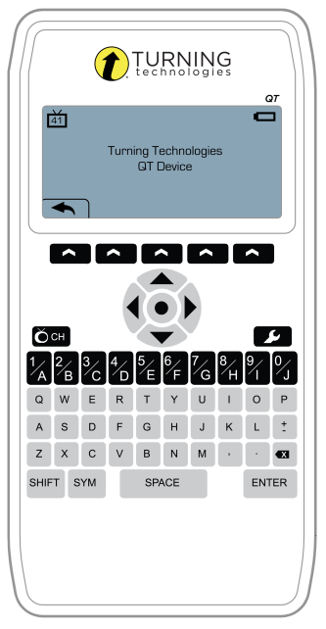  New QT Device  RRP R795.00 excl. VAT | 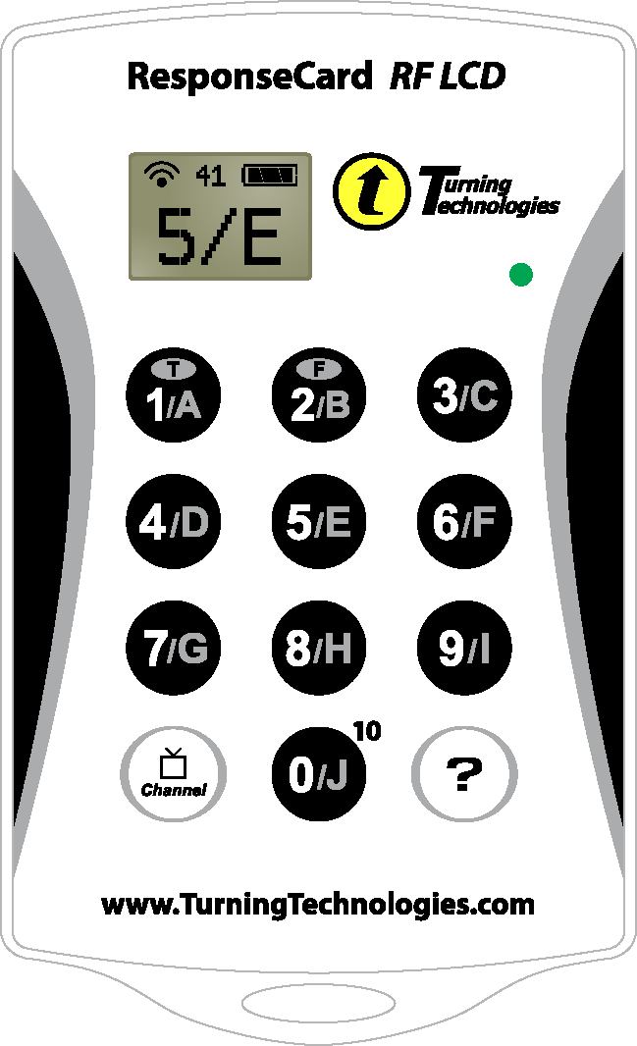
 | New ResponseCard RF LCD
 | RRP R595.00 excl. VAT
- 12 Month limited warranty
- LCD offers visual confirmation of input and channel
- Lightweight, rugged and durable enclosure

- 12 Month limited warranty
- Input capabilities - Multiple Choice, Multiple Response, Numeric Response, Short Answer, True/False, Essay
- Class list creation - Automatically creates participant lists with QT Device’s user stored data or have participants log in to an existing list. Easily move from one session to another.
- Self-paced testing - Participants use QT Device to navigate to any question on the test or assignment and select a response. The QT Device has the largest storage capacity in the industry, storing all responses into non-volatile memory to ensure data security and stability.
- Successful transmission - Participants and presenters receive visual successful transmission notification
 | Refurbished ResponseCard RF LCD
 | RRP R445.00 excl. VAT
- 3 Month limited warranty
- LCD offers visual confirmation of input and channel
- Lightweight, rugged and durable enclosure
- Faceplate may differ in design

