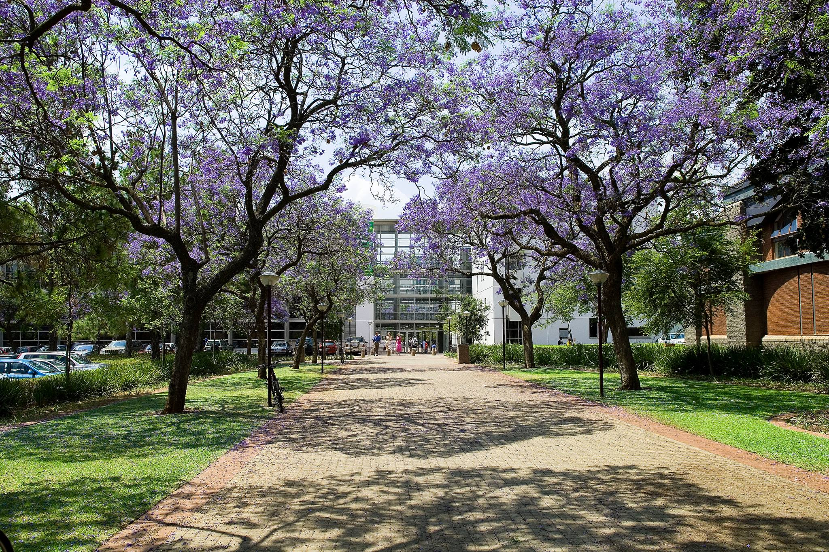

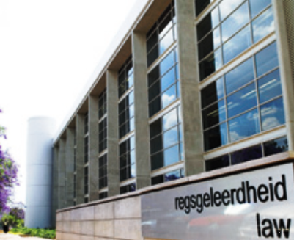

2020 Dean’s Merit List

UP Law
honours and recognises its
First-year to Penultimate-year LLB Students
for their
consistent academic achievement
during the 2020 academic year.

Category 1

First-year LLB

Category 2

Second-year LLB

Category 3

Third-year LLB

Category 1 – First-year LLB

Aaron |  | Cheyne
Abraham | Jacobus | van Jaarsveld
Aeglesia | Mariam | Caunhye
Akudzwe |  | Mhangami
Alastair | Camden | Naicker
Alexander | Michael | Maack
Alexander | John | Goddard
Alysa | Jenna | Bunting
Alyssa | May | Farrand
Amy | Lynn | Pawson
Andani |  | Mashige
André | Hendrik | Breedt
Andrea |  | Dolphin
Anrich | Malan | Otto
Aretha |  | du Plessis
Asandekahle | Zesuliwe Sibonelesihle | Masuku
Asandiswa | Likho | Chitha
Brandon | Timothy | Bora
Caitlin | Anne | Kavanagh
Caitlyn | Jacqui | Sim
Cameron | Michael | Goodhead
Caylie |  | Dirker
Chanel |  | Marais
Chibugom | Ezinne Chimdi | Abanno
Christéle |  | Duvenage
Christopher |  | Williamson
Clement |  | Khumalo
Comfort | Okikiolami | Ayelomi
Courtney | Catherina Yvonne | Naudé
Damian | Frederick | Vosloo
Daneel |  | Henn
Danyal | Zahid | Minty
Dashia |  | Govinden
Dayne |  | van Wyk
Dehal |  | Jivan
Douglas |  | Kabuzi
Elzette |  | Preuyt
Emily | Kate | Inman
Emma | Pam | Efstratiou
Erika |  | Lutchmana
Esmeralda |  | de Lange
Fortune | Podile | Chego
Gabrielle | Chanél | Krügel
Genevieve | Ashleigh | Chalmers
Grete-Lee |  | Swanepoel
Hansie | Vorster | Buitendag
Ilhaam |  | Wadvalla
Izabella |  | Gutlar-Balkovic
Jacobus | Johannes | Bouwer
Jacques |  | Erasmus
Jade | Lyn | Werner
Jamee | Lee | Boodoo
Janus |  | Greyling
Jerusha |  | Chetty
Jessica | Leigh | Penney
Joshna | Neirah | Narasoo
Justin |  | Wentzel
Katya | Marie | Harper
Kaylah | Jesse | Poonsamy
Keagile | Peter | Madiba
Kerryn | Leigh | Shelley
Kgositsile |  | Motlhaoloa
Khutso |  | Maloka
Kwandilokuhle | Noluthando Philile | Nkosi
Kyra | Lynn | Scully
Laaikah |  | Lutchmia
Lara | Jayne | Thom
Lathan | John | Schippers
Lauren | Sarah | Greggor
Lilandi |  | Niemand
Lizahn |  | Truter
Louis |  | Pretorius
Mankwana | Palesa | Marobela
Marcell |  | Fourie
Marco | Jacobus | Hoogenraad-Vermaak
Marthinus | Philippus | Fourie
Mathilda |  | van der Merwe
Matthew | John | Davis
Megan | Leanne | Smith
Melanie |  | Venter
Mia |  | van Zyl
Micheala |  | Mendes
Michelle | Anne | Gouws
Mignonne |  | Roestoff
Mila |  | Grobler
Mishka |  | Cassim
Molebogeng | Thoriso | Rampa
Morn |  | du Plessis
Mothusi |  | Machete
Naeemah |  | Ismail
Nicolaas | Jacobus | Nel
Nicole | Meshail | Sentoo
Nishan |  | Pillay
Nkateko |  | Hlongwane
Nomonde | Tusekile | Ngwenya
Odirile | Precious | Matladi
Omar |  | Ismail
Novuyo |  | Madela
Parthenopi |  | Ioannou
Pheladi | Kutlwano | Boshielo
Phumlani | Amogelang | Shenxane
Reabetswe |  | kgaile
Rebecca | Jane | Fernandes
Reece | Gemma | Pierce-Jones
Reine | Alyssia | Aldous
Reneilwe | Mmachuene | Malebatja
Riani |  | Jordan
Robyn | Adrienne | Culverwell
Robyn |  | Anderson
Robyn | Delana | Loff
Rowena | Victoria | Ogg
Roxanne | Jayne | Allan
Ruan | Thomas William | Stevens
Ryan |  | Haines
Ryan | James Paveley | Price
Sabine | Hélène | Letellier
Sarah | Valerie | Vyvyan-Day
Savanna |  | Primmer
Sebrina | Angelica | Grobler
Seetsa | Setshego Roberta | Kekana
Semliki |  | Addison
Shannon |  | Busacker
Shaun |  | Putter
Sibulele | Zandile | Gando
Sky |  | üuger
Sumari | Eriné | Coetzee
Tamara |  | Levendal
Tanatswa | Reachel Sharleen | Chigwande
Thabiso |  | Skhosana
Thanica |  | Wessels
Thupe | Phillip | Marumule
Tiara |  | Joseph
Tlotlang | Phitlhelelo | Seabo
Tony | Karabo | Misago
Tristan | Alexander | Wallace
Tristan |  | Behr
Tristan | Alexander | McKenzie
Tristan | Sean | Edwards
Tshegofatso |  | Lerole
Tshepang |  | Shidi
Tyler | Robert | Jardine
Tyne | Brett | Potgieter
Uzziah | Thato | Mokgweetsi
Vaschel |  | Naidoo
Wihan |  | Esterhuizen
Wilhelm | Hermanus | Berrangé
Willem | Johannes | Palmer
Xolani | Celeste | Masemola
Yolandi |  | Cloete
Yusraa |  | Abed
Zahra |  | Patel
Zandisile | Prudence | Mashinini
Ziyanda |  | Bandla
Zoë |  | Meyer

Category 2 – Second-year LLB

Zahraa | Bibi | Aboo
Thomas | Geoffrey | Anderson
Nyeleti | Risuna | Baloyi
Chelsea-Lee |  | Beelders
Daniel |  | Bloom
Cornelia |  | Botha
Daniélle | Francis | Botha
Lizelle |  | Brink
Bianca |  | Buitendach
Vinolia | Ritshidze | Bulala
Mika |  | Burger
Cassidy |  | Channon
Mayuree |  | Chiba
Tanyaradzwa | Sasha | Chivaura
Kristen |  | de Beer
Zané |  | de Beer
Ruben | Alexander | De Koning
Samathari | Hans | Ditshwene
David | Kwame | Donkor
Olivia |  | du Plessis
Andre | Christiaan | du Toit
Thubelihle | Anele | Dumisa
Chloe | Esme | Eacott
Willem | Gerhardus | Engelbrecht
Tochukwu |  | Eresia-Eke
Tichanung | Chiano | Fombad
Sean |  | Fourie
Thabisile | Ntombenhle | Gaba
Luvania |  | Govender
Jared | Rowan | Hall
Lauren | Gayle | Harries
Jacobus | Johannes | Hudson
Jarod |  | Jacobs
Renaldo |  | Janse van Vuuren
Rebecca | Lynne | Jones
Wessel | Johannes | Jordaan
Richélle |  | Joubert
Bibi |  | Kader
Jennifer | Rose | Koen
Kamogelo | Clifford | Komane
Nicole |  | Kotzé
Themba | Hope | Kubeka
Asanda |  | Lembede
Chanel | Clare | Louw
Snethemba |  | Luhabe
Rhulani | Blessed | Mabasa
Makhosazana | Londeka | Maduna
Gomolemo |  | Mahange
Yolande | Refilwe | Maimela
Andile |  | Makaringe
Phokwane | Paulina | Makhubela
Edgar |  | Malomane
Tumelo | Ntombikayise | Mamabolo
Amaan |  | Mansingh
Charné |  | Martin
Felicia |  | Masedi
Sinelisiwe |  | Masemola
Olebogeng | Nicole | Masenya
Thandolwethu | Busisiwe Nomusa | Mathebula
Betty |  | Matsane
Gundo | Oscar Junior | Mbedzi
Nhlanhla | Lucia | Mbonane
Ziphozethu |  | Metu
Aphiwe | Phumelele | Mfeka
Steven | Vernon | Mijiga
Lerato |  | Modishane
Motlalekgomo |  | Mofokeng
Palesa | Elizabeth | Mofomme
Selina | Tebogo | Mokwena
Koketso | Bontle Boitumelo | Moshira
Nokwazi | Busisiwe Nomhlekhabo | Mtsweni
Adivhaho |  | Mudanalwo
Carmen | Abigail | Muir
Mutsawashe | Sophie | Muzamhindo
Amira |  | Nagvadari
Kherina |  | Narotam
Chanë |  | Nel
Sanelisiwe |  | Ntombela
Bongiwe |  | Nyembe
Simphiwe |  | Nyembe
Louw |  | Oberholzer
Melinda | Caitlin | Opperman
Mmatshepo | Mmaseapo | Papo
Jeneil | Naghmeh | Peterson
Dinendri |  | Pillay
Ruan |  | Pretorius
Cameron | Jabu | Price Moor
Nomonde | Lydia | Ragophala
Tamaryn | Rose | Robinson
Daniel | Michael | Sarkis
Luke | Daniel | Schwulst
Kgaugelo | Judith | Sehoole
Christiaan | Jacob Homann | Small
Megan | Leigh | Soal
Riccardo | Christos | Souris
Joanna | Victoria | Sprighton
Letlotlo | Remofilwe | Stemmer
Lisa |  | Strydom
Michelle |  | Swarts
Ilané |  | Swift
Gaisang | Matila | Tjikane
Khanyisile |  | Thobane
Khanyisa |  | Tshoba
Adolf |  | van Coller
Cornelia | Magdalena | van der Merwe
Jordyne | Joan | van Niekerk
Kassandra |  | Vercueil
Ronald | Carl | Voges
Joshua | Daniel | Williams
Rochaan |  | Zwarts

Category 3: Third-year LLB

Antonie |  | Ackerman
Mansah | Dondo | Amoah
Cordney |  | Baird
Tiya |  | Balakisten
Shikara |  | Balkishun
Chanel | Maria Catherine | Brown
Andrew | Manuel | Carmichael
Leisha |  | Chiba
Marilise |  | Cilliers
Mariana |  | Claassen
Kiranteba | Schalk | Coetzee
Bianca |  | Coetzer
Marikoula | Aristea | De Paiva
Bianca |  | Dempers
DeWaal |  | du Plessis
Mason |  | du Plessis
Nicholas | Pieter | du Toit
Arno |  | Erasmus
Shannen | Marie | Etter
Lizerie |  | Ferreira
Jamie |  | Flemmer
Megan-Mari |  | Gerber
Bianca |  | Gibbs
Albert |  | Gooding
Megan | Helena | Kayser
Tshegofatso | Louisah | Kgoele
Dawn |  | Khumalo
Christin |  | Kleingeld
Helena | Cecile | Kruger
Siboniso |  | Langa
Savannah |  | Lavis
Hannah |  | le Roux
Sasha | Maria | Lordan
Tshilidzi |  | Mahumela
Takudzwa |  | Matekwe
Morgan |  | Mayhew
Kamogelo |  | Mothibe
Lungelo | Melusi | Mkhize
Mornalisa |  | Mphaga
Makaziwe | Granny | Mthethwa
Kyla | Annancia | Muller
Zandile | Nontanjana | Munyai
Keanen | Daryll | Naidoo
Sandro | Luis | Nobrega de Freitas
Charmaine |  | Nyundu
Damilola | Naomi | Odeyemi
Johannes | Jurie | Oosthuizen
Aalwyn | Jacques Darius | Opperman
Nthato | Busang | Padi
Themba | Mtha | Papu
Saajidah |  | Patel
Jacques | Lukas | Peacock
Amonique |  | Plaisier
Mariska |  | Rall
Raisha |  | Ramkhelawan
Tobias | Gerhardus | Roelofse
Lusani | Hope | Sadiki
Moshahlama |  | Satekge
Israel |  | Shnketa
Gustav | Marthinus | Snyman
Inge |  | Swanepoel
Zoe-Lee | Anne | Teperson
Manyaku |  | Thulare
Rozelle |  | Trumpie
Didintle | Dimpho | Tselapedi
Chené |  | van der Merwe
Francois | Gerhardus | van der Merwe
Jason | Dusan | Venter
Aislinn | Mae | Volker
Samantha | Kelly | Whelan
Devin |  | Wykerd
Sanele | Sthabile | Zulu

Dear Students recognised on the 2020 Dean’s Merit List

The Faculty of Law at the University of Pretoria
is extremely proud of you, our academic achievers.
On behalf of UP Law and the University of Pretoria
we congratulate you on your achievements!
Your achievements motivate the work of everyone at UP Law –
from faculty and staff, to students and alumni, to our partners and supporters.
Congratulations again!

Dean Professor Elsabe Schoeman, Deputy Dean Professor Charles Maimela
and staff

